**6**

***I General Question***

***A- Choose the correct answer:***

|  |  |  |  |  |
| --- | --- | --- | --- | --- |
| C:\Users\user\Desktop\exams\clipart\images (32).jfif1- What's the greeting you usually say it before you go to bed? | | | | |
| c- Good night. | | | b- Good bye. | 1. Good morning. |
| C:\Users\user\Desktop\exams\clipart\images (33).jfif2- How much is the jacket? | | | | |
| c-It's huge. | b-It's 100 SR. | | | a- Yes, thanks. |
| C:\Users\user\Desktop\exams\clipart\download (6).jfif3- Which subject do you like ? | | | | |
| c-I go to Makkah | | b-I sleep early. | | a- I like P.E. |

***B- Choose the correct opposite:***

|  |  |  |  |  |
| --- | --- | --- | --- | --- |
| 1-The opposite of **big**? | | | | |
| small | | strong | | cute |
| 2-The opposite of **open**? | | | | |
| play | go | | close | |

***C-Choose the correct answer:***

|  |  |  |  |  |  |
| --- | --- | --- | --- | --- | --- |
| 1-It's an animal which is the mother of a lamb,it gives us wool. | | | | | |
| sheep | | | turtle | | monkey |
| 2-It's an animal ,lives in the sea ,it has 8 legs. | | | | | |
| Dolphin. | | Crocodile. | | Octopus. | |

**5**

***II Controlled Writing***

***A-Choose the correct answer:***

1-I have ( stomachache – headache –toothache).

2- ( go straight – turn right – stop).

3- To make fresh orange juice ( cut – squeeze – write ) some oranges.

3- To make fresh orange juice ( cut – squeeze – write ) some oranges.make fresh orange juice ( cut – squeeze – write ) some oranges.

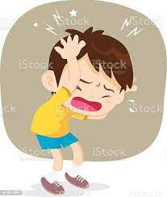

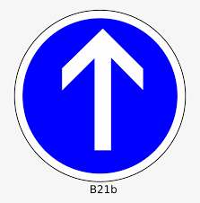

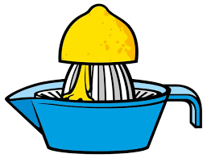

***B-Rearrange the sentences:***

|  |
| --- |
| ‪Mary Had A Little Lamb PNG Transparent Images Free Download | Vector Files  | Pngtree‬‏1- lamb / had / Rana / alittle /  …………………………………………………………………………………………………. |
| ‪190+ Mom Home Exercise Stock Illustrations, Royalty-Free Vector Graphics & Clip  Art - iStock‬‏  2- should / do / some / I /exercise.  ………………………………………………………………………………………………………………………. |

**4**

***III Reading short Sentences:***

***A- Match:***

|  |  |  |  |
| --- | --- | --- | --- |
| 1-I'm going to the bakery. 3-He got up late.  2-I take a bath. 4- No eating No drinking. | | | |
| ‪No food and drink forbidden sign, modern round sticker • wall stickers clip  art, illustration, vector | myloview.com‬‏ | ‪30+ Messy Hair Bed Stock Illustrations, Royalty-Free Vector Graphics & Clip  Art - iStock | Wake up mad, Wake up late, Oversleeping‬‏ | ‪Download Actions, Take A Bath, Bathroom. Royalty-Free Stock Illustration  Image - Pixabay‬‏ | C:\Users\user\Desktop\exams\clipart\download (10).jfif |

***IV Grammar***

**5**

***A – Choose:***

|  |  |  |  |  |  |  |
| --- | --- | --- | --- | --- | --- | --- |
| 1- I should ………………….three meals a day. | | | | | | |
| c- eaten | | | | b- ate | | a- eat |
| 2- We ……………………………….to the bookstore. | | | | | | |
| c- am going | | b- are going | | | | a- is going |
| 3- He is going to …………………………in Dubai. | | | | | | |
| c-shopped | | | b- shopping | | | a- shop |
| 4- There …………………a dining room. | | | | | | |
| 3- was | 2- were | | | | a- are | |

***B-Write the past tense of the following verbs:***

|  |  |  |  |  |  |
| --- | --- | --- | --- | --- | --- |
| A | drink | ………………………. | B | watch | ………………….. |

***V Vocabulary***

**6**

***A- Circle the odd word:***

|  |  |  |  |  |
| --- | --- | --- | --- | --- |
| English | bird | science | art | math |
| never | sometimes | usually | teeth | always |

***B-Classify the words:***

[ August – pink – January – Sunday – silver – Friday ]

|  |
| --- |
|  |

|  |  |  |
| --- | --- | --- |
| Colors | Months | Days |
|  |  |  |
|  |  |  |

***C- Write the correct word under each picture:***

[ flower store – bus stop – earache –wealthy ]

|  |  |  |  |
| --- | --- | --- | --- |
| ‪Earache Outline for Classroom / Therapy Use - Great Earache Clipart‬‏ | ‪Florist, flower, flower shop, flower store, leaf, plant, retail business  icon - Download on Iconfinder‬‏ | ‪Rich Gal - Retro Clipart Illustration Stock Vector Image & Art - Alamy‬‏ | ‪Clipart of a Black and White Bus Stop Building Icon - Royalty Free Vector  Illustration by dero #1411514‬‏ |
|  |  |  |  |

***VI Orthography***

**4**

***Fill in the missing letters :***

|  |  |  |  |  |  |  |  |
| --- | --- | --- | --- | --- | --- | --- | --- |
| **C:\Users\user\Desktop\exams\clipart\download (8).png** | **C:\Users\user\Desktop\exams\clipart\download (9).png** | **C:\Users\user\Desktop\exams\clipart\download (10).png** | **C:\Users\user\Desktop\exams\clipart\download (11).png** | ‪Free Vectors |‬‏ | **C:\Users\user\Desktop\exams\clipart\images (41).jfif** | **C:\Users\user\Desktop\exams\clipart\images (43).jfif** | ‪Cute Cat Cartoon Clipart Free Stock Photo - Public Domain Pictures‬‏ |
| S\_arf | C\_be | Bur\_er | Ska\_e | U\_iform | D\_D | \_lue | Cu\_te |

**The End**

With my best wishes / Tr.AN



**التاريخ : / / 1445هـ**

**الصف: السادس الابتدائي**

**الزمن: ساعة ونصف**

**المادة : اللغة الإنجليزية**

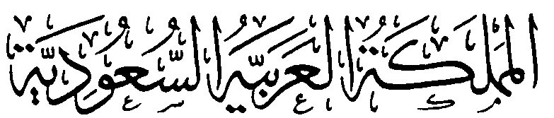

**وزارة التعليم**

**الإدارة العامة للتعليم بمنطقة .................**

**مدرسة ......................................**

**اختبار اللغة الإنجليزية نهائي – الدور الأول – للصف السادس – الفصل الدراسي الثالث 1445ه**

اسم الطالب: ..................................................... الفصل: .........

6

**I- General Questions:**

A- Match the questions in column (A) with the correct answers in column (B):

|  |  |
| --- | --- |
| B | A |
| ( ) I'm going to Jeddah.  ( ) Yes, I got up early this morning.  ( ) I'm going diving.  ( ) I should drink a lot of water.  ( ) I have a headache .  ( ) Go straight and you'll find it. | 1- Did you get up early this morning?  2- What's the matter?  3- Where are you going at weekend?  4- Where's the post office?  5- What are you going to do there?  6- What should you do to live in a healthy life? |

**II- Controlled Writing:**

5

A- Complete the sentences with the correct word:

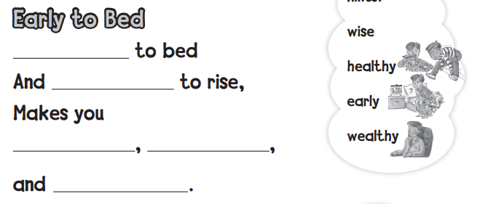

4

**III- Reading Short Sentence:**

A- Read the sentences and match them with the correct pictures:

**1-** I should brush my teeth. **2-** No parking **3-** I have an earache **4-** I shouldn't eat junk food.

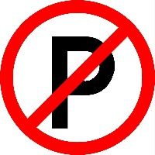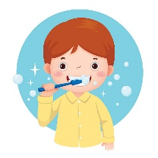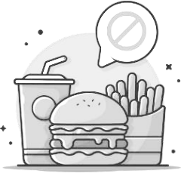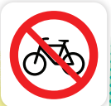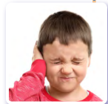

**IV- Grammar:**

5

A) Choose the correct word:

1- Yesterday, I ( play - played ) computer games.

2- He ( am - is ) going to the book store.

3- We are going to ( visit - visited ) Abha.

4- Last year, I [ went – go – going ] to Riyadh..

5- What are ( she - they ) doing?

6

**V- Vocabulary:**

A) Write the correct number under each picture:

**1**- butcher shop **2**- shower **3**- stomachache **4**- burger **5**- candy store **6**- flower store

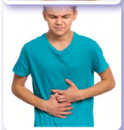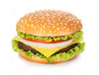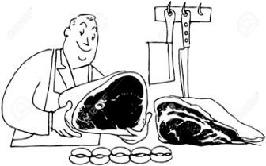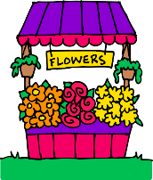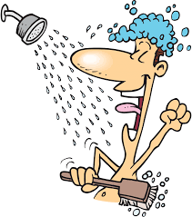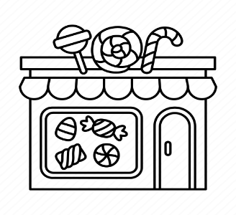

( ) ( ) ( ) ( ) ( ) ( )

**VI- Orthography:**

4

A) Choose the correct letter:

ir ue sc ur

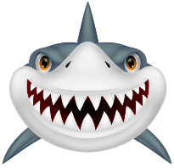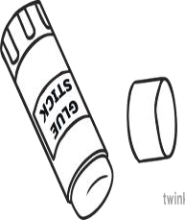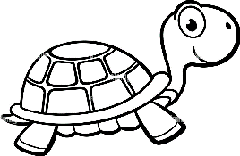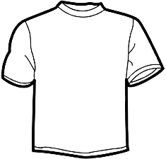

4- sh\_ \_ t 1- t \_ \_ tle 2- **\_ \_ ary** 3- gl \_ \_

|  |  |  |
| --- | --- | --- |
| المملكة العربية السعودية  وزارة التعليم  إدارة التعليم ب  مكتب تعليم  الابتدائية |  | **المادة: اللغة الإنجليزية**  **الصف: السادس ابتدائي**  **الزمن: ساعة و نصف**  **عدد الأوراق : ٣ أوراق**  **عدد الأسئلة : ٦ أسئلة** |
| اختبار نهاية الفصل الدراسي الثالث للعام الدراسي ١٤٤٥هـ | | |

6

**Q1 : General Questions**

|  |
| --- |
| C:\Users\user\Desktop\exams\clipart\images (30).jfif 1– Do you have school lunch at your school ?  A. It has a big yellow bus B. No, we don't |
| C:\Users\user\Desktop\exams\clipart\images (31).jfif 2– Which grade are you in this year ?  A. 5th grade . B. 6th grade . |
| 3- Where is the supermarket ?  A. No, we don’t. B. It’s near here. |
| 4– What should you do to live a healthy life ?  A. I should get up early . B . I should eat too much . |
| C:\Users\user\Desktop\exams\clipart\download (6).jfif5- Which subject do you like ?  A. I like English B . I live in Taif . |
| C:\Users\user\Desktop\exams\clipart\images (33).jfif6- How much is the jacket ?  A. It's 100 SR.. B. Yes, thanks. |

**- Choose the correct answer**

4

**Q2 : Reading Short Sentences**

- Match the picture with the correct sentence :

|  |  |  |  |
| --- | --- | --- | --- |
| **1-**  **I have a toothache. 2-**  **I do some exercises.**  **3-**  **Don't shout speak clearly. 4-**  **I shouldn't drink too much soda.** | | | |
| C:\Users\user\Desktop\exams\clipart\download (9).jfif | C:\Users\user\Desktop\exams\clipart\images (34).jfif | No Shouting Sign Vector Images (over 210) | C:\Users\user\Desktop\exams\clipart\images (35).jfif |

**1**

5

**Q3 : Controlled Writing**

**- Do as shown between brackets :**

|  |
| --- |
| 1- you? - I – Can – help ( Rearrange )  …………………………………………………………………………………………………. |
| 2- had - Rana -lamb. - a little ( Rearrange )  …………………………………………………………………………………………………. |
| 3- bakery. \_ to \_ the \_ going \_ She's ( Rearrange )  ………………………………………………………………………………………………….. |
| 4- I \_\_\_\_\_\_\_\_\_\_\_\_\_\_\_ a lot of water . ( choose )  ( do - drink - eat ) |
| 5- I \_\_\_\_\_\_\_\_\_\_\_\_\_\_\_ to bed early. ( choose )  ( take - go - eat ) |

6

**Q4 : Vocabulary**

**- Write the correct words under each picture:**

**tissue \_ school bus \_ school uniform**

**flower store \_ No Parking \_ headache**

**2**

|  |  |  |
| --- | --- | --- |
|  |  | Flower Shop Clipart Flower Stand Florist Girl Selling - Etsy Israel |
|  |  |  |
|  | School Bus Vector Isolated Stock Illustration - Download Image Now - School  Bus, Bus, Vector - iStock | Free Tissues Cliparts, Download Free Tissues Cliparts png images, Free  ClipArts on Clipart Library |
|  |  |  |

5

**Q5 : Grammar**

**- Choose the correct answer**

|  |  |  |  |
| --- | --- | --- | --- |
| watch | eat | play | **1–**  **I should \_\_\_\_\_\_three meals a day.** |
| is | are | am | **2-**  **We \_\_\_\_\_\_ going to the bookstore.** |
| shopping | shop | shopped | **3– She is going to \_\_\_\_\_\_\_\_ in Dubai.** |
| brushed | brush | brushes | **4- Did you \_\_\_\_\_\_\_ your teeth ?** |
| is | were | was | **5- There \_\_\_\_\_\_\_\_ two floors.** |

**Q6 : Orthography**

4

**- Choose the correct answer**

|  |  |  |  |  |  |  |  |  |
| --- | --- | --- | --- | --- | --- | --- | --- | --- |
| C:\Users\user\Desktop\exams\clipart\download (9).png | | C:\Users\user\Desktop\exams\clipart\download (8).png | | | IMG_256 | |  | |
| c \_ be | | \_ \_arf | | | gl\_ \_ | | g\_ \_l | |
| u | y | | sc | sk | ue | oo | ir | ar |

|  |  |  |  |  |  |  |  |  |
| --- | --- | --- | --- | --- | --- | --- | --- | --- |
|  | | صورة تحتوي على تلبيس, تنورة, أسود وأبيض  تم إنشاء الوصف تلقائياً | | | C:\Users\user\Desktop\exams\clipart\download (10).png | | صورة تحتوي على مستطيل, إطار الصورة, الإطار, التصميم  تم إنشاء الوصف تلقائياً | |
| sh\_ \_t | | \_ \_irt | | | b\_ \_ger | | \_ \_uare | |
| or | ir | | sq | sk | or | ur | sk | sq |

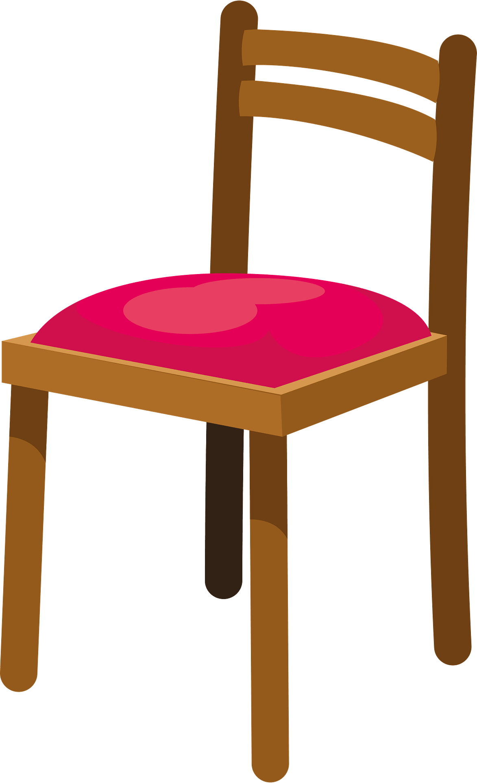Best wishes ♥ ♥

Najla 😊

**3**



المادة: اللغة الإنجليزية

الزمن: ساعة و نصف

عدد الأوراق: ٣

عدد الأسئلة: ٦

المملكة العربية السعودية

وزارة التعليم

الإدارة العامة للتعليم ب

مكتب التعليم ب

المدرسة

|  |  |  |  |  |  |
| --- | --- | --- | --- | --- | --- |
| السؤال | الدرجة رقماً | الدرجة كتابةً | المصححة | المراجعة | المدققة |
| **الأول**  **General Questions**  **( 6 marks )** |  | فقط |  |  |  |
| **الثاني**  **Reading short sentence**  **(4 marks )** |  |  |  |  |
| **الثالث**  **Controlled Writing**  **(5 marks)** |  | فقط |  |  |
| **الرابع**  **Vocabulary**  **( 6 marks )** |  | فقط |  |  |
| **الخامس**  **Grammar**  **( 5 marks )** |  | فقط |  |  |
| **السادس**  **Orthography**  **( 4 marks )** |  | فقط |  |  |
| **مجموع الاختبار التحريري**  **30 درجات** |  | فقط | فقط |  |

**اسم الطالبة**: ................................................................................................................................................................

**الصف**: سادس / ..............................................................................................................................................

**رقم الجلوس**: .............................................................................................................................................................

## الاختبار النهائي لمادة اللغة الانجليزية للمرحلة الابتدائية للصف السادس الابتدائي

## الفصل الدراسي الثالث للعام الدراسي ١٤٤٥هـ

|  |  |  |  |
| --- | --- | --- | --- |
| **المملكة العربية السعودية**  **وزارة التعليم**  **الإدارة العامة للتعليم بـن مدرسة مستقبل ن الابتدائية** | **بسم الله الرحمن الرحيم** **اختبار الفصل الدراسي الثالث**  **للعام الدراسي 1445 هـ** | **المادة** | **لغة انجليزية** |
| **الصف** | **السادس** |
| **الزمن** | **ساعة ونصف** |
| **الفصل** | **----- /6** |
| **اسم الطالب رباعيا: .............................................................................................................**   |  |  |  |  |  |  |  |  | | --- | --- | --- | --- | --- | --- | --- | --- | | **السؤال** | **1** | **2** | **3** | **4** | **5** | **6** | **المجموع** | | **الدرجة** |  |  |  |  |  |  |  | | **الدرجة** | 6 | 5 | 4 | 5 | 6 | 4 | 30 | | **المصحح** |  |  |  |  |  |  |  | | | | |

**I- General Questions:**

**6**

**Q1: Answer the following questions correctly:**

**1. What time does your school start? -------------------.**

**2. What food should you eat?**  **-------------------------.**

**3. How much is this sweater? ---------------------- .**

**5**

**II- Controlled Writing:**

**Q2: Do as shown between brackets:**

**1. train - is - the – Where – station? (Rearrange)>**

**\_\_\_\_\_\_\_\_ \_\_\_\_ \_\_\_\_\_ \_\_\_\_\_\_\_\_ \_\_\_\_\_\_\_\_\_\_\_?**

**2. What would you like to drink? (Answer) >. \_\_\_\_\_\_\_\_\_\_\_\_\_\_\_.**

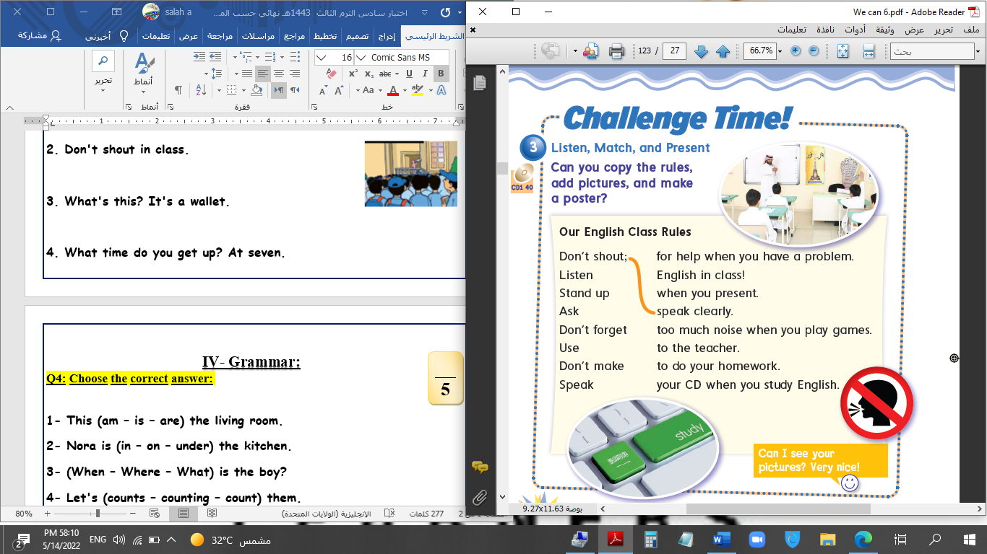**III- Reading Short Sentence:**

**4**

**Q3: Match the sentence with the pictures:**

**1. There are about 300 students.**

**2. Don't shout in class.**

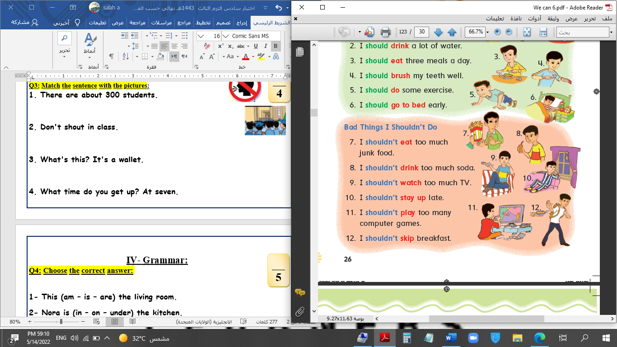**3. You shouldn't eat junk food.**

**4. I have a bad headache.**

**IV- Grammar:**

**5**

**Q4: Choose the correct answer:**

**1- Which city (do – does – did) you live in last year?**

**2- I should (eats – eat – eating) three meals a day.**

**3- He (drink – drinks – drank) three glasses of water yesterday.**

**4- How (long – many – old) does it take to school?**

**5- We (are going – is going – am going) to the bakery.**

**V- Vocabulary:**

**6**

**Q5: Write the number under picture:**

**1.flowers 2.bus stop 3.No bicycles 4.toothache 5.bookstore 6.business**

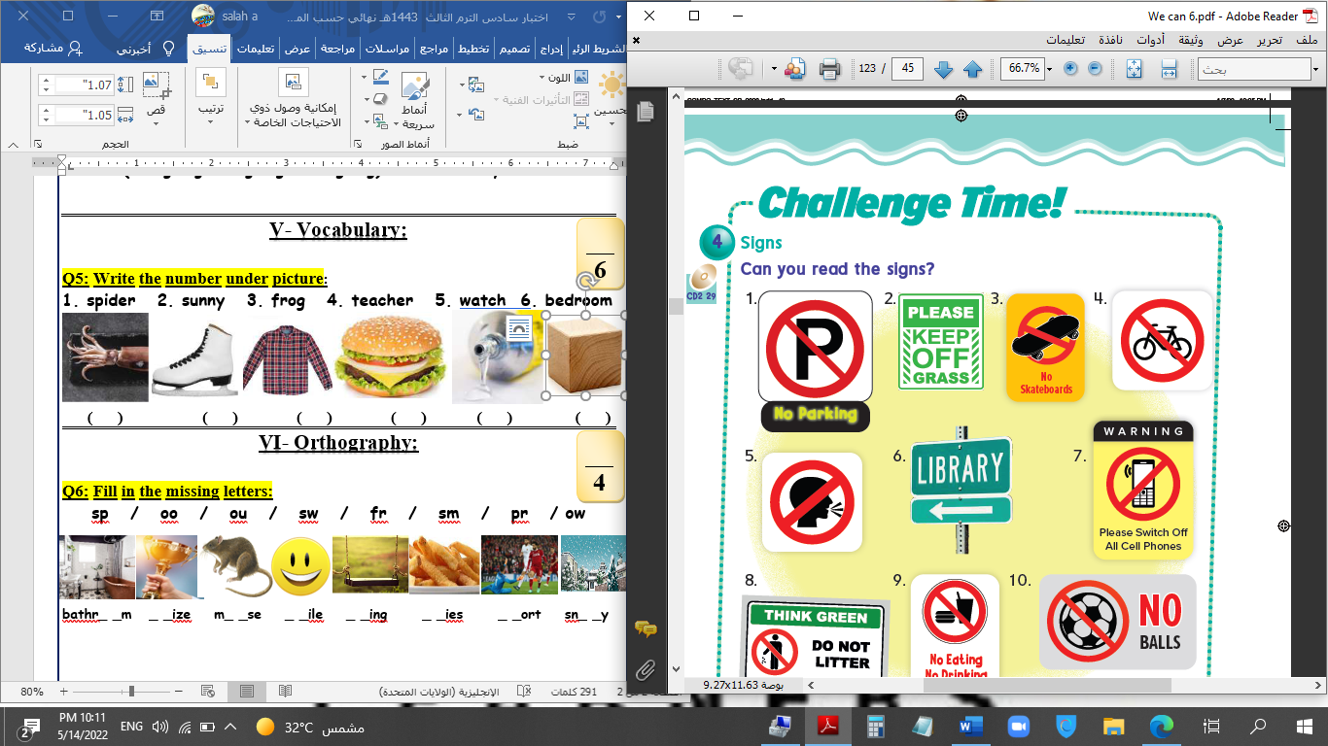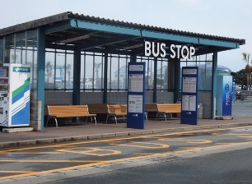****

**( ) ( ) ( ) ( ) ( ) ( )**

**VI- Orthography:**

**4**

**Q6: Fill in the missing letters:**

**ue / u-e / ir / ur / sk / sc / sq / sc**

**\_ \_uid \_ \_ate sh\_ \_rt b\_ \_ger gl\_ \_ c\_\_b\_ \_ \_an \_ \_y**

**End of Questions**