|  |  |  |  |  |  |  |  |  |
| --- | --- | --- | --- | --- | --- | --- | --- | --- |
| **Distribution of the syllabus Super Goal 2 - First Term 1446** | | | | | | | | |
| **4th week** | | **3rd week** | | **2nd week** | | **1st week** | | **today** |
| **What Are They Making? Reading**  **Writing & Project**  **Form, Meaning and Function** | **5/3** | **What Are They Making? Listen and Discuss + Pair work**  **Grammar**  **listening & pronunciation**  **Conversation & About you** | **28/2** | **Are You Here on Vacation?**  **Conversation & About you Reading**  **Writing & Project**  **Form, Meaning and Function** | **21/2** | **Are You Here on Vacation?**  **Listen and Discuss + Pair work**  **Grammar**  **listening & pronunciation** | **14/2** | **Sun** |
| **6/3** | **29/2** | **22/2** | **15/2** | **Mon** |
| **7/3** | **30/2** | **23/2** | **16/2** | **Tue** |
| **8/3** | **1/3** | **24/2** | **17/2** | **Wed** |
| **9/3** | **2/3** | **25/2** | **18/2** | **Thurs** |
| **8th week** | | **7th week** | | **6th week** | | **5th week** | | **today** |
| **Favorite Pastimes**  **Reading**  **Writing & Project**  **Form, Meaning and Function** | **3/4** | **Favorite Pastimes**  **Listen and Discuss + Pair work**  **Grammar**  **listening & pronunciation**  **Conversation & About you** | **26/3** | **إجازة اليوم الوطني** | **19/3** | **Who’s Who**  **Listen and Discuss + Pair work**  **Grammar**  **listening & pronunciation**  **Conversation & About you** | **12/3** | **Sun** |
| **4/4** | **27/3** | **Who’s Who**  **Reading**  **Writing & Project**  **Form, Meaning and Function** | **20/3** | **13/3** | **Mon** |
| **5/4** | **28/3** | **21/3** | **14/3** | **Tue** |
| **6/4** | **29/3** | **22/3** | **15/3** | **Wed** |
| **7/4** | **30/3** | **23/3** | **16/3** | **Thurs** |
| **12th week** | | **11th week** | | **10th week** | | **9th week** | | **today** |
| **Final exams** | **1/5** | **اختبارات المواد العملية والشفهية** | **24/4** | **Is There Any Ice Cream? Conversation & About you Reading**  **Writing & Project**  **Form, Meaning and Function** | **17/4** | **Is There Any Ice Cream? Listen and Discuss + Pair work**  **Grammar**  **listening & pronunciation** | **10/4** | **Sun** |
| **2/5** | **25/4** | **18/4** | **11/4** | **Mon** |
| **3/5** | **26/4** | **19/4** | **12/4** | **Tue** |
| **4/5** | **27/4** | **20/4** | **13/4** | **Wed** |
| **5/5** | **28/4** | **21/4** | **إجازة نهاية اسبوع مطولة** | **14/4** | **Thurs** |
| شعار وزارة التعليم مع الرؤية 2030 ” نماذج مفرغه وشفافه “ | المرسالشعار وزارة التعليم مع الرؤية 2030 ” نماذج مفرغه وشفافه “ | المرسال | | **تواريخ مهمة** | | | | | | **Date** |
| **بداية الدراسة للفصل الدراسي الثاني** | | | | | **15 / 5 / 1446** | |
| **إجازة منتصف العام الدراسي** | | | | | **03 / 7 / 1446** | |
| **بداية الدراسة بعد إجازة منتصف العام الدراسي** | | | | | **12 / 7 / 1446** | |
| **نهاية الفصل الدراسي الثاني** | | | | | **21 / 8 / 1446** | |
| **بداية الدراسة للفصل الدراسي الثالث** | | | | | **02 / 9 / 1446** | |
| **Headmaster:** | | | **Supervisor:** | | | **Teacher:** | | |
|  | | |  | | |  | | |

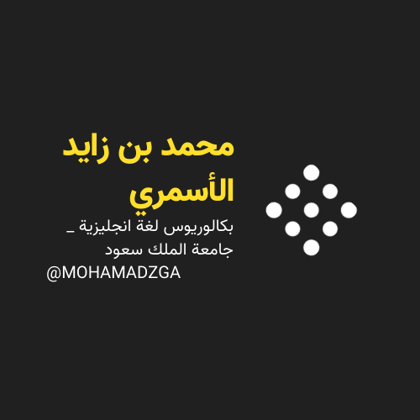

** قناتي**



**M_zaid0 MOHAMADZGA**

**لا تنسوني من صالح دعائكم**