**KINGOM OF SAUDI ARABIA …………………………………. Education directorate**

**MINISTRY OF EDUCATION ……………………………. Elementary school**



|  |  |  |  |  |
| --- | --- | --- | --- | --- |
| **14/2 _ 18/2 1st week From** | | | | **Unit 1**  **Feelings** |
| **SB_P3** | | **SB_P2** | **Introduction** |
| **2nd week From 21/2 _ 25/2** | | | |
| **SB_P7** | **SB_P6** | **SB_P4.5** | **Talk Time, Rhythms & Listening** |
| **3rd week From 28/2 _ 2/3** | | | |
| **SB_10** | **SB_9** | **SB_P8** | **Words & Phonics** |
| **4th week From 5/3 _ 9/3** | | | |
| **Evaluation unit1** | **SB_P28,29** | **SB_11** | **Phonics & Phonics practice** |
| **From 12/3 _ 16/3 5th week** | | | | **Unit 2**  **Things We Wear** |
| **SB_P15** | **SB_P14** | **SB_P12,13** | **Talk Time, Rhythms & Listening** |
| **From 19/3 _ 23/3 6th week** | | | |
| **SB_P16,17** | **SB_P30,31** | **إجازة اليوم الوطني** | **Phonics practice & Words** |
| **From 26/3 _ 30/3 7th week** | | | |
| **Evaluation unit2** | **SB_32,33** | **SB_P18,19** | **Phonics & Phonics practice** |
| **From 3/4 _ 7/4 8th week** | | | | **Unit 3**  **Things We Do** |
| **SB_P22** | **SB_P21** | **SB_P20** | **Talk Time, Rhythms & Listening** |
| **From 10/4 _ 14/4 9th week** | | | |
| **SB_P25** | **SB_P24** | **SB_23** | **Rhythms & Listening , Words** |
| **From 17/4 _ 21/4 10th week** | | | |
| **SB_P34** | **SB_P27** | **SB_P26** | **& Phonics practice**  **Phonics** |
| **From 24/4 _ 28/4 11th week** | | | |
| **Evaluation unit3** | **Remedial Plans** | | **Revision** |
| **From 1/5 _ 5/5** | | | | **12th**  **week** |
| **End of the continuous evaluation**  **Remedial Plans** | | | |

**SYLLABUS DISTRIBUTION FOR 2nd ELEMENTARY GRADE**

**(WE CAN 2) (FIRST TERM) 1446 H**

إجازة مطولة إجازة اليوم الوطني

**Teacher…………….… Headmaster………………. Supervisor ……………….**

SB كتاب الطالب Pرقم الصفحة بكتاب الطالب

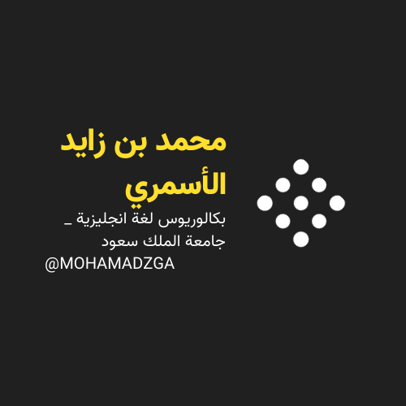



**قناتي**



**MOHAMADZGA M_zaid0**

**لا تنسوني من صالح دعائكم**