

Kingdom of Saudi Arabia

Ministry of Education

……..Education Directorate

………………… School

English Language

elementary Grade …..

period Exam

…………….\20

Student's Name : class:

……\ 4 marks

General questions

[](https://t.me/Asmaworld)

**A.Answer the questions**

|  |  |  |  |
| --- | --- | --- | --- |
| I never forget to feed it. |  | What are you afraid of? | 1 |
| It's mine. |  | What school subject is more difficult at school? | 2 |
| I think math is more difficult. |  | Whose dress was it?? | 3 |
| I'm afraid of spiders. |  | How often do you feed the fish? | 4 |

Controlled Writing

……\ 1 marks

**A-reorder.**

1-computer \ that \ Whose\ is \ ?

………………………………………………………………………………………………………

……\ 4 marks

Reading short sentence

|  |  |  |
| --- | --- | --- |
| Little boy with guitar. Boy playing guitar. Child playing musical  instrument 20629557 Vector Art at Vecteezy | **1- He is playing on the guitar ( )** | |
| 1,531 Child Feed Dog Stock Vectors and Vector Art | Shutterstock | **2- My little brother is kind . He always feeds dogs. ( )** |

**A-Put (** ✔ **) or (**  X  **)**

**B. Choose the correct answer**

|  |  |  |  |
| --- | --- | --- | --- |
| Math | naughty | School | 1-My little brother is very ………….. |
| helpful | chatty | lazy | 2- Noura likes to talk a lot. She is very………… |

……\ 4 marks

Grammar

**A-Choose the correct answer.**

1-I’m( do – did – doing) my homework.

2-The chocolate cake ( was – were – am )delicious.

3-Omar usually( go – goes – going ) fishing on the weekend.

4-How ( old – much – often) does your sister go cycling?

Vocabulary

……\ 5 marks

**A.write the correct word under each picture**

**( strong - drums - bus - cat - grandpa)**

**)**

|  |  |  |  |  |
| --- | --- | --- | --- | --- |
| Strong Man And Weak Man Strong Image Firm Vector, Strong, Image, Firm PNG  and Vector with Transparent Background for Free Download | Drums |  | Cute kitten cartoon clipart AI Generated 27241786 PNGGrandpa | PNG All | School bus |
|  |  |  |  |  |

Orthography

……\ 2 marks

**A. Fill in the missing letters**

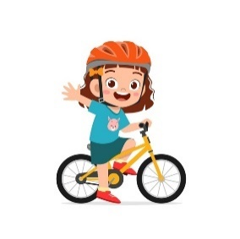

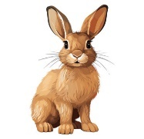

**1-Ca…..era**

**( m – j - y )**

**4- ….allon**

**( k – b - s )**

**3- …ycling**

**( l - c - x)**

**2- rab…it**

**( b – j - s )**

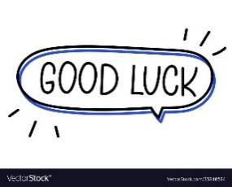

Your teacher:

Your teacher …..:…………………………….

المملكة العربية السعودية الصف :

وزارة التعليم الفصل الدراسي الاول

مدرسة

اختبار منتصف الفصل الدراسي الأول 1446هـــ

**اسم الطالب : الصف :**

**20**

**Match "A" with "B":**

|  |  |  |  |
| --- | --- | --- | --- |
| "A" |  | "B" | |
| 1. my mom's brother is |  | 1. uncle |
| 2. I get anger with my brother |  | 1. 20th |
| 3. mom and dad are my |  | 1. He is very naughty. |
| 4. twentieth |  | 1. parents |
|  |  |  | 1. cousins |

General Questions

**Answer :**

1. The ordinal numbers for seven is ____________
2. dad _________ (**change to informal** )
3. How / at / do / you / ? / study / home / often ( **order the words)**

___________________________________________________

Controlled Writing

**Read and match the numbers with the correct pictures**:

1. I sometimes go to the beach .
2. Everyone prepares for the photo.
3. My grandma is weak.

Reading short sentences

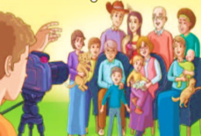صورة تحتوي على تلبيس, ملعب, شخص, داخلي

تم إنشاء الوصف تلقائياً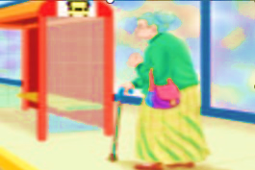

**Choose the correct letter :**

|  |  |  |  |  |  |  |  |
| --- | --- | --- | --- | --- | --- | --- | --- |
|  | | |  | |  | | |
| chat_y | | |  | | s_n | | |
| **e** | **t** | **i** | |  | **u** | **o** | **w** |

Orthography

**Choose the correct answer:**

|  |  |  |  |
| --- | --- | --- | --- |
| **c**) more difficult | **b**) easy | 1. difficult | 1. **Math is _________ than English .** |
| **c**) my | **b**) yours | **a**) you | 1. **It's your bag. It's ________** |
| **c**) were | **b**) is | **a**) was | 1. **Yesterday___ a nice day.** |
| **c**) rarely | **b**) usually | **a**) never | 1. **My brother makes dinner .** |

grammar



**Write the correct word under each picture:**

|  |  |  |  |
| --- | --- | --- | --- |
|  |  |  |  |
|  |  |  |  |

|  |  |  |  |
| --- | --- | --- | --- |
| afraid | kind | go cycling | lazy |

Vocabulary

**اختبار مادة اللغة الإنجليزية TOPGOLA1 منتصف الفصل الدراسي الاول 1446هـ**

20

اسم الطالب: ............................................ الفصل: /

**General Questions**

**A- Match the questions in column (A) with the correct answers in column (B):**

|  |  |
| --- | --- |
| B | A |
| ( ) it's his.  4  ( ) science.  ( ) he's chatty .  ( ) Riyadh. | 1-which school subject is more interesting ?  2- Diriyah is near to :  3- whose car is this?  4- He tells a lot of stories :  **Controlled Writing** |

tired

cousin

strong

**A- Complete the sentences with the correct word:**

1 – Rayan is not weak. He is ……………...

3

2 – My uncle has a son. He is my ……...

**B – Rearrange:**

always / English / I / . / speak

…………………………………………………………………….

**Reading Short Sentence**

3

**A- Read the sentences and write the correct number under each picture**:

1- They are playing a soccer ball 2- The taste of cheese is terrible. 3- she is shy

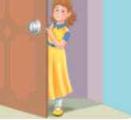

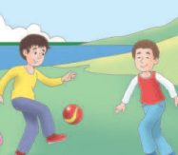

**Orthography**

**A-Choose the correct spelling :**

|  |  |  |  |
| --- | --- | --- | --- |
|  |  |  |  |
| **1** | **2** | **3** | **4** |
| Feshing | running | afrraid | second |
| fishing | runing | afraiid | sacond |
| fisshing | ranning | afraid | Secand |

2

4

**Grammar**

**A- Choose the correct word:**

|  |  |  |  |
| --- | --- | --- | --- |
| **c**) Which | **b**) What | 1. Who | 1. **_______ school subject is more difficult ?** |
| **c**) watches | **b**) watch | **a**) watching | 1. **They are ________ TV now.** |
| **c**) sometimes | **b**) always | **a**) rarely | 1. **I ______________ go to school in the morning** |
| **c**) thirteenth | **b**) third | **a**) twelfth | 1. **13th ________** |
| **c**) much | **b**) often | 1. many | 1. **How _____ do you play football?** |
| **c**) you | **b**) my | **a**) mine | 1. **It's your car. It isn't ________** |
| **c**) Whose | **b**) Where | **a**) What | 1. **____ photos are these? They're ours.** |
| **c**) never | **b**) go never | **a**) never go | 1. **I_____ to school by bike.** |

4

**Vocabulary**

**Write the correct number under each picture**:

1. **3- grandpa**
2. **4- helpful**
3. **2- balloons**
4. **1- kind**
5. **8- family**
6. **7- exciting**
7. **6- lazy**
8. **5- park**

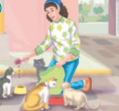

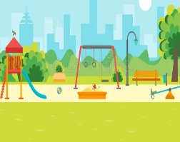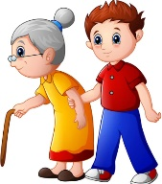

TELEGRAM: **top123goal**

  **Midterm Exam– Top** **Goal1**

**مدرسة:**

|  |  |  |  |  |  |
| --- | --- | --- | --- | --- | --- |
| **الاسم ثلاثي:** |  | **الفصل** | **/** | **الدرجة** | **20 /** |

__________________________________________________________________________________________

**Choose the correct answer:**

|  |
| --- |
| 1– What school subject is more difficult at school?    A**. I think math.** B**. I am surprised**. |
| 2 –What is your favorite place to visit?  A**. Diriyah is my favorite place .** B**. I usually visit my uncle** . |

____________________________________________________________________________________________________

**Choose 🗸 or 🗴:**

|  |  |  |
| --- | --- | --- |
| She is afraid. | He is fishing in a boat**.** | She is playing a soccer. |
| 383,634 Afraid Images, Stock Photos, 3D objects, & Vectors | Shutterstock | Boat Cartoon Fishing Stock Illustrations – 8,414 Boat Cartoon Fishing Stock  Illustrations, Vectors & Clipart - Dreamstime | ‪Premium Vector | Cartoon little girl playing tennis‬‏ |
| **🗸 🗴** | **🗴 🗸** | **🗸 🗴** |

___________________________________________________________________________________________

|  |  |  |  |
| --- | --- | --- | --- |
| 1- a terrible – It – game – is ( Rearrange) ……………………………………………………………………………………… | | | |
| **grandparents** | **parents** | **uncle** | 2 - My mom and dad are my ______. (choose ) |

**Do as shown between brackets :**

**Choose the correct word:**

|  |  |  |  |
| --- | --- | --- | --- |
| **are** | **do** | **does** | 1- How often ____ you see your cousin? |
| **were** | **was** | **is** | 2- We ____ happy . |
| **mine** | **your** | **my** | 3- Whose dress was it? It was _____ . |

**Choose the correct word:**

|  |  |  |  |  |  |
| --- | --- | --- | --- | --- | --- |
| Premium Vector | Cartoon cute boy weightlifting | Cartoon Fishing Images - Free Download on Freepik | Cartoon funny little boy running Royalty Free Vector Image | Cartoon Drums Images – Browse 43,462 Stock Photos, Vectors, and Video |  Adobe Stock | Vector Cartoon Danger Icon in Comic Style. Attention Caution Sign  Illustration Pictogram Stock Illustration - Illustration of sign, caution:  133003613 | Bus Cartoon Vector Images (over 20,000) |
| Strong | Cycling | Running | Drum | Stop | Bus |
| weak | Fishing | Reading | Guitar | Dangerous | Poster |

**Choose the correct letter to fill in the blank:**

|  |  |  |  |
| --- | --- | --- | --- |
| People Celebrate Achievement Victory Friends Birthday Stock Vector (Royalty  Free) 2055918341 | Shutterstock | Cartoon Camera Images – Browse 156,520 Stock Photos, Vectors, and Video |  Adobe Stock | Grandfather Cartoon Images – Browse 121,428 Stock Photos, Vectors, and  Video | Adobe Stock | Cute Kitten Cartoon Illustration, Cute Clipart, Cartoon Clipart, Kitten  Clipart PNG Transparent Image and Clipart for Free Download |
| Cele_ration | Ca_era | grand_a | kitte_ |
| **b** | **n** | **p** | **n** |
| **d** | **m** | **m** | **b** |

Good luck T.

Controlled writing



**Mid Term Exam (answers)**

**20**

**Name : Class : ◊ 4th ◊ 5th ◊ 6th**

**3**

Q1) Match "A" with "B":

|  |  |  |  |
| --- | --- | --- | --- |
| "A" |  | "B" | |
| 1. **? What are you afraid of ?** |  | **3** | **It was mine.** |
| 1. **Who is the tallest in the class?** |  | **2** | **Ali is the tallest.** |
| 1. **Whose dress was that ?** |  | **1** | **I am afraid of snakes.** |

**Q2) Order the words to make a sentence:**

**1**

**1. makes – My mom – always – dinner.**

My mom always makes dinner.

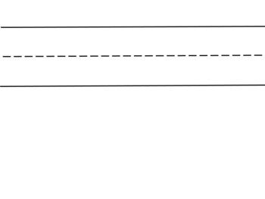

**2**

**Q 3) Put (✔️) or ( ✖️):**

|  |  |
| --- | --- |
| **✔️** | 1- My aunt always feeds the cat. She is kind . |
| **✖️** | They are my grandparents . 2- |

**Q 4 ) Choose the correct word:.**

**4**

1. She ( was _ were _ weren't ) sick.

Amal is ( short _ shorter _ shortest ) than Maha . 2.

3. How often ( do _ does _ doing ) you visit your grandparents?

4- . It’s her kitten.It’s  **(theirs _ she _ hers )**.

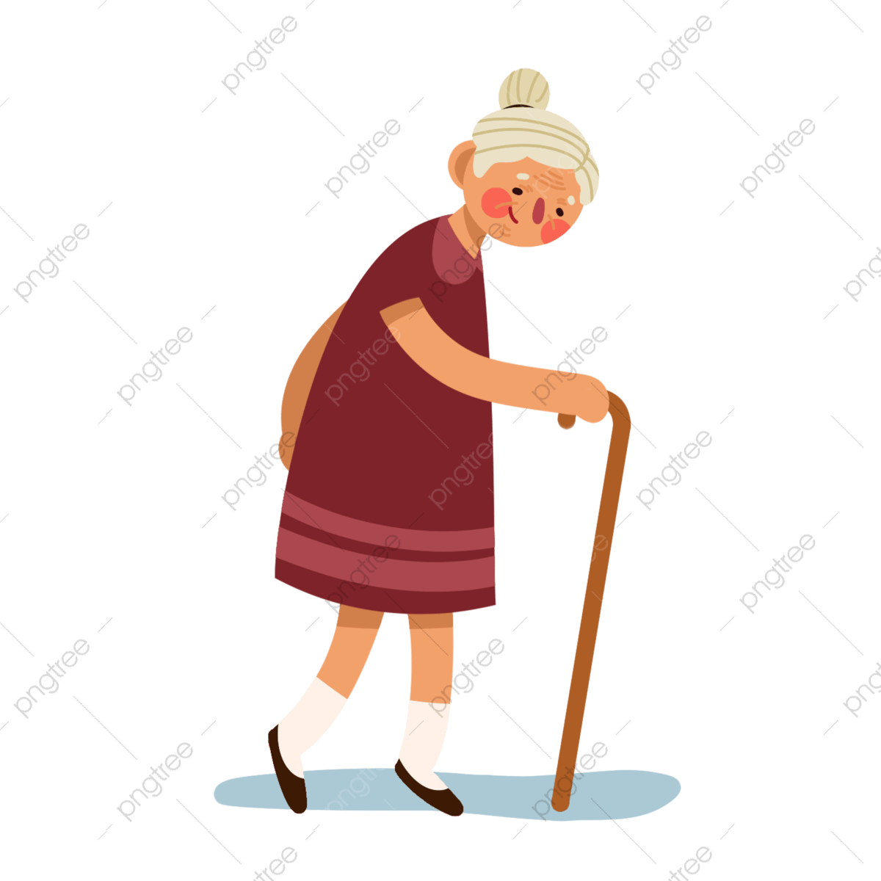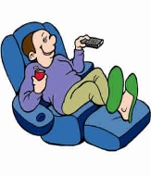 Q5 ) Number :

**3**

**1. She is a weak grandma.**

**2. My brother is naughty.**

**3. He is a lazy boy**.

*********************************************************************************

**2**

*Q6) Choose the correct answer :*

|  |  |
| --- | --- |
| 1. ***Mom and dad are my…….*** | **صورة تحتوي على أسود, الظلام  تم إنشاء الوصف تلقائياًصورة تحتوي على أسود, الظلام  تم إنشاء الوصف تلقائياًصورة تحتوي على أسود, الظلام  تم إنشاء الوصف تلقائياًصورة تحتوي على أسود, الظلام  تم إنشاء الوصف تلقائياً***2-* |
| 1. *Parents* 2. *Cousins* | 1. **صورة تحتوي على أسود, الظلام     تم إنشاء الوصف تلقائياً** *always* 2. *never* |

**صورة تحتوي على أسود, الظلام

تم إنشاء الوصف تلقائياً**

**3**

**Q 7 ) : Tick the correct word:**

|  |  |  |  |  |  |
| --- | --- | --- | --- | --- | --- |
|  |  |  |  |  |  |
| **□ chatty**  **□ sleepy** | **□ drums**  **□ guitar** | **□ granny**  **□ daddy** | **□ tired**  **□ exciting** | **□ one**  **□ first** | **□ reading**  **□ cycling** |

**2**

**Q 8) Write the missing letters :**

|  |  |  |  |
| --- | --- | --- | --- |
| **sh**  **m**  **m**  **sh**  **ph**  **y** | | | |
|  |  |  |  |
| **ca m era** | **ph oto** | **dadd y** | **shy** |