**Kingdom of Saudi Arabia**

**Subject**: English

**Date** : - 4 -1446H

**First term Exam**

**Period** :

**Time** : two hours

**عدد أوراق الاختبار : ( 3 )**

**Ministry of Education**

**General Directory of Education in Gizan**

**…………………………. School**

**اسئلة اختبارالفصل الدراسي الأول لمادة اللغة الإنجليزية الصف ثاني متوسط لعام1446هـ ( الدور الأول)**

**اسم الطالبة :**.......................................................................

**رقم الجلوس :** .............................................**الصف ثاني متوسط _( )**

|  |  |  |  |  |  |  |  |  |
| --- | --- | --- | --- | --- | --- | --- | --- | --- |
| **المجموع الكلي** | **Listening and speaking** | **Total** | **5th**  **orthography** | **4th**  **Vocabulary** | **3rd**  **Grammar** | **2nd**  **comprehension** | **1st composition** | **Question** |
| 40 | .**+**  10marks | **30 marks**  **only** | **4 marks only** | **7marks only** | **7 marks**  **only** | **6 marks only** | **6 marks**  **only** |
|  |  | **Teacher:..** | | | | | | **Corrector** |
|  |  | **Teacher..** | | | | | | **Reviser** |
|  |  | **مديرة المدرسة:** | | | | | |  |

**1-Composition**

Write a short paragraph a bout your pastime or hobby .Use the answers to the questions below:

**6**

1. What's your favorite hobby ?/ 2- What equipment do you need for it ?

3-How often do you do it and where do you do it ? 4- Why do you like it ?

……………………………………………………..

……………………………………………………………………………………………………………………………………………………………………………………………………………………………………………………………………………………………………………………………………………………………………………………………………………………………………………………………………………………………

**اسم الطالبة : .................................................................رقم الجلوس: ............................**

**اسم الطالبة : ..................................................**

**6**

**2-Comprehension**

**Read the following passage, then answer the questions:** 

Ali is at home with his family. He is sitting in the kitchen and he is having breakfast. He usually plays football on Saturday mornings, but today it’s raining outside. Everyone in the house is busy. His mother is cleaning the kitchen. His sister is talking on her cell phone. His father is washing the car. And his brother is playing video games. Later his whole family is going to his grandmother’s house. They always have dinner there on Saturdays. Then they usually watch TV. Sometimes they fight over what to watch. Ali and his father like documentaries, but his mother and his sister like detective stories. Ali likes spending time with his family on the weekend.

**A) Write "√ " or "X" :**

1. Ali is at the supermarket with his family ( )
2. He usually plays football on Saturday mornings ( )
3. His mother is cleaning the kitchen ( )
4. Ali and his father like movies. ( )

**B) Choose the correct answer:**

**1-** They always have dinner there on………. **a**-Fridays **b**- Mondays **c**-Saturdays

**2-** His father is washing the………… **a**- car **b**- clothes **c**- room



**3-Grammar**

**7**

**A)** **Choose the correct answer:**



* 1- I am **( write - writing - writes )** a story.
* 2-The ball is **( across - between – far )** the two squares.
* 3-They **( plays – playing – play )** football every day .
* 4-- I don't have **( some - any - many )** milk .
* 5- I love the teacher **( who - which - where )** is kind
* 6- Are you here for the festival? Yes, **( I am - he is - I am not )**



**B) Do as shown between brackets**:

1- She is from Egypt . { Change into **negative** }.

………………………………………….

2- She always read books. ( ) {Say if the place of the adverb in the following sentences is **correct √** or **not correct**× }

اقلبي الصفحة

**اسم الطالبة : .................................................................رقم الجلوس: ............................**

**4-Vocabulary**

**7**

**A ) Match the words to its meaning :**

|  |  |  |  |
| --- | --- | --- | --- |
| 1 | I see |  | yes |
| 2 | Yeah |  | I I understand . |
| 3 | I'll have |  | a strong ( No ) |
| 4 | not at all |  | I want – I'd like |
|  |  |  | All by my self |



**B) Write the number of words under the pictures:**

( 1- policeman 2- cook 3- reporter - 4- salad - 5- watch TV

6- doctor 7- painting )

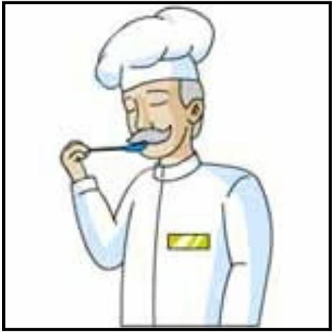

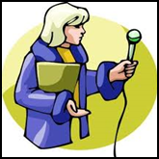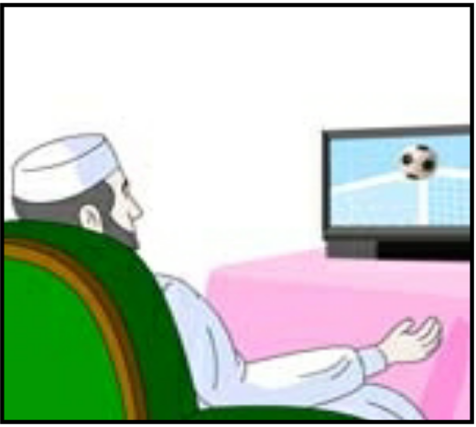



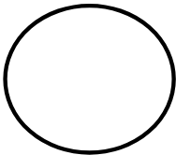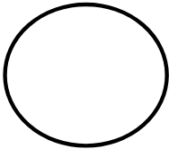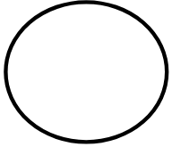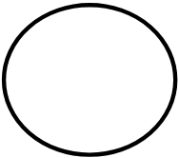

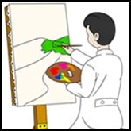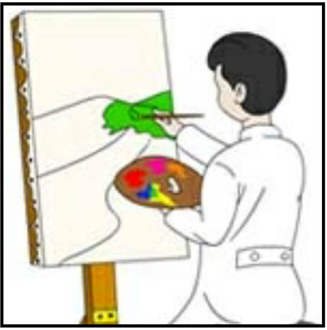

**5-Orthography :**

**4**

1. ***Fill in the missing letter*** :

1- co__fee ( f - d ) 2- jo_ ( b – p )

3- g_eet ( r – n ) 4- fe__tival ( s - h )

5- fi__m ( j – l ) 6- pas__ime ( t – d )



B- Unscramble the letters to form words :

1- enmu………………….. 2- oock…………….

Best Wishes

Teacher ; Amal

|  |  |  |  |  |
| --- | --- | --- | --- | --- |
| **المملكة العربية السعودية**  **وزارة التعليم**  **الإدارة العامة للتعليم ...... .......** | **http://tabuk2day.com/wp-content/uploads/IMG_3362.jpg**  **اختبار الفصل الدراسي الأول**  **للعام الدراسي 1446 هـ** | **المادة** | لغة انجليزية | |
| **الصف** | الثاني المتوسط | |
| **الزمن** | ساعة ونصف | |
| **الدور** | الأول | |
| **الاسم: .............................................................................................................** | | | | |

**30**

1. **Composition**

***Write a paragraph about (* yourself *) not less than 6 sentences using the following words .***

**6**

***( name – age – favorite sport – live –like )***

…………………………………………………………………………………………………………………………………………………………………………………………………………………………………………………………………………………………………………………………………………………………………………………………………………………………………………………………………………………………………………………………………………………………………………………………………………………………………………………………………………………………………………………………………….

**6**

**2. Reading Comprehension**

**Read the passage and answer the questions below :**

**Every Thursday, Mr. Saleh goes shopping. He likes to buy things from the supermarket near his house. It is a big supermarket. He buys meat, fruit, milk and vegetables for the week. Today, two of his children are going with him, Maram and Basil. Maram wants to buy biscuits for her sister Hanan. Basil wants to buy ice-cream. Basil does not have much money. He asks his father to give him some money.**

**Answer :**

**1- What does Mr. Saleh like to buy ? .....................................................................**

**2- Where is the supermarket ? ...............................................................**

**Choose :**

**3- Mr. Saleh likes to…………… things from a supermarket. ( buy - drink - eat )**

**4- Basil asks his father to give him some ( money - milk - ice-cream )**

**5- Today, two of his ……… are going with him. (children - friends teachers)**

**6- It is a ……………… supermarket. ( good - big - small )**

**7**

**3. GRAMMAR**

**Choose the correct words :**

**1- ( who - when - why ) is the tall man?**

**2- he is ( playing - plays - play ) football now .**

**3-she doesn't ( work - works - worked ) in hosbital.**

**4- I am good in math ( and - but - because ) English .**

**5- The book ( which - who ) I read is good .**

**6- sorry we don’t have ( any - some ) juice.**

**7- I know how to ( reads - read - reading ) stories.**

**7**

**4. Vocabulary**

**A-Match the meaning and the responses to the situations :**

|  |  |  |  |
| --- | --- | --- | --- |
| **1** | **How are you?** |  | **I am from Saudi Arabia** |
| **2** | **what are you doing?** |  | **3 books** |
| **3** | **How many books?** |  | **I am playing football** |
| **4** | **Where are you from?** |  | **I fine** |

**B-Match the picture with words:**

**( coffee - shrimp - elevator )**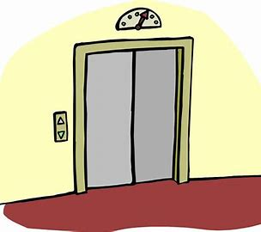

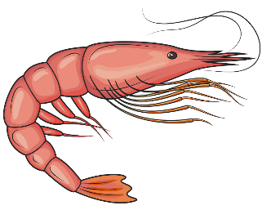

………………………………. ………………………… ....................................

**5. orthography**

**Write the missing letters :**

**4**

**1-comp_ny ( o – a ) 2- j_b ( o - m )**

**3- spo_t ( r- m) 4- vis_on ( i - f)**

**انتهت الاسئله**

|  |  |  |  |  |  |  |
| --- | --- | --- | --- | --- | --- | --- |
| |  | | --- | | **المملكة العربية السعودية** | | **وزارة التعليم** | | **تبوك** | | **المتوسطة الحادية والعشرون** | |  | **اختبار الفصل الدراسي الأول**  **عام 1446**  **اللغة الإنجليزية**  **للصف الثاني متوسط**  **الزمن: 45 دقيقه** |

|  |
| --- |
| اسم الطالبة: الفصل: |

20

**1- Write at least 4 sentences about your last vacation. Use guide words.**

20

**[ went to Abha – with my family – stayed in a hotel – hiking – visited – Asir National Park –]**

**……………………………………………………………………………………**

**…………………………………………………………………………………….**

**……………………………………………………………………………………..**

**…………………………………………………………………………………….**

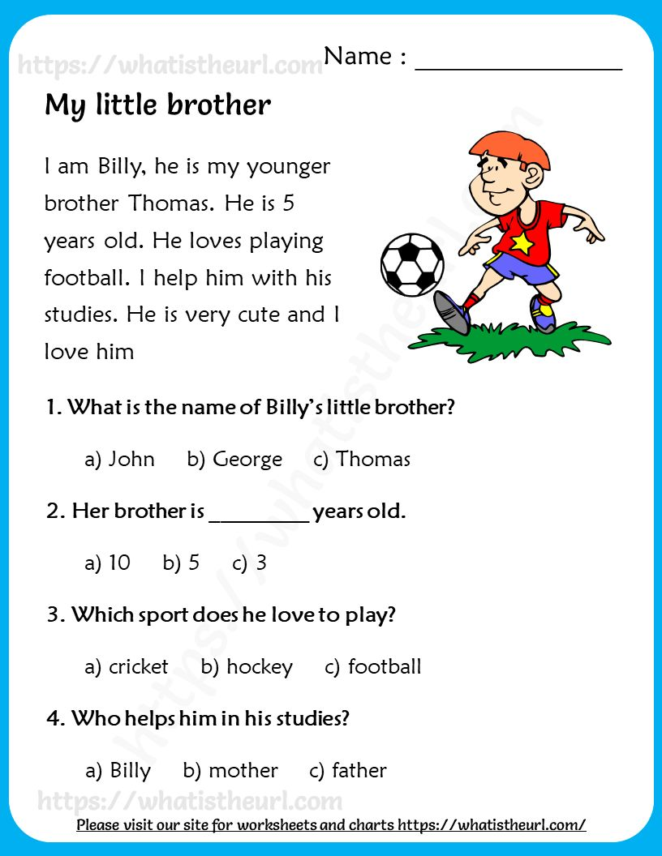***2-Read the following passage and choose the correct answers:***

3-GRAMMAR/A. Choose the correct answer.

1-Riyadh (is – are – am) in Saudi Arabia.

2-(How – what – where ) old are you?

3-Are you (reads – reading – read) the story ?

4-Don't (eat – ate – eating ) the lunch.

B. Do as shown between brackets. [ Correct]

a-Dubai aren't in Egypt. ……………

. b- when is your name? ………………

…………………………………………………………………………………………

4- VOCABULARY: A-Write the opposite:

1- inside x……………………. 2- in front of x …………………..

3- over x ……………… ……. 4- easy x ………………………

Ee elevator credit card hotel castle passport

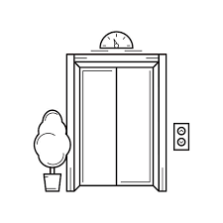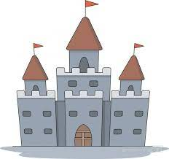صورة تحتوي على قصاصة فنية, لقطة شاشة, التصميم

تم إنشاء الوصف تلقائياً

……………….. ……………………. ………………….. ………………….

**5- Fill in the missing letters:**

1-act….r [ t – o -y] 2- d…rector [ i - a -y]

3- fi….m [ L – e -h] 4- stu…io [ u – o -d]

***T.AFAF Salem***

[](https://t.me/akhtbarnhae)المملكة العربية السعودية الصف: الثاني متوسط

وزارة التعليم الفصل الدراسي: الأول

الإدارة العامة للتعليم بمحافظة الليث العام الدراسي 1446 هـ

مدرسة متوسطة وثانوية حفار الزمن: ساعة ونصف

**الاختبار النهائي لمادة اللغة الإنجليزية – الصف الثاني متوسط – الفصل الدراسي الأول (الدور الأول) لعام 1446 هـ**

**عزيزتي الطالبة:**

* **استعيني بالله ثم اجيبي عن الأسئلة**
* **فضلا تأكدي من كتابة اسمك الرباعي ورقم الجلوس**
* **الإجابة باللون الأزرق فقط**

|  |  |  |  |
| --- | --- | --- | --- |
| **اسم الطالبة رباعيا** |  | | |
| **رقم الجلوس:** | | **الصف: الثاني متوسط** | **المادة: اللغة الإنجليزية** |
| **اليوم:** | **التاريخ: / / 1446 هـ** | | |

|  |  |  |  |  |  |
| --- | --- | --- | --- | --- | --- |
| **المدققة وتوقيعها** | **المراجعة وتوقيعها** | **المصححة وتوقيعها** | **الدرجة كتابة** | **الدرجة رقما** | **السؤال** |
|  |  |  |  |  | **Guided**  **Composition** |
|  |  |  |  |  | **Reading Comprehension** |
|  |  |  |  |  | **Grammar** |
|  |  |  |  |  | **Vocabulary** |
|  |  |  |  |  | **Orthography** |
|  |  |  |  | **30** | **المجموع** |

Kingdom of Saudi Arabia 2nd Intermediate Grade

Ministry of Education Time: An hour and a half

Hifar Intermediate and Secondary School Number of papers: 3

Final Exam – First Term - 1446 AH

1. **Guided Composition:**

**6**

“Happy is the man who can make a living by his hobby!”. Use the following word

bank to write a paragraph about your ***hobby.***

**Word bank:** (need – room – twice – alone – interesting - weekend)

________________________

__________________________________________________________________________________________________________________________________________________________________________________________________________________________________________________________________________________________________________________________________________________________________________________________________________________________________________________________________________________________________________________________________________________________________________________________

**6**

1. **Reading Comprehension:**

***Read the passage and answer the questions below:***

My name is Sam. I have a brother named James. **We** live in a big house. I have a dog. Its name is Fitch. My dad's name is David. My mother's name is Lena. My father is a teacher, and my mother is a nurse. I like chicken, cheese, and corn. James loves hamburgers. We usually hang out on Tuesday and Friday. I love my family.

1. **Answer the following question:**
2. **What does David do?**

………………………………………………

1. **Choose the correct answer:**
2. There are ……. members in Sam’s family.

|  |  |  |  |
| --- | --- | --- | --- |
| 1. 3 | 1. 4 | 1. 6 | 1. 8 |

1. Sam’s mother works in the ………...

|  |  |  |  |
| --- | --- | --- | --- |
| 1. school | 1. store | 1. hospital | 1. bank |

1. Sam’s brother likes to eat ………..

|  |  |  |  |
| --- | --- | --- | --- |
| 1. cheese | 1. fish | 1. doughnut | 1. hamburgers |

1. **hang out** means: ………… with someone in a place.

|  |  |  |  |
| --- | --- | --- | --- |
| 1. spend time | 1. sleep | 1. study | 1. read |

1. **We** in line **1** refers to:

|  |  |  |  |
| --- | --- | --- | --- |
| 1. Sam | 1. Fitch | 1. Sam’s family | 1. Lena |

1. **Check ( T ) or ( F ):**
2. Sam has a pet. ( )
3. Lena is Sam’s sister. ( )
4. Sam and James are friends. ( )
5. Sam’s family lives in a small house. ( )
6. Sam’s family hangs out twice a week. ( )

**7**

1. **Grammar:**
2. **Choose the correct answer:**
3. Mr. Nasser ……… a teacher.

|  |  |  |  |
| --- | --- | --- | --- |
| 1. am | 1. is | 1. are | 1. can |

1. The restaurant is ……… the pharmacy and the supermarket.

|  |  |  |  |
| --- | --- | --- | --- |
| 1. next to | 1. on | 1. between | 1. near |

1. Rasha ………… a novel now.

|  |  |  |  |
| --- | --- | --- | --- |
| 1. read | 1. reads | 1. reading | 1. is reading |

1. The cameraman is standing ………… the camera.

|  |  |  |  |
| --- | --- | --- | --- |
| 1. under | 1. behind | 1. outside | 1. inside |

1. This is the boy ………. had an accident.

|  |  |  |  |
| --- | --- | --- | --- |
| 1. who | 1. which | 1. where | 1. when |

1. Jana went to the mall ……….. she didn’t buy anything.

|  |  |  |  |
| --- | --- | --- | --- |
| 1. and | 1. or | 1. but | 1. because |

1. Amal can’t stand ……. In line.

|  |  |  |  |
| --- | --- | --- | --- |
| 1. wait | 1. waits | 1. to wait | 1. waiting |

1. I know how ………..

|  |  |  |  |
| --- | --- | --- | --- |
| 1. ski | 1. to ski | 1. skied | 1. skiing |

1. There isn’t ……. milk in the fridge.

|  |  |  |  |
| --- | --- | --- | --- |
| 1. A | 1. An | 1. some | 1. any |

1. When the water boils, ………. the spaghetti in the pot.

|  |  |  |  |
| --- | --- | --- | --- |
| 1. put | 1. puts | 1. putting | 1. is putting |

1. **Do as shown between brackets:**
2. I would like **(drink)** some coffee. **(Correct the verb)**

…………………………………….

1. Nada bakes a cake. **(Change into negative)**

…………………………………….

1. I don’t have ……… time to cook dinner. **(Use ‘too’ or ‘enough’)**

……………………………………

1. **Vocabulary**:

**7**

1. **Write the words under the pictures:**

**waiter – climb – menu – ladder – elevator**

**[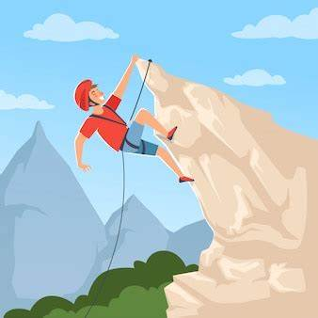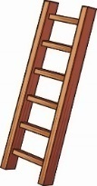**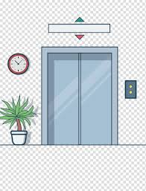

___________ ___________ ___________ ___________

1. **Classify the words:**

**pilot – steak – ice cream – call center**

|  |  |  |  |
| --- | --- | --- | --- |
| **Dessert** | **Jobs** | **Workplaces** | **Meat** |
|  |  |  |  |

1. **Choose the correct answer to fill in the blank in each question:**
2. **‘giant’** means:

|  |  |  |  |
| --- | --- | --- | --- |
| 1. small | 1. big | 1. new | 1. single |

1. I had only one ………of cake.

|  |  |  |  |
| --- | --- | --- | --- |
| 1. bottle | 1. cup | 1. piece | 1. glass |

1. The baby is too young to …………. itself.

|  |  |  |  |
| --- | --- | --- | --- |
| 1. actor | 1. film | 1. scene | 1. Feed |

1. The opposite of **‘safe’**:

|  |  |  |  |
| --- | --- | --- | --- |
| 1. dangerous | 1. boring | 1. popular | 1. easy |

1. **Circle the odd word:**
2. grilled – fried – sauce – steamed
3. Bye – Hello – See you later – Take care

1. **Orthography:**

**4**

1. **Choose the correctly spelled word:**
2. advertisement – advertizement – advertisiment - advertiziment
3. fejetable – fegetable – vejetable – vegetable
4. relaking – relaxing – realxing – relaxeng
5. introbuce – entroduce – introduce – introduse
6. **Complete the missing letters:**
7. Make **ex__rcise** a part of your daily routine.
8. The exam is not **diffi__ult.**
9. I love the **s__ell** of the flowers.
10. I like eating **c__cumber** salad.

**END OF QUESTIONS**

**BEST OF LUCK**

**Ms. Tahani AlGhamdi**

**[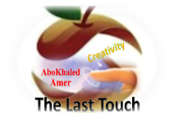](https://t.me/akhtbarnhae)** 

##### 

##### **وزارة التعليم**

**الإدارة العامة للتعليم بمنطقة ---------**

**مجمع -------------------------- ( بنين )**

**اختبارات نهاية الفصل الدراسي الأول 1445هـ**

|  |  |  |
| --- | --- | --- |
| **المادة:**  **لغة انجليزية** | **الصف: الثاني المتوسط رقم الجلوس : ( )** | **الزمن:**  **ساعتان** |
| **اسم الطالب: ................................................................................................................................................** |

|  |  |  |  |  |  |  |  |
| --- | --- | --- | --- | --- | --- | --- | --- |
| **Total**  **written** | **5 spelling** | **4 Vocabulary** | **3 Grammar** | **2 Comprehension** | | **1 Composition** | **Q. NO.** |
|  |  |  |  |  | |  | **Mark Given** |
| **30** | **4** | **7** | **7** | **6** | | **6** | **Mark** |
|  | | | **Reviser** | |  | | **Corrector** |
|  | |

[**https://t.me/abokhaledamer**](https://t.me/abokhaledamer)

**0557325813**

**6**

1) **Composition**

**1- Write a paragraph about: (Your Hobby or Pastime)**

**1- What is your hobby? 2- What equipment do you need?**

**3- How often do you do it? 4- Where do you do it?**

**5- Why do you like it?**

…………………………………………

……………………………………………………………………………………………………………………………………………………………………………………………………………………………………………………………………………………………………………………………………………………………………………………………………………………………………………………………………………………………………………………………………………………………………………………………………………………………………………………………………………………………………………………………….

**2) Comprehension**

**6**

**2- Read the following passage then answer the questions:**

**My brother Ali is 25 years old. He works in a furniture shop. He is a salesperson. He wants to develop his abilities so; he is studying business management in college at night. He wants to be a marketing manager.**

**A- Put ( ) or ( x ):**

**1. Ali is my friend. ( )**

**2. He is a salesperson. ( )**

**3. He is a manager. ( )**

**4. He works in college. ( )**

**5. He is forty years old. ( )**

**B- Choose the correct answer:**

**1. Ali is ………. years old.**  a) twenty b) twenty-five c) fifty-two

**2. He works in a …………. shop.**  a) clothes b) shoes c) furniture

**3. He wants to ………… his abilities.** a) develop b) decrease c) slow down

**4. He is studying in …………………...** a) school b) shop c) college

**C- Answer the following questions:**

**1. What is the name of the character?**

----------------------------------------------------

**2. What is the job of the character?**

----------------------------------------------------

**3. What does he want to be?**

----------------------------------------------------

**7**

**3) Grammar**

**A: Choose the correct answer:**

**1. He is a teacher. He (** teach – teaches – teaching **) at school.**

**2. What are you (** doing – do – does **)?**

**3. (** Who – How – Why **) often does she go shopping?**

**4. I don’t know how to (** ski – skis – skiing **).**

**5. What (** do – does – are **) you do?**

**6. (** What – Who – Where**) does he work?**

**7. I’d like (** a – an – some **) cup of coffee, please.**

**8. Are they from Egypt? Yes, (** he is – I am – they are **).**

**B: Do as shown between brackets:**

**1- you – on – Are – here – vacation? [** Unscramble **]** ----------------------------

**2- I’m (go) to the park now. [** Correct the verb **]** ---------------------------------

**3- He works in a hospital. [** Ask Yes/No Question **]** ----------------------------

**4- There is some juice. [** Make Negative **]** ----------------------------------

**5- I watch TV every day. [** Ask using: How long **]** ----------------------------

**6- I know how to ski. [** Rewrite using: can **]** ------------------------------

**4) vocabulary:**

**7**

**A- Write the correct number under its pictures:**

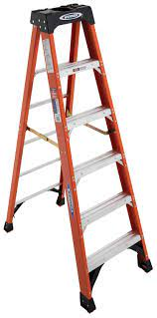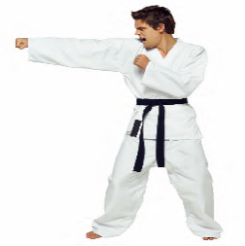**1.Karate – 2.steak – 3.nurse – 4.ladder – 5.director – 6.pasta 7. plane**

****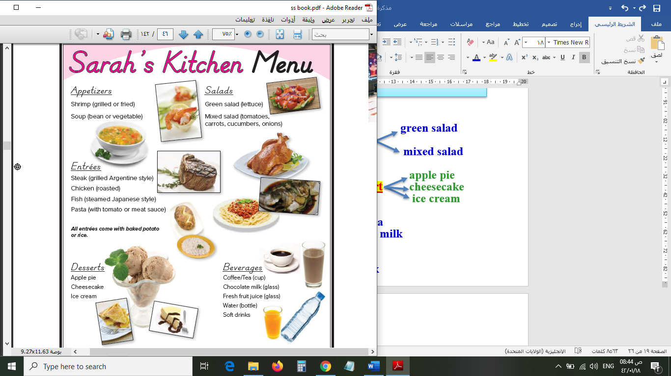

**( ) ( ) ( ) ( ) ( ) ( ) ( )**

**B- Match the answers:**

|  |  |  |
| --- | --- | --- |
| a. in a travel agency. | **1. Nice to meet you.** | **-----** |
| b. I’d like a chicken sandwich. | **2. The stuntman** | **-----** |
| c. is making dangerous scenes. | **3. A travel agent works** | **-----** |
| d. Nice to meet you, too. | **4. How often do you study?** | **-----** |
| e. I study every day. | **5. May I take your order?** | **-----** |

**C- Circle the correct spelling:**

**2. elevator – elvator - elevtor**

**3. meno – menu – manu**

**3. pasime – pastim – pastime**

**4**

**5) Orthography**:

**A- Fill in the missing letters:**

**c – t – p – e**

**1- hos__el**

**2- sales__erson**

**3- coffe__**

**4- a__tor**

**B- Choose the odd one out:**

**1. Good morning Going Good evening Good night**

**2. always often usually friend**

**3. teacher driver doctor school**

**4. bad time free time leisure time spare time**



**End of Questions**

[**https://t.me/abokhaledamer**](https://t.me/abokhaledamer)

**0557325813**

**Best of Luck**



##### 

##### **وزارة التعليم**

**الإدارة العامة للتعليم بمنطقة ----------------------**

**مجمع مدارس ------------------------ ( بنين )**

**اختبارات نهاية الفصل الدراسي الأول 1445هـ**

|  |  |  |
| --- | --- | --- |
| **المادة:**  **لغة انجليزية** | **الصف: الثاني المتوسط رقم الجلوس : ( )** | **الزمن:**  **ساعتان** |
| [**https://t.me/abokhaledamer**](https://t.me/abokhaledamer)  **0557325813**  **اسم الطالب: ................................................................................................................................................** |

|  |  |  |  |  |  |  |  |
| --- | --- | --- | --- | --- | --- | --- | --- |
| **Total**  **written** | **5 spelling** | **4 Vocabulary** | **3 Grammar** | **2 Comprehension** | | **1 Composition** | **Q. NO.** |
|  |  |  |  |  | |  | **Mark Given** |
| **30** | **4** | **7** | **7** | **6** | | **6** | **Mark** |
|  | | | **Reviser** | |  | | **Corrector** |
|  | |

**6**

1) **Composition**

**1- Write a paragraph about: (Your Free Time) You may use the words below:**

usually – basketball – mall – watch TV – video games –skiing – vacation – hiking

…………………………………………

………………………………………………………………………………………………………………………………………………………………………………………………………………………………………………………………………………………………………………………………………………………………………………………………………………………………………………………………………………………………………………………………………………………………………………………………………………………………….

**2) Comprehension**

**6**

**2- Read the following passage then answer the questions:**

**Planning a vacation now is relaxing and funny. In the past people used to plan their vacation through travel books and magazines. But now we can plan them using travel- planning applications on our smart phones or computers such as Tripit, Minube, Booking and Tourist Eye. First, decide where to go then book your tickets early to keep costs low. Then book a room in a hostel. Hostels are cheaper than hotels. But many people like apartments because they are more comfortable.**

**A- Put ( ) or ( x ):**

**1. Planning a vacation now is not relaxing. ( )**

**2. we can plan vacations using travel-planning applications. ( )**

**3. decide where to go then book your tickets late. ( )**

**4. Hostels are more expensive than hotels. ( )**

**5. Apartments are more comfortable. ( )**

**B- Choose the correct answer:**

**1. (** Playing – Planting – Planning **) a vacation is funny.**

**2. People used to plan their vacation through (**clothes – magazines – schools)

**3. book your tickets early to keep costs (** low – high – slow ).

**4. Hotels are mor expensive than (** hostels – shops – colleges )

**C- Answer the following questions:**

**1. What is relaxing and funny?**

----------------------------------------------------

**2. How can you book a vacation now?**

----------------------------------------------------

**3. What is the opposite of “high”?**

----------------------------------------------------

**7**

**3) Grammar**

**A: Choose the correct answer:**

**1. I’d like (** a – an – some **) cup of coffee, please.**

**2. (** Who – How – Why **) often does she go shopping?**

**3. I don’t know how to (** ski – skis – skiing **).**

**4. What (** do – does – are **) you do?**

**5. He is a teacher. He (** teach – teaches – teaching **) at school.**

**6. (** What – Who – Where**) does he work?**

**7. What are you (** doing – do – does **)?**

**8. Are they from Egypt? Yes, (** he is – I am – they are **).**

**B: Do as shown between brackets:**

**1- There is some juice. [** Make Negative **]**

--------------------------------------------------------

**2- I watch TV every day. [** Ask using: How long **]**

------------------------------------------------

**3- I know how to ski. [** Rewrite using: can **]**

--------------------------------------------------------

**4- He works in a hospital. [** Ask Yes/No Question **]**

--------------------------------------------------------

**5- I’m (go) to the park now. [** Correct the verb **]**

-------------------------------------------------

**6- you – on – Are – here – vacation? [** Unscramble **]**

--------------------------------------------------------

**4) vocabulary:**

**7**

**A- Match the words with the pictures:**

**director – elevator – exercise – pasta – airplane – water**

**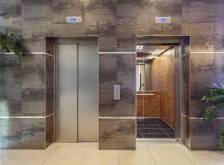******

**…………. ………. …….…..……. ………..…… ……………… ………..……..**

**B- Match the answers:**

|  |  |  |
| --- | --- | --- |
| a. in a travel agency. | **1. Nice to meet you.** | **-----** |
| b. I’d like a chicken sandwich. | **2. The stuntman** | **-----** |
| c. is making dangerous scenes. | **3. A travel agent works** | **-----** |
| d. Nice to meet you, too. | **4. How often do you study?** | **-----** |
| e. I study every day. | **5. May I take your order?** | **-----** |

**C- Circle the correct spelling:**

**1. nurse - norse – nures**

**2. hotle – hotel - hatel**

**3. pasime – pastim – pastime**

**5) Orthography**:

**4**

**A- Fill in the missing letters:**

**1- coffe__**

**c – g – r – e**

**2- restau__ant**

**3- engi__eer**

**4- a__tor**

**B- Choose the odd one out:**

**1. teacher driver doctor school**

**2. coffee water editor milk**

**3. Hi Saudi Hello Welcome**

**4. bad time free time leisure time spare time**

**[](https://t.me/madty8t)**

**End of Questions**

**Best of L**

[**https://t.me/abokhaledamer**](https://t.me/abokhaledamer)

**0557325813**