**اختبار تقييم المهارات الفترة الأولى للوحدة (1+2) الفصل الدراسي الثاني-الصف الثاني ابتدائي1446هـ**

|  |  |
| --- | --- |
| **Name: …………………………………………….…** | **Class : …………..** |

**ـــــــــــــــــــــــــــــــــــــــــــــــــــــــــــــــــــــــــــــــــــــــــــــــــــــــــــــــــــــــــــــــــــــــــــــــــــــــــــــــــــــــــــــــــــــــــــــــــــــــــــــــــــــ**

|  |  |  |  |  |  |
| --- | --- | --- | --- | --- | --- |
| **غير مجتاز** | **متمكن** | **متقدم** | **متفوق** | **2** | **رقم المهارة** |

صورة تحتوي على نص, الإلكترونيات, لقطة شاشة, عرض

تم إنشاء الوصف تلقائياً**Choose the correct answer:**

|  |  |  |  |  |  |
| --- | --- | --- | --- | --- | --- |
| **غير مجتاز** | **متمكن** | **متقدم** | **متفوق** | **3 + 5** | **رقم المهارة** |

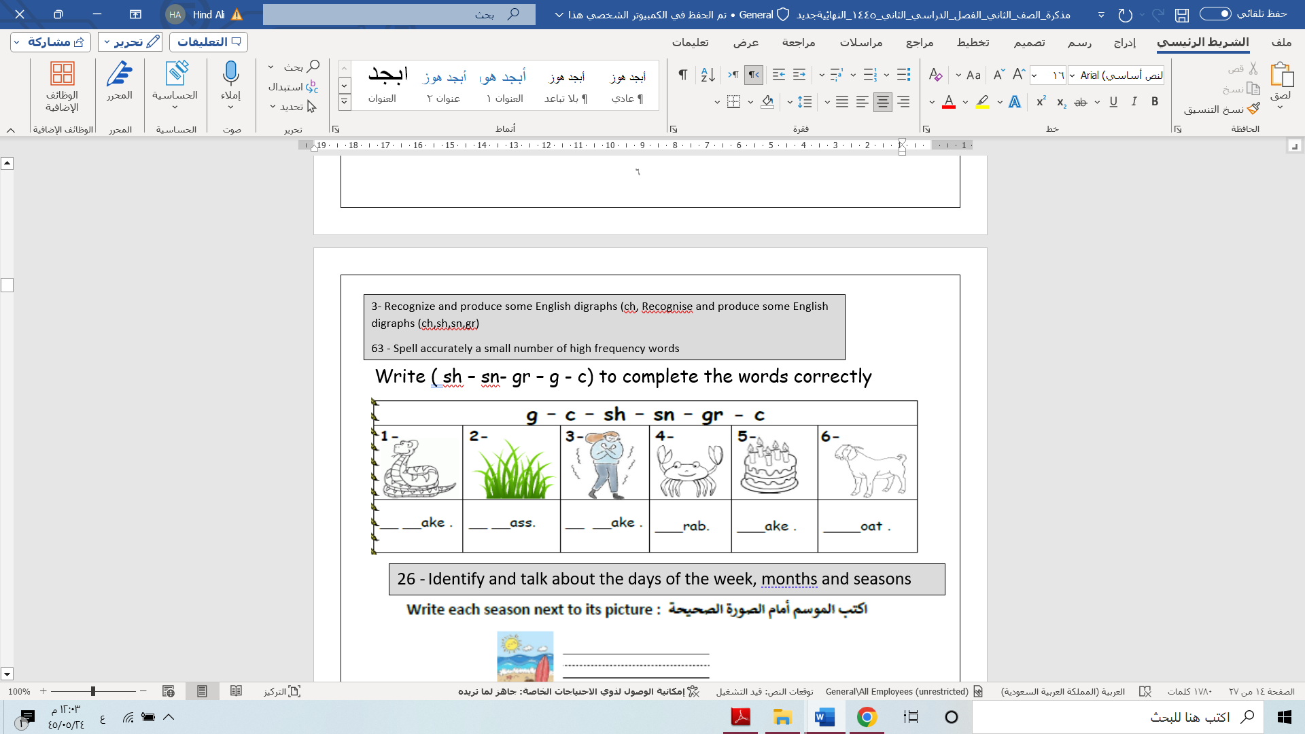**Fill in with the suitable letter**

|  |  |  |  |  |  |
| --- | --- | --- | --- | --- | --- |
| **غير مجتاز** | **متمكن** | **متقدم** | **متفوق** | **11** | **رقم المهارة** |

**Choose the correct answer:**

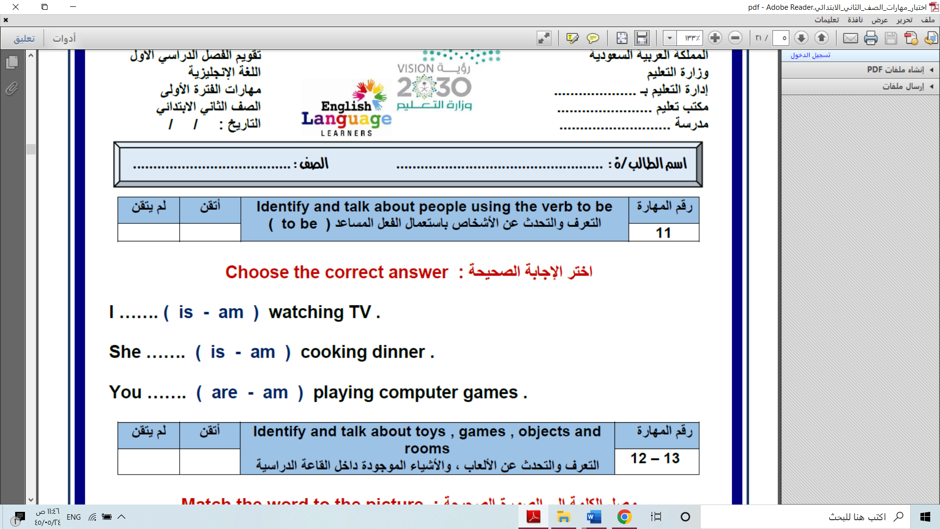

|  |  |  |  |  |  |
| --- | --- | --- | --- | --- | --- |
| **غير مجتاز** | **متمكن** | **متقدم** | **متفوق** | **15** | **رقم المهارة** |

**Write the correct word for each picture:**

صورة تحتوي على نص, برمجيات, أيقونة الحاسوب, برامج الوسائط المتعددة

تم إنشاء الوصف تلقائياً

|  |  |  |  |  |  |
| --- | --- | --- | --- | --- | --- |
| **غير مجتاز** | **متمكن** | **متقدم** | **متفوق** | **23** | **رقم المهارة** |

**Fill in with the correct adjective:**

صورة تحتوي على نص, لقطة شاشة, برمجيات, الحاسوب

تم إنشاء الوصف تلقائياً

|  |  |  |  |  |  |
| --- | --- | --- | --- | --- | --- |
| **غير مجتاز** | **متمكن** | **متقدم** | **متفوق** | **24** | **رقم المهارة** |

**Rearrange the words to make a suggestions :**

صورة تحتوي على نص, لقطة شاشة, برمجيات, أيقونة الحاسوب

تم إنشاء الوصف تلقائياً

|  |  |  |  |  |  |
| --- | --- | --- | --- | --- | --- |
| **غير مجتاز** | **متمكن** | **متقدم** | **متفوق** | **26** | **رقم المهارة** |

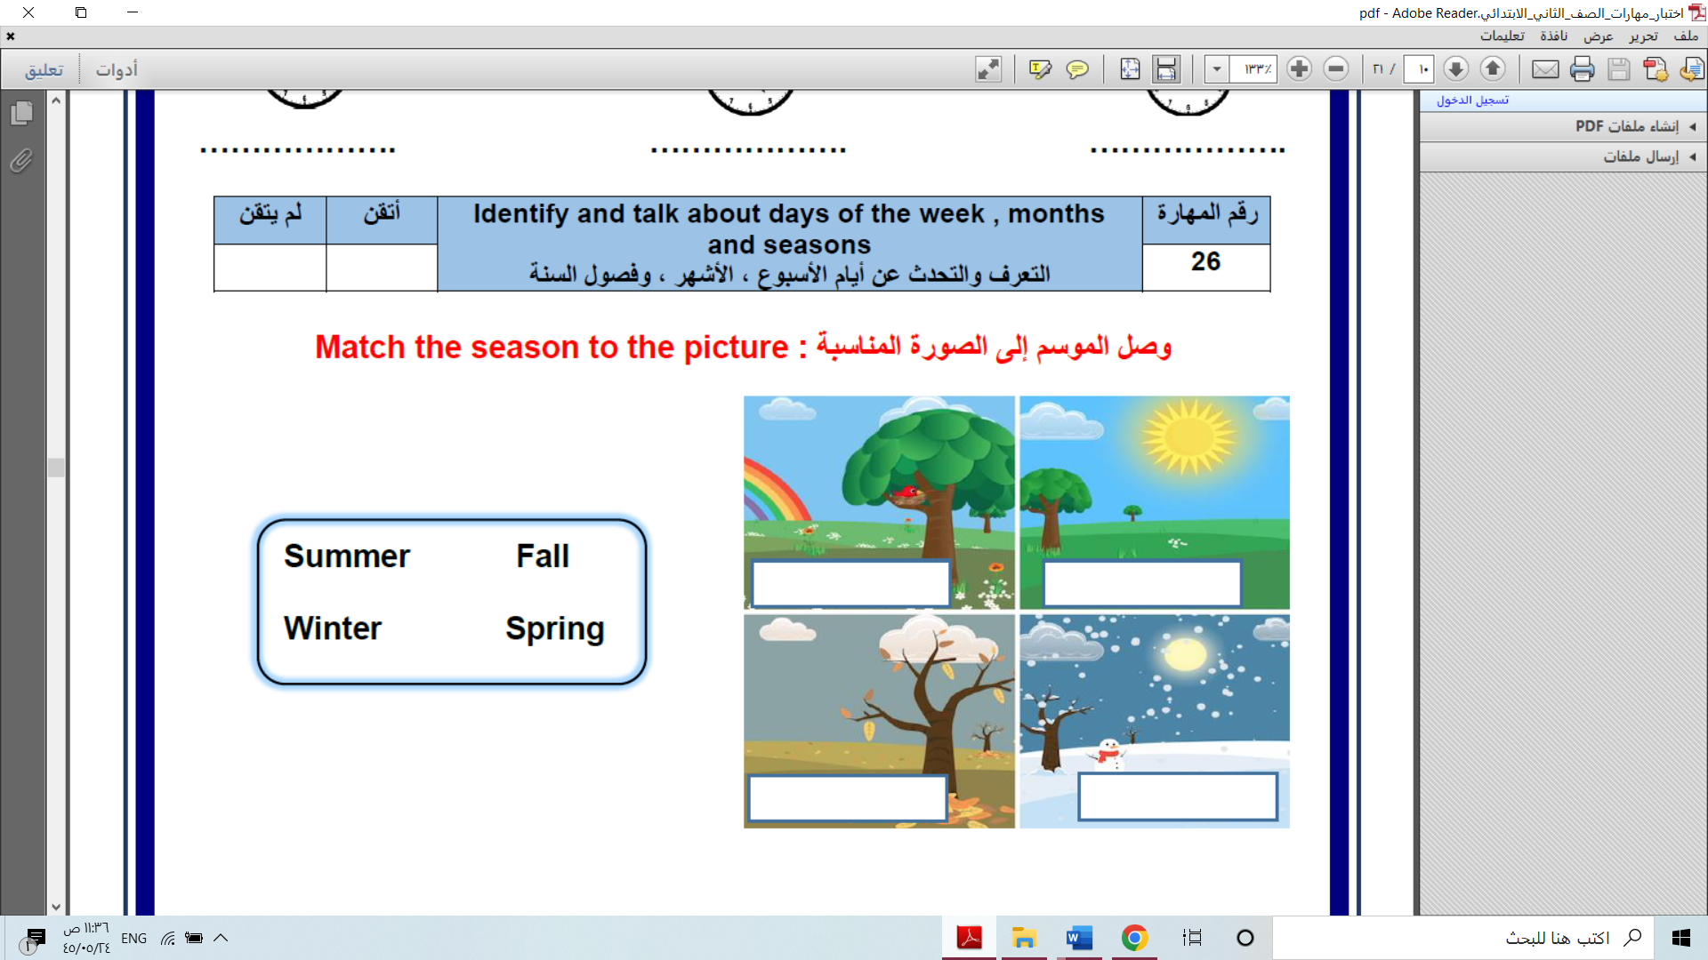**Write the correct season under the picture:**

**Good Luck : Tr.Hind Alzahrani**

**اختبار تقييم المهارات الفترة الثانية للوحدة (3+4) الفصل الدراسي الثاني-الصف الثاني ابتدائي1446هـ**

|  |  |
| --- | --- |
| **Name: …………………………………………….…** | **Class : …………..** |

**ـــــــــــــــــــــــــــــــــــــــــــــــــــــــــــــــــــــــــــــــــــــــــــــــــــــــــــــــــــــــــــــــــــــــــــــــــــــــــــــــــــــــــــــــــــــــــــــــــــــــــــــــــــــ**

|  |  |  |  |  |  |
| --- | --- | --- | --- | --- | --- |
| **غير مجتاز** | **متمكن** | **متقدم** | **متفوق** | **4 + 5** | **رقم المهارة** |

**Fill in with the suitable letter:**

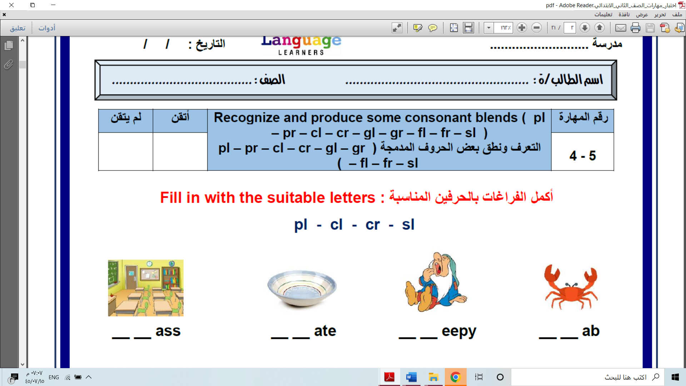

|  |  |  |  |  |  |
| --- | --- | --- | --- | --- | --- |
| **غير مجتاز** | **متمكن** | **متقدم** | **متفوق** | **9** | **رقم المهارة** |

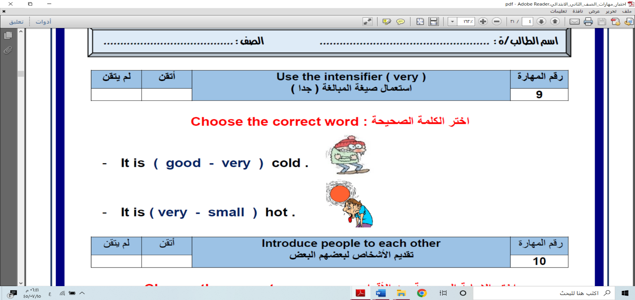**Choose the correct answer:**

|  |  |  |  |  |  |
| --- | --- | --- | --- | --- | --- |
| **غير مجتاز** | **متمكن** | **متقدم** | **متفوق** | **15** | **رقم المهارة** |

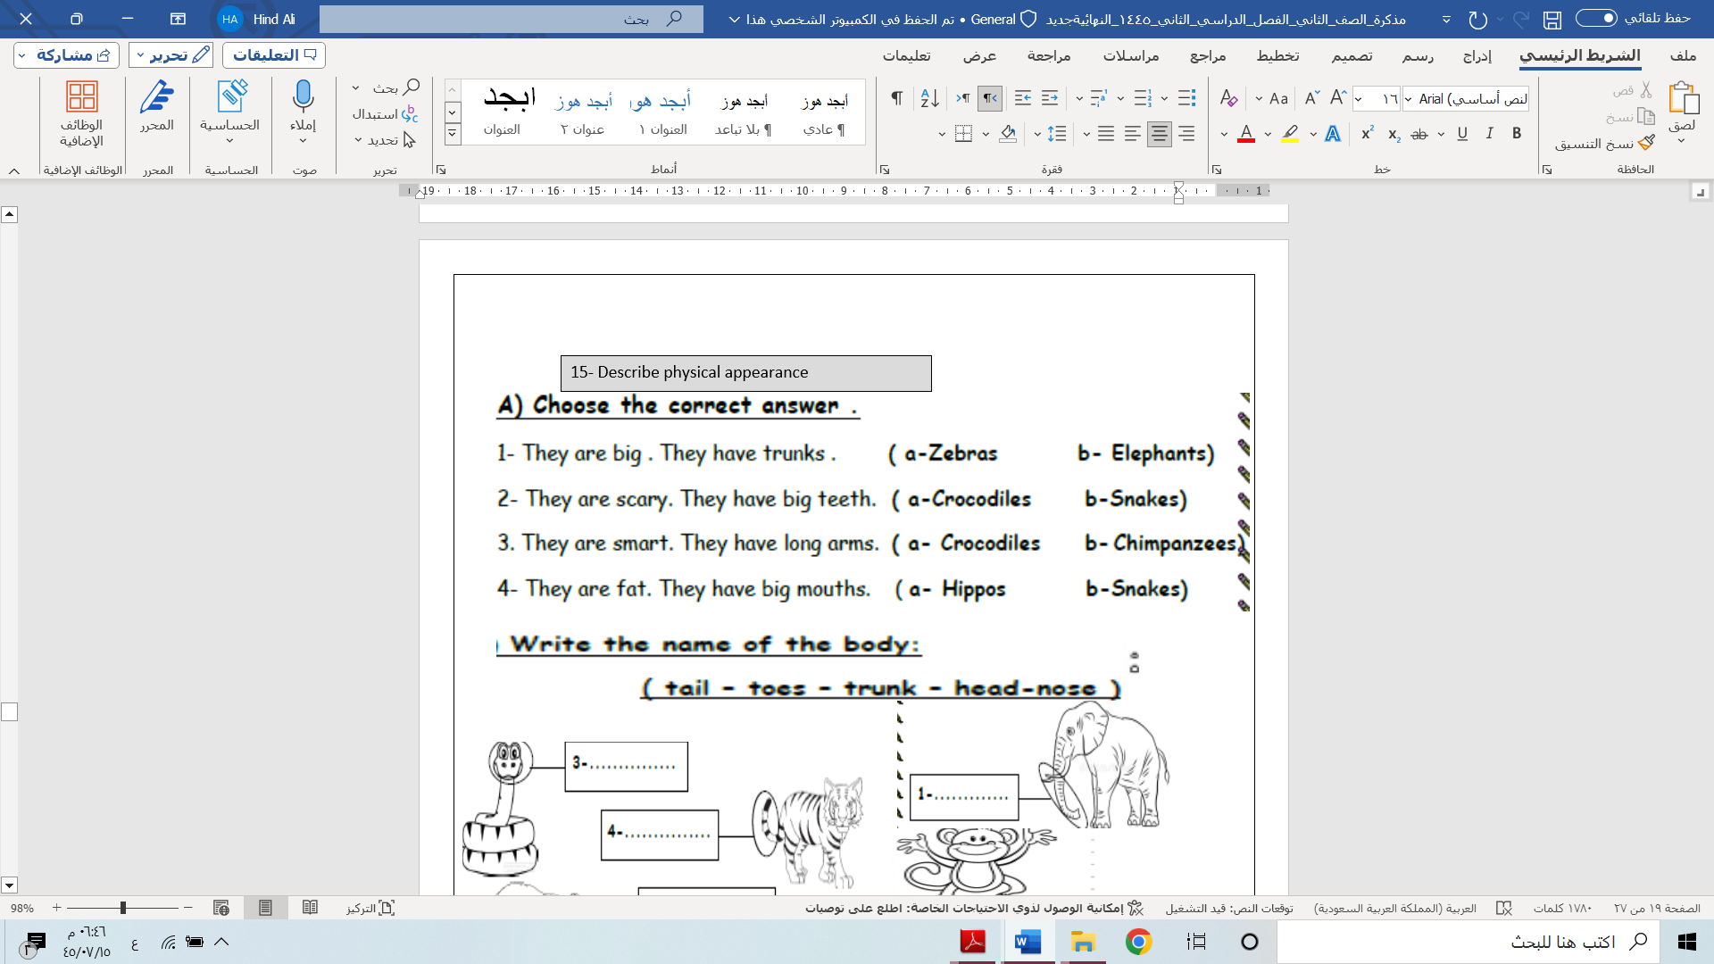**Choose the correct answer:**

|  |  |  |  |  |  |
| --- | --- | --- | --- | --- | --- |
| **غير مجتاز** | **متمكن** | **متقدم** | **متفوق** | **61 + 62** | **رقم المهارة** |

**Put ( √ ) or ( X )**

|  |  |  |  |  |  |
| --- | --- | --- | --- | --- | --- |
| **غير مجتاز** | **متمكن** | **متقدم** | **متفوق** | **63** | **رقم المهارة** |

**Fill in with the suitable letter:**



|  |  |  |  |  |  |
| --- | --- | --- | --- | --- | --- |
| **غير مجتاز** | **متمكن** | **متقدم** | **متفوق** | **64 + 65** | **رقم المهارة** |

**Write the correct words under the picture:**



|  |  |  |  |  |  |
| --- | --- | --- | --- | --- | --- |
| **غير مجتاز** | **متمكن** | **متقدم** | **متفوق** | **68** | **رقم المهارة** |

**Choose the correct answer:**



General Questions

|  |
| --- |
| **1 – This is my friend Nora ?**  **A**. **Nice to meet you Nora** **.** **B**. **I am 10 .** |
| **2 – Good morning !**  **A**. **Nice to meet you,too** **.** **B**. **Good morning**. |
| Buy Decor Kafe 'Cartoon boy Playing Soccar' Wall Sticker (PVC Vinyl Film,  54.99 cm x 88.01 cm x 0.99 cm) Online at Low Prices in India - Amazon.in **3 – Is he playing ?**  **A**. **Yes, he is .** **B**. **No, he isn’t .** |
| **4- Where is she ?**  **A**. **She is playing .** **B**. **She is at home**. |

Reading short sentences

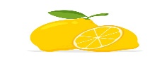

|  |  |  |
| --- | --- | --- |
| **1. Lemons are sour .** | 🗸 | 🗴 |
| **They are walking . .2** | 🗸 | 🗴 |

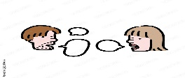

Controlled writing

|  |  |  |  |
| --- | --- | --- | --- |
| **___________________** | | | **1 – hot – rice – is . ( Rearrange )** |
| **sweet** | **cold** | **hot** | **2-Apples are ______ .** |

Grammar

|  |  |  |  |
| --- | --- | --- | --- |
| **are** | **am** | **is** | **1 – She _____ playing .** |
| **am** | **is** | **are** | **2- They _____ cycling .** |
| **or** | **and** | **but** | **3- I have apples ___ oranges .** |

**morning - soup – chips -carrots - bath**

Vocabulary

|  |  |  |  |  |
| --- | --- | --- | --- | --- |
|  | Wake Up Cartoon Images – Browse 21,099 Stock Photos, Vectors, and Video |  Adobe Stock | Premium Vector | Cute cartoon boy having bath |  | 36,624 Cartoon Soup Images, Stock Photos & Vectors | Shutterstock |
| ---------- | ---------- | --------- | --------- | --------- |

Orthography (spelling)

Choose the correct letter: **( ch , l , g , o )**

|  |  |  |  |
| --- | --- | --- | --- |
|  | Boy Sweats In Very Hot Summer Days Stock Illustration - Download Image Now  - Heat - Temperature, Child, Cartoon - iStock | Ice Cube Cartoon White Transparent, Cartoon Blue Ice Cubes, Ice Clipart,  Cartoon, Blue PNG Image For Free Download | Ice cube drawing, Ice drawing,  Ice cube painting | Free Vector | Sandwich with cheese and vegetable in cartoon style |
| **Oran _ e** | **H _ t** | **Co _ d** | **Sandwi _ _** |

Controlled writing

Good luck

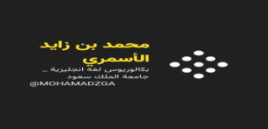



**M_zaid0**

|  |  |  |  |  |
| --- | --- | --- | --- | --- |
| **2- 63** | **متفوق** | **متقدم** | **متمكن** | **غير مجتاز** |

**الفصل:**

**الاسم:**

**Choose the correct answer:**

1- cats ( s - z - iz ) 2- Hills ( s - z - iz )

**________________________________________________________________**

|  |  |  |  |  |
| --- | --- | --- | --- | --- |
| **3-63-5-6** | **متفوق** | **متقدم** | **متمكن** | **غير مجتاز** |

**Cr - sn - gl - C**

**Fill the missing letters:**

|  |  |  |  |
| --- | --- | --- | --- |
| نتيجة الصورة لـ clipart cap | نتيجة الصورة لـ clipart glass | نتيجة الصورة لـ clipart snake | نتيجة الصورة لـ clipart crab |
| ap__ | ass__ | ake__ | ab__ |

|  |  |  |
| --- | --- | --- |
| **are** | **am** | 1- I ………………. Watching TV. |
| **are** | **is** | 2- She is ………………… cooking. |
| **sweat** | **cold** | 3- apples are …………….. . |
| **hot** | **salty** | 4-coffee is ………………… . |

|  |  |  |  |  |
| --- | --- | --- | --- | --- |
| **11** | **متفوق** | **متقدم** | **متمكن** | **غير مجتاز** |

**Choose the correct answer:**

|  |  |  |  |  |
| --- | --- | --- | --- | --- |
| **15** | **متفوق** | **متقدم** | **متمكن** | **غير مجتاز** |

**Match**

|  |  |  |
| --- | --- | --- |
| نتيجة الصورة لـ clipart سفقخىل |  | **long** |
| Long Clipart at GetDrawings | Free download |  | **strong** |

|  |  |  |  |  |
| --- | --- | --- | --- | --- |
| **24-65-** | **متفوق** | **متقدم** | **متمكن** | **غير مجتاز** |

|  |  |  |
| --- | --- | --- |
| **……………………………………………….** | **Rearrange** | 1- Love - I - flowers. |
| **……………………………………………….** | **Rearange** | 2- watch - let's - TV. |

|  |  |  |  |  |
| --- | --- | --- | --- | --- |
| **35-61 -23** | **متفوق** | **متقدم** | **متمكن** | **غير مجتاز** |

|  |  |  |  |
| --- | --- | --- | --- |
| 🗴 | 🗸 | نتيجة الصورة لـ clip art chips | 1- chips is sweat |
| 🗴 | 🗸 | نتيجة الصورة لـ clip art هؤثؤقثشة | 2- Ice cream is cold |

|  |  |  |  |  |
| --- | --- | --- | --- | --- |
| **26** | **متفوق** | **متقدم** | **متمكن** | **غير مجتاز** |

|  |  |
| --- | --- |
| **summer** | **winter** |

|  |  |
| --- | --- |
| نتيجة الصورة لـ clip art summer | نتيجة الصورة لـ clip art winter |
| …………………………………… | ……………………………………….. |

|  |  |  |  |  |
| --- | --- | --- | --- | --- |
| **67** | **متفوق** | **متقدم** | **متمكن** | **غير مجتاز** |

|  |
| --- |
| 1- What is the opposite of ( big ) ?  a) small b) short |
| نتيجة الصورة لـ clip art gorilla2- What is this?  a) Gorilla b) cat |

T.Kholoud Al Harbi