[](https://t.me/Asmaworld)

English Language

2nd secondary Grade

period Exam

…………….\10

Kingdom of Saudi Arabia

Ministry of Education

…………… secondary school

Student's Name : class:

……\ 2 marks

**1-Read the passage then answer the questions:**

We cannot live without the sun’s heat or the air that we breathe, but these givers of life can also become dangerous killers. Moreover, they can behave even more dangerously when they are combined with another great natural force: water. The largest and most destructive results of this are hurricanes. These huge storms can hit land so powerfully that they destroy everything in their path. Information is therefore collected from space satellites.

|  |  |  |
| --- | --- | --- |
| 1-Name the three things in nature that combine to produce hurricanes. | | |
| c- sun's heat ,air and trees | b- sun's heat ,air and mountains | a- sun's heat ,air and water |
| 2- How hurricane forecasters get their information? | | |
| c- radio | b-News  **Grammar** | a- space satellites |

**A.choose the correct answer:**

1- It is important that you ( brush _ brushes – brushing ) your teeth.

2- It was apart time job, ( isn't – wasn't – doesn't ) it ?

3-You ( must – had to – need to ) stop at " STOP " sing.

4- If you heat the water to 100 Cº , it ( boil – boils – boiling ).

**B-Do as shown between brackets.**

**1-(correct)**

a- We decide to **gets** good marks. ………

b- Would you mind **tell** me where the supermarket is?....................

**2-( reorder)**

a- could \ me \ you \ help \ ? ………………………………………………………………………

……\ 4 marks

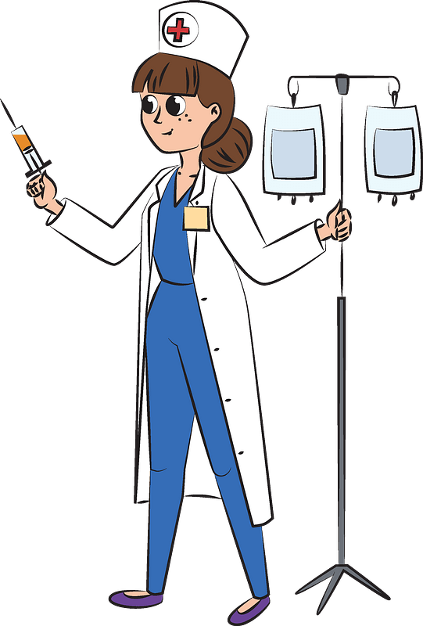

……\ 4 marks

**Vocabulary**

Your teacher:

……………………….

……………………….

……………………….

……………………….

**C-write the correct word under each picture.** ( **tailor – recycle- nurse – turbines )**

**B.Find the odd words.**

1- wood glass plastic

2- fashion fabric window

2-

**A-Complete the sentences with these words:** (organic veterinarian pesticides)

1-………………. Food is produced entirely without chemicals.

2-………………………………is a doctor for animals.

|  |  |  |
| --- | --- | --- |
| Kingdom of Saudi Arabia  Ministry of Education  General Directorate of Education in Type Your GDE here. |  | Type Your School here. School  English Mega Goal 2.2 Midterm Exam  2nd Term 1446  Time: 45 minutes |

**Name: Class: Your Mark:** **/10**

# **▪ Tick where each match meets.**

***Vocabulary***

|  |  |  |  |  |  |  |  |  |
| --- | --- | --- | --- | --- | --- | --- | --- | --- |
|  | |  | **dedicated** | **do me a favor** | **organic** | **leave** | **inadequate** | **for example** |
|  | **help me out** | |  |  |  |  |  |  |
|  | **lame** | |  |  |  |  |  |  |
|  | **take off** | |  |  |  |  |  |  |
|  | **committed** | |  |  |  |  |  |  |
|  | **for instance** | |  |  |  |  |  | Checkmark with solid fill |

**▪ Choose the correct option.**

1. **to be grateful for**

□ **A.** cooperate □ **B.** entail □ **C.** satisfy □ **D.** appreciate

1. **substances that cause sensitivity or reactions in some people**

□ **A.** flair □ **B.** infection □ **C.** allergens □ **D.** captive

1. **Pollution is the of many environmental problems.**

□ **A.** consumption □ **B.** pesticide □ **C.** conditioner □ **D.** source

# **▪ Number the correct option in the box.**

***Grammar***

1. **She asked that we be late.**
2. **He didn’t get the job, ?**
3. **I enjoy horror stories.**
4. **If you put water in the freezer, it ice.**

□ help □ had to □ becomes

□ not □ don’t □ did he

□ Could □ Would □ to help

□ reading □ to use □ need

**▪ Choose the correct option.**

1. **I want you the report this afternoon.**

□ **A.** finish □ **B.** to finish □ **C.** have finished □ **D.** finishing

1. **You stop at the ‘STOP’ sign.**

□ **A.** must □ **B.** needs to □ **C.** needn’t □ **D.** don’t need to

1. **Does Planet Earth round the sun?**

□ **A.** go □ **B.** goes □ **C.** went □ **D.** going

# **▪ Read and choose the correct option.**

***Reading***

There is a climate crisis. We need to stop using oil and gas. The European Space Agency (ESA) is testing giant solar farms in space. It wants to send energy wirelessly from space into people's homes. One solar-farm satellite could make the same amount of power as a power station. The ESA wants many of these farms in space.

The ESA project is called Solaris. The ESA wants "a clean and secure energy future". This means becoming more carbon-neutral. The ESA said we needed to cut the use of fossil fuels. Solar farms could help us to do this. One farm is around 1.7 km long. This is bigger than the International Space Station, which is 110 m long.

1. **Using oil and gas don’t affect the climate.**
2. **ESA is trying to transfer energy from space to our houses wirelessly.**
3. **One farm in Solaris project is around 110 km long.**

**Best of Luck!**

**MARWAN**

**English Language**

**Mega Goal 2.2**

**2nd Secondary Grade**

**Time: 45 minutes**

**Kingdom of Saudi Arabia**

**Ministry of Education**

**…………………………….. Education Directorate**

**…………………………………………………….. School**



**Midterm English Language Exam Form for the Year 1446 AH – 2nd Semester**

**Name:** ………………………………………………………………………………….……… **Class:** ……………….

**10**

**2**

**1. *Guided Composition***

***Consider the following English proverb "Home is where the heart is." Then, derive your own quote***

***about home that embodies your feelings and vision in short.***

|  |  |  |  |  |  |  |  |  |  |
| --- | --- | --- | --- | --- | --- | --- | --- | --- | --- |
|  |  |  |  |  |  |  |  |  |  |
|  |  |  |  |  |  |  |  |  |  |
|  |  |  |  |  |  |  |  |  |  |
|  |  |  |  |  |  |  |  |  |  |
|  |  |  |  |  |  |  |  |  |  |
|  |  |  |  |  |  |  |  |  |  |
|  |  |  |  |  |  |  |  |  |  |

**2**

**2. *Reading Comprehension***

***Read the following passage. Then, tick 🗹 the correct option:***

**Out of concern for the environment and a desire for self-reliance, a growing number of people have made the bold decision to live off the grid. Living off the grid entails sacrifices, and is certainly not for everyone. But for the thousands of people who have made this bold choice, life off the grid is filled with rewards that can't be matched by the conveniences and luxuries of life on the grid. Among *those*, the avoidance of the environmental and financial costs that come with on-grid living.**

|  |  |  |
| --- | --- | --- |
| ***1. The bold choice is to live …*** | ***🔾 on the grid*** | ***🔾 off the grid*** |
|  |  |  |
| ***2. Living off grid requires ...*** | ***🔾 selfishness*** | ***🔾 sacrifices*** |
|  |  |  |
| ***3. Living off the grid costs much less.*** | ***🔾 True*** | ***🔾 False*** |
|  |  |  |
| ***4. The demonstrative pronoun (those) on line (6) refers to …*** | ***🔾 people*** | ***🔾 rewards*** |

**1**

***Please turn the page over***

**3**

**3. *Grammar***

***Do as required in the brackets:***

|  |  |
| --- | --- |
| ***1. Finish the project tonight.*** | ***Use one: subjunctive / 'd like … to/ want … to*** |
| ***…………………………………………………………………………………………………………………………………………………………………………………………………………….…………………..*** | |
|  | |
| ***2. Your uncle is a snow researcher, ………………………….?*** | ***Supply the missing tag question*** |
|  | |
| ***3. The team …………..… if the players practice hard.*** | ***Choose the correct option*** |
| ***🞏 needn't win 🞏 won 🞏 will win 🞏 have not won*** | |

**3**

**4. *Vocabulary***

***1. Replace the underlined words with the suitable synonym:***

***quit – outfits – are grateful for – pedicurists – extremely large***

|  |  |
| --- | --- |
| ***a). Good people appreciate each other.*** | ***……………….…………………………………….*** |
| ***b). The house is enormous as if it is a palace!*** | ***……………….…………………………………….*** |

***2. Supply the missing word from the given options:***

***consumption – profession – organic – go green – satisfaction***

|  |
| --- |
| ***Incomplete Sentences*** |
| ***a).*** ***The food regarded to be ……………………..………. is produced entirely without chemicals.*** |
| ***b). Heating and cooling are represented half of the average of family's energy ……………………..………… .*** |

***3. Match the underlined expression from column (A) with its explanation from column (B):***

|  |  |
| --- | --- |
| ***A*** | ***B*** |
| ***1). Look! I've done it! It was a piece of cake.*** | **a). very easy** |
| **b). very delicious** |
| ***2). Hind is in a bind, and we have to give her our hands.*** | **a). in a difficult situation** |
| **b). feel sleepy** |

***Questions Over***

***With best wishes,***

***Nourah Abdul-Aziz***

**2**

**أسئلة الاختبار النصفي للفصل الدراسي الثاني للعام الدراسي 1446 هــ**

**ـــــــــــــــــــــــــــــــــــــــــــــــــــــــــــــــــــــــــــــــــــــــــــــــــــــــــــــــــــــــــــــــــــــــــــــــــــــــــــــــــــــــــــــــــــــــ**

**اسم الطالب : .......................................................................................................................... الفصل : .......................................**

1. **Put the following job titles with the job descriptions:**

(Zoologist – Surgeon - Social worker - Screen writer)

1. _______________ This person is involved in the study and care of animals.
2. _______________ This is someone who helps people in need, such as the poor or disabled.

3. _________________ This is a special kind of doctor that operates on sick or injured people**.**

1. **Choose the correct answer :**
2. I recommended that he …………………………… a specialist ( . a - see b- seeing -c was see)
3. I’d like you to ………………………………… this medicine .( a - takes b- taken -c take )
4. They don't play, ……………………………… (do they – don't they – they do – aren't they) ?
5. You ……………………….. ………… (have to – must – need to – mustn't) smoke in the hospital.
6. I don't …………………………… ( needn't – must – need to – mustn't) take my passport. ID card is ok .
7. **It is important that he ( works ) here today . ( Correct )**

**………………………………………………………………………………………**

1. **She is a good teacher, …………………………………..?** (Write the question tag)
2. **Match the words to their meanings :**
3. flair ( ) A- confined, kept under restraint or control .

2- captive ( ) B- exactly the same .

3- identical ( ) C- a natural talent or ability .

4- analyze ( ) D- to study closely

1. What is Lily Martinez’s job ?

……………………………………………………………………………………………………………………………