|  |  |  |  |  |  |
| --- | --- | --- | --- | --- | --- |
| ظ **Kingdom of Saudi Arabia**  Ministry of Education  ………Education  …………………Secondary School . |  | Corrected by:  ………………….. | | **Midterm Exam**  second term  1446  Third grade  Time:50 m  Mega Goal 3.2 | |
| Reviewed by:  ………………….. | |
| …………………..  10 |
| Checked by:  ………………….. | |
| Name | ……………………………………………….... | | Class | | …………… |

**1.Reading**

**2**

**Read , then answer the following questions**:

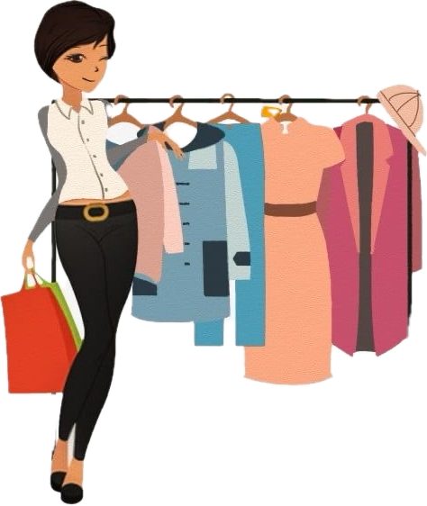 Mrs. Sara often blow too much money on clothes. She does not need new clothes, but she loves buying them . Yesterday she saw a beautiful coat in a shop window . She went in and put it on . It was just the right size, but the problem is that she maxed out her credit card . Mrs. Sara did not have enough money ,but she took the coat home and showed it to her husband . He liked it very much , but he did not like the price. His wife gave him a bill for 2000 RS.

**A** -

**True/ false)** )

1. Mrs. Sara left the coat in the shop ( )
2. Mrs. Sara does not need new clothes , but she loves buying them( )

**B- choose :**

1- Her husband did not like..........

a- the color of the coat b – the price of the coat.

2- The coat was very………

a- expensive b- very cheap

**3**

**2. Grammar**

1. **Choose :**

|  |
| --- |
| 1. You can put it (so that – wherever – because) you like . |
| 1. How long have you ( be taught – be teaching - been teaching ) ? |
| 1. I'm not very good at ( cooks - cooked – cooking ) |
| 1. I won't go to the party (unless – if – because) she invites me . |
| 1. If you put water in freezer, it( became – becomes – becoming ) ice. |
| 1. Don’t forget ( to email – emailing – email ) me the photos . |
| 1. ( If – since – now that ) you want go shopping , I'll go with you . |
| 1. We don’t like fishing (or – but – and ) our father does . |

**B- Correct the underlined errors :**

* If you cook an egg in the microwaves , it **explode** . ______________________
* **Because of** it was late we were tired . ______________________

**3.Vocabulary**

**2**

1. **Choose the correct answer:**

|  |  |  |  |
| --- | --- | --- | --- |
| **feminine – tedious – masculine – logo - consumer** | | | |
|  |  |  |  |
| **…………………..** | **…………………** | **…………….………….** | **………………** |

1. **Match :**

**1**

|  |  |  |
| --- | --- | --- |
| **1- Broke** | **….** | **emotionally close** |
| **2-You can say that again** | **….** | **Respect** |
| **3-admire** | **….** | **I agree with you completely.** |
| **4.intimate** | **….** | **Out of money** |

**4. Writing**

Extra marks for excellent answers

**2**

🖎 Complete the sentences about yourself:

1. What kind of things do you blow money on ?

……………………………………………………………………………………………………………………………………………………………………………………

1. I always remember ……………………………………………………………………
2. Is there a place you know like the back of your hand ? where is it ?

………………………………………………………………………………………………………………………………………………………………………………………………..

Best Wishes

………..