

English Language

Intermediate Grade 1st

1st period Exam

Kingdom of Saudi Arabia

Ministry of Education

………………… School

[](https://t.me/Asmaworld)

Student's Name : class:

……\ 5 marks

1**-Read the following passage and answer the questions below:**

My house is where my family lives. It is white. It is big. There are four bedrooms. We have a kitchen and three bathrooms. Our family room is where we like to watch television together. When people come over, we eat in the dining room. We have a playroom in the basement. We have a swing in the backyard. I love my house.

|  |  |  |
| --- | --- | --- |
| 1-What color is the house? | | |
| c- brown | b- blue | a- white |
| 2-There are ……………bedrooms. | | |
| c-six | b-three | a-four |
| 3-There are a kitchen and three ………… | | |
| c-garages | b-bathrooms | a-living rooms |
| 4- Who lives in the house? | | |
| c-family | b-cousins | a-friends |
| 5- What is in the backyard? | | |
| c- a swing | b-swimming pool | a- television |

**2-Choose the correct answer.**

……\ 5 marks

|  |  |  |  |
| --- | --- | --- | --- |
| c- for | b- on | a- in | 1- We live ………….the twelfth floor |
| c- but | b- and | a- or | 2- We read …………..write in class. |
| c- Am | b- Are | a- Is | 3- ………..there curtains in the kitchen? |
| c- best | b- better | a- good | 4- Healthy food is……. than fast food. |
| c- am | b- are | a- is | 5- There ………… a car in the garage |
| c-hottest | b-hotter | a- hot | 6- Summer is the………. time of the year. |
| c- smartest | b- smarter | a-smart | 7- Sami is …………….. |
| c- or | b- and | a- but | 8- Would you like coffee …….tea? |
| c- in | b- from | a- in | 9- Ali lives …….. Jeddah. |
| c-but | b-and | a- or | 10- Do you write with a pencil ……..a pen? |

……\ 2 marks

**3. Do as shown between brackets.**

**(make a question then answer).**

a-There is a desk in the bedroom.

………………………………………………?

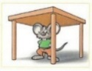**(choose the correct answer)**

a-The mouse is ( under – far from – behind )the table.

……\ 6 marks

**A -Choose the correct answer.**

1- A place to take a walk( (school- park – supermarket )

2- She was looking at her reflection in the ( motorcycle – mirror – trees)

**B- Find the odd words**

1- Health club bookstore armchair

2- washer laptop dryer

**C-Match the correct word for each picture. ( lake post office bathtub refrigerator )**

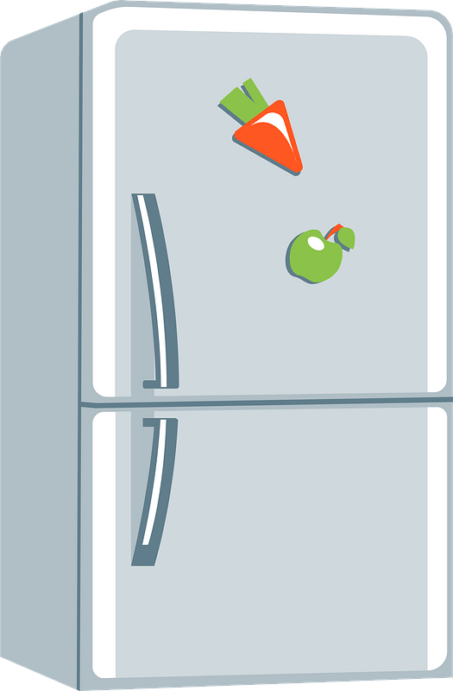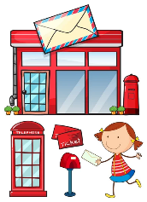



………………..

………………..

………………..

………………..

**A-choose the missing letters**

……\ 2 marks

1- He went to the museu… by taxi. ( j – h – m ).

2- He has a clo….et full of new clothes. ( s – d – j )

**B-write the missing letter**



2- Shel..….

….…ym 1-



Your teacher:



Kingdom of Saudi Arabia

Ministry of Education

………… Education Directorate

……………….. Intermediate School

**Super Goal 1** - **Test** unit 6 & 7

Name :………………………………………………………………………… Class:…….……….

**Comprehension**

2 Marks

* **Read the text and answer the questions. Write T or F at the end of each question/statement.**

**M**y grandparents’ house is probably the home that means the most to me. It is more than 200 years old. There are seven rooms and two bathrooms in my grandparents’ house. There are three bedrooms upstairs and a big wooden staircase going downstairs. The living room has a red rug and a red sofa in it. There are also lots of big, comfortable armchairs in the living room. The dining room has a big wooden table and six wooden chairs around it.

1. The paragraph is about the writer’s grandparents’ house. ( )
2. There are two bedrooms upstairs. ( )
3. The living room has a red rug and a red sofa in it. ( )
4. The dining room has a small wooden table.( )

**Grammar**

* **Choose the best answer to fill in the blank in each question.**

5 Marks

1. ___________ some flowers on the table. They look nice.

**a**. There aren’t **b**. Is there **c**. There are **d.** are

1. The stove is _______________ the pot.

**a**. on **b**. under  **c**. behind **d.** in

1. **Amy:** _____ a table in the kitchen? **Mia:** No, there isn’t.

**a**. There aren’t **b**. are there **c**. There are  **d.** Is there

1. I live ________ the third floor. (building)

**صورة تحتوي على نص

تم إنشاء الوصف تلقائياًa**. between **b**. next to **c**. on **d.** in

1. The pharmacy is _________the bookstore.

**a**. next to **b**. near  **c**. far from  **d.** on

* **Write or, but, or and to fill in the blank.**

1.5 Marks

1. There’s a stove in the kitchen, ________ there isn’t a dishwasher.
2. There’s a bed _________ a closet in the bedroom .
3. You can read a book ______________ watch TV.

* **Complete the sentences with the comparative or superlative forms of the adjectives. Use the before superlatives.**

1.5 Marks

1. The bookstore is _______________________than the library. (popular)
2. That restaurant has the _______________________ food in town. (bad)
3. The park is ______________in the spring than in the winter. (beautiful)

**Vocabulary**

* **Choose the best answer to fill in the blank in each question.**

5 Marks

1. The _____ are in the living room.

**a**. trees **b**. sinks  **c**. toilets **d.** armchairs

1. The pot is on the _____.

**a**. stove **b**. bathroom  **c**. yard  **d.** kitchen

1. The tree is in the _____.
2. bathroom **b**. garden **c**. laundry room **d.** garage
3. Is there a ____________ near here? I’m hungry.

**a**. airport **b**. gym  **c**. restaurant **d.** post office

1. I buy vegetables from the ____________ on the corner of Main St. and Elm St.

**a**. supermarket **b**. bank **c**. subway station **d.** park

* **Write the correct word under the picture.**

3 Marks

|  |  |  |  |  |  |
| --- | --- | --- | --- | --- | --- |
| **1** | **Car** | **2** | **Washer** | **3** | **Health club** |
| **A** |  | **B** | **صورة تحتوي على قصاصة فنية, رسوم متحركة  تم إنشاء الوصف تلقائياً** | **C** |  |
| ……………………..……………….. | | ……………………..……………….. | | ……………………..……………….. | |

**Orthography**

* **Choose the correct letter.**

2 Marks

1. it's very nice and comforta….le

**a**. ( b ) **b**. ( t ) **c**. ( m )

1. it' the museum is nea… the hotel

**a**. ( a ) **b**. ( k )  **c**. ( r )

**Good luck !**



English Language

Intermediate Grade 1st

period Exam

………\20

Kingdom of Saudi Arabia

Ministry of Education

………..Education Directorate

………………… Intermediate School

Student's Name : class:

**Reading comprehension ✦**

[](https://t.me/Asmaworld)

……\ 5 marks

1-Read the following passage and answer the questions below:

My house is where my family lives. It is white. There are four bedrooms. We have a kitchen and three bathrooms. Our family room is where we like to watch television together. We have a playroom .There is a garden in the house and we have a swing there. Our house is near the elementary school.

|  |  |  |
| --- | --- | --- |
| 1-What color is the house? | | |
| c- red | b- white | a- blue |
| 2-Who lives in the house? | | |
| c- students | b- friends | a- family |
| 3-How many bedrooms are in the house? | | |
| c- four | b- five | a- one |
| 4-The house is …….. the elementary school. | | |
| c- next to | b- near | a- on |
| 5-What is in the garden? | | |
| c- bicycle | b- football | a- swing |

……\ 4 marks

**Grammar**  ✦

**A. Choose the correct answer.**

1- Ahmad is the ( tall – taller – tallest ) student in the class.

2- We live ( in – on – for )the twelfth floor.

3- We read ( or – and – but ) write in class.

4-( Is – Am - Are )there curtains in the kitchen?

5-There ( is - are – am ) a car in the garage ..

6-Sami is ( smart – smarter – smartest ).

7-. Ali lives ( in – on – from ) Jeddah.

8-Healthy food is( good – better – best ) than fast food.

**B. Do as shown between brackets.**

**1-Correct**

a-Summer is the **hotter** time of the year. …………………

b-There **are** a Tv in the living room. ……………………….

……\ 2 marks

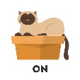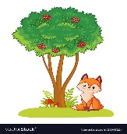**2-Choose the correct answer.**

……\ 2 marks

a-The cat is ( in – far from - on ) the box.

b-2-the fox is ((across from - between – next to )the tree.

✦  **Vocabulary**

……\ 5 marks

**A.Match the correct word for each picture.**

stove bridge bathtub lake

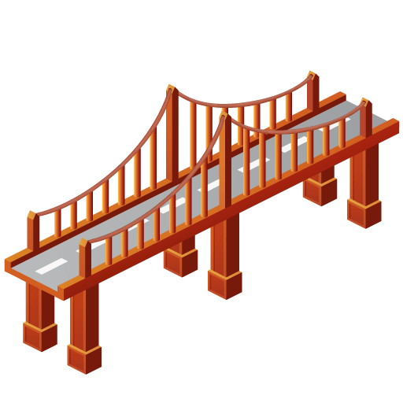

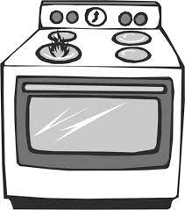

………………..

………………..

………………..

………………..

**B-choose the correct answer.**

1-a place to eat ( restaurant – bank - airport )

2-The opposite of small≠ ( big - tiny - happy)

3- The opposite of unusual ≠ ( cave – usual – bookstore)

4-a place to take a walk( (school- park – supermarket )

**C-Find the odd words.**

1- ( house parts ) : bedroom garage bank

2-(Laundry Room): washer laptop dryer

**✦ Orthography**

**Choose the corre**

……\ 2 marks

**A-Write the missing letters.**

1- Ar…..chair 2- Clo….et

**B.Choose the missing letters.**

1- a piz..eria is a restaurant that sells pizza.( z - o - k ).

2-He went to the museu… by taxi ( j – h – m ).



Your teacher …..:…………………………….



**Kingdom of Saudi Arabia**

**Ministry of Education**

**………… Education Directorate............**

**…………..……………….. Intermediate School**

|  |
| --- |
|  |
| **20** |

**Total**

**Midterm Test**

|  |
| --- |
| **First Intermediate Grade** |

**Name ………………………………… Class ………………………………**

__________________________________________________________________________________________

/ 4

**Comprehension**

**Read the following then answer the questions:**

Ali is a schoolboy. He is 13 years old. His father is a doctor. His mother is a teacher. He has 3 brothers. Ali and his family have a big house. He likes English.

**A- Put (√ ) for true or ( ᵡ ) for false :**

|  |  |
| --- | --- |
| **( )** | **1.** Ali is 14 years old. |
| **( )** | **2.** His father is a doctor. |

**B- Choose the right answer:**

|  |  |  |  |  |
| --- | --- | --- | --- | --- |
| **a doctor** | **a pilot** | **a nurse** | **a teacher** | **1-**His mother is _________. |
| **five** | **three** | **four** | **two** | **2-**He has ___ brothers. |

_________________________________________________________________

**Grammar**

/ 5

**Choose the right answer:**

|  |  |  |  |  |
| --- | --- | --- | --- | --- |
| D**.There** | C**. Is there** | B**. There are** | A**. There is** | 1. ______ a table in the kitchen. |
| D**. under** | C**. at** | B**. in** | A**. on** | 2. I live ___ Jeddah. |
| D**. after** | C**. in** | B**. on** | A**. at** | 3**.** He lives ___ the third floor. |
| D**. taller** | C**. tallest** | B**. big** | A**. tall** | 4**.** Ali is ____ than Ahmad. |
| D**. read** | C**. studies** | B**. study** | A**. studying** | 5**.** I am ______ now. |

**Vocabulary**

/ 4

**A- Choose the best answer to fill in the blank:**

|  |
| --- |
| **1.** The ______ is in the garage**.** |
| **A. tree B. shower C. motorcycle D. stove** |
| **2**. The apartment has a _____ with a beautiful view. |
| **A. balcony B. bathroom C. stove D. floor** |
| **3-** The supermarket is much _____than the convenience store. . |
| **A. far B. bigger C. big D. beautiful** |
| **4-** He is drinking a _________. |
| **A. sandwich B. pizza C. cup of tea D. fruit** |

**B- Put the right word under its picture:**

|  |  |  |  |
| --- | --- | --- | --- |
| Smartphone Mobile Phone Cartoon, PNG, 723x1109px, Smartphone, Animation,  Blue, Brand, Cartoon Download Free | Turn left Basic Rounded Lineal icon | Bedroom Graphic Black White Isolated Furniture: immagine vettoriale stock  (royalty free) 2217488523 | Shutterstock | Workout Cartoon Clipart Images | Free Download | PNG Transparent Background  - Pngtree |
|  |  |  |  |

**Bedroom - Health club - Turn right - Cell phone**

/ 4

_______________________________________________________________________________

/ 3

**Orthography**

**Choose the correct letter:**

|  |  |  |  |
| --- | --- | --- | --- |
| C**. ( b )** | B**. ( v )** | A**. ( d )** | 1. It is very nice and comforta__le. |
| C**. ( f )** | B**. ( n )** | A**. ( m )** | 2. I live in this apart__ent. |
| B**. ( t )** C**. ( z )** | | A**. ( s )** | 3**.** They are reading maga_ines. |

Good luck T.