

English Language

Intermediate Grade 2nd

1st period Exam

Kingdom of Saudi Arabia

Ministry of Education

………………… School

[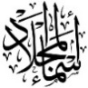](https://t.me/Asmaworld)

Student's Name : class:

……\ 5 marks

1-Read the following passage and answer the questions below:

Last winter my family and I went to France. At the beginning of our trip, we went on a cruise on the River Seine. It was a wonderful experience. Then we went sightseeing and of course, we went to the Louvre Museum. There were so many interesting things to see there. We also visited the Eiffel tower and took lots of pictures. They were amazing! My parents and I also tried horse riding. It was lots of fun. My brother didn’t want to go anywhere near the animal. You see, he was afraid. I really want to visit France again. It’s beautiful and there are many things to see there!

|  |  |  |
| --- | --- | --- |
| 1-When did they go to France? | | |
| c- last spring | b- last winter | a- last summer |
| 2-They went on a cruise on the………… | | |
| c-River Amazon | b- River Seine | a-Nile Seine |
| 3-They went to the …………… Museum. | | |
| c-Ithra | b-Egyptian | a- Louvre |
| 4-They visited the ……………….. and took lots of pictures. | | |
| c- Eiffel tower | b- Pyramids | a-kingdom tower |
| 5- They tried ……………….. riding | | |
| c- elephant | b-camel | a- horse |

**2-choose the correct answer.**

……\ 5 marks

|  |  |  |  |
| --- | --- | --- | --- |
| c- studying | b- studied | a- study | 1- Omar …………..Math yesterday. |
| c-are | b- were | a- was | 2- There ……… a book on the table |
| c- anything | b- no one | a-someone | 3- Do you want …………to eat? |
| c- am | b- were | a- was | 4- Where………… the football game? |
| c- X | b-too | a-very | 5- The museum was ……. great . |
| c-do | b-were | a-was | 6- They …….. at school. |
| c- anything | b- someone | a- something | 7- I know………. who gives yoga lessons. |
| c-so | b- Neither | a-more | 8- I don’t have a driver’s license. - …… do I. |
| c- watching | b- watched | a- watch | 9- Did you ………T.V this morning? |
| c-too | b-so | a- because | 10- She was scared ….. he was driving too fast |

……\ 2 marks

**3. Do as shown between brackets.**

**A-(Correct)**

**a.** There **were** a party last night. …………………

b. Noura **win** the game last moth…………………..

……\ 6 marks

**A -Choose the correct answer.**

1- Thuluth is a long and elegant ( script - Kufic – shuttle)

2- Don’t lose your cool means : Don’t get( angry- happy – sad)

3- You can shake hands with a moving robot at (Science -history- art) museum.

2- ( witness – insurance- injury ) means: Hurt from an accident.

**B-Match the correct word for each picture. ( ticket – sleepy – angry – binocular )**

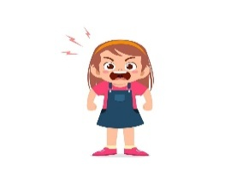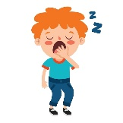

………………..

………………..

………………..

………………..

**A-choose the missing letters**

……\ 2 marks

1- She's wor….ied about her grades. (d – r – e)

2- The word calligra…hy means “beautiful writing.” ( p – o - h )

**B-write the missing letter**

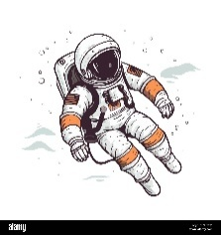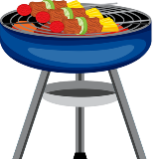

1-bar……ecue

2-a…….tronaut

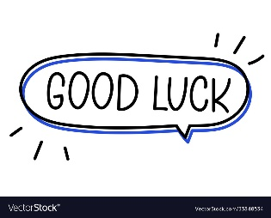

Your teacher:



Kingdom of Saudi Arabia

Ministry of Education

………… Education Directorate

……………….. Intermediate School

**Super Goal 2** - **Test** unit 6 & 7

Name :………………………………………………………………………… Class:…….……….

**Comprehension**

2 Marks

* **Read the text and answer the questions. Write T or F at the end of each question/statement.**

**Police Department**

**Witness Report**

Incident: Motor Vehicle Accident

Witness: Larry Johnson

There was an accident at the corner of Main Street and Oak Street last night. A car crashed into *The Café.* The accident happened around 6:30 P.M. I saw it happen. I was at the bus stop across the street. A car drove through the intersection very fast. Someone started to walk across the street. The driver couldn’t stop. He turned and crashed into the café. Fortunately, no one was hurt. I was scared and worried about the people in the café. But everyone was OK. It was the driver’s fault. He was driving too fast.

1. The car drove too fast. ( )
2. The driver turned and crashed into the café. ( )
3. The driver was hurt. ( )
4. It was the driver’s fault.( )

**Grammar**

* **Choose the best answer to fill in the blank in each question.**

5 Marks

1. How was the museum tour ? - it ______ good.

**a**. were **b**. is  **c**. was **d.** none

1. The museum exhibit was ____ interesting.

**a**. absolutely  **b**. completely **c**. really **d.** totally

1. The dinosaur skeleton at the Natural History Museum is ____.

**a**. completely big **b**. absolutely enormous **c**. quite a big  **d.** very huge

1. ______are you Worried ? - Because I have a test tomorrow .

**a**. Why **b**. When  **c**. What  **d.** Where

1. Why did the driver start to shout ? - ________ he was angry .

**a**. What **b**. Because  **c**. There **d.** Have

1.5 Marks

* **Find the mistake, underline it and write the correct word.**

1. Did you had fun at the weekend? - **_______________ .**
2. What did you watched on TV yesterday? - **_______________ .**
3. Do you write an email yesterday? - **_______________ .**

* **Complete with there was – there were.**

1.5 Marks

1. _____________________ no clouds in the sky !
2. _____________________________ two wolfs !
3. _____________________ a picture in the room.

**Vocabulary**

* **Choose the best answer to fill in the blank in each question.**

5 Marks

1. That _______________ shows wonderful modern art by a Spanish artist.

**a**. gallery **b**. exhibit **c**. history  **d.** museums

1. She is _______ of dogs, she can't buy one.

**a**. tired  **b**. scared **c**. sleepy **d.** liked

1. The word 'calligraphy' means:

**a**. creative writing **b**. beautiful writing **c**. bad writing  **d.** big writing

1. **Lucy:** Why is Jen so ____? -**Ann:** Because she stayed up late last night.

**a**. happy **b**. angry  **c**. worried **d.** sleepy

1. **Bill:** Why is Brian so ____? - **Ali:** Because his brother was in an accident this morning.

**a**. Happy **b**. tried  **c**. surprised  **d.** worried

* **Write the correct word under the picture.**

3 Marks

|  |  |  |  |  |  |
| --- | --- | --- | --- | --- | --- |
| **1** | **Happy** | **2** | **Robot** | **3** | **Pizza** |
| **A** | صورة تحتوي على نص, قصاصة فنية, رسوم المتجهات  تم إنشاء الوصف تلقائياً | **B** |  | **C** | **صورة تحتوي على لقطة شاشة, قصاصة فنية, الرسومات, رسوم متحركة  تم إنشاء الوصف تلقائياً** |
| ……………………..…………….. | | ……………………..…………….. | | ……………………..…………….. | |

**Orthography**

* **Choose the correct letter.**

2 Marks

1. I like his…..ory museums best

**a**. ( p ) **b**. ( t ) **c**. ( m )

1. I was slee…y and I didn't see the car coming.

**a**. ( p ) **b**. ( s ) **c**. ( c )

**Good luck !**



English Language

Intermediate Grade 2nd

period Exam

………\20

Kingdom of Saudi Arabia

Ministry of Education

………..Education Directorate

………………… Intermediate School

Student's Name : class:

**Reading comprehension ✦**

[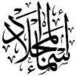](https://t.me/Asmaworld)

……\ 5 marks

1-Read the following passage and answer the questions below:

We do many different things in this amazing job. Here’s just one twelve hour day. At 1:30 pm the police call us to a road accident. There’s no fire, but a driver is caught inside her car. We free her with our special cutting equipment. Then the paramedics take over at 3:30 pm. There’s training back at the fire station. Today it’s ‘How to deal with dangerous chemicals’. Even the older officers are there. In this job, training never ends!

|  |  |  |
| --- | --- | --- |
| 1-Why do the police call the fire service? | | |
| c- to fire accident | b- to a road accident. | a- to electricity accident |
| 2-The driver is caught inside her ………. | | |
| c- taxi | b- bus | a- car |
| 3- The paramedics take over at …………..pm. | | |
| c- 3:30 | b- 3:50 | a- 3:10 |
| 4-What is the training about? | | |
| c- How to deal with negative emotions | b- How to deal with children | a-How to deal with dangerous chemicals’ |
| 5-Get from the passage the synonyms of: career | | |
| c- job | b- football | a- cat |

**A. Choose the correct answer.**

1- Omar ( study – studied – studying ) Math yesterday.

2- There ( was – were – are ) a book on the table .

3- They ( was – were – do ) at school.

4- Do you want ( someone – no one - anything )to eat?

5- She was scared ( so – because – to ) he was driving too fast .

6- I don’t have a driver’s license. - ( Neither – So – more ) do I.

7- What did she ( does – do – did ) on Sunday **?**

8- Where( was – were – am ) the football game?

……\ 4 marks

**Grammar**  ✦

**B. Do as shown between brackets.**

**1-( Make Yes or No questions)**

a- Ali played football . ……………………………………………………………..…..?

……\ 1 marks

 **2-( use very )**

……\ 3 marks

a- He is clever. ………………………………………………………………………….................

**3-( use So )**

a-No one was hurt . I am extremely relieved .

…………………………………………………………………………………………..………………

**4- ( Give short answer )**

a- Were the players good? -No , ………………………………………………………………..

……\ 5 marks

✦  **Vocabulary**

**A.Match the correct word for each picture.**

stadium scared museum angry

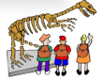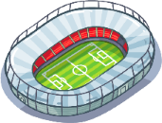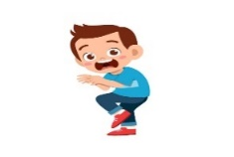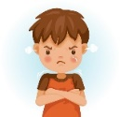

………………..

………………..

………………..

………………..

**B- Find the odd words.**

**1-House parts:** Living room police balcony

**2-Family:** Sad daughter mother

**✦ Orthography**

**Choose the corre**

……\ 2 marks

**A-Choose the correct missing letters.**

1- She's wor….ied about her grades. (d – r – e)

2- The word calligra…hy means “beautiful writing.” ( p – o - h )

3- A piz…eria is a restaurant that sells pizza. ( d – o - z )

4- He didn’t see the sto… sign.( j – k – p )

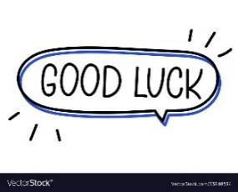

Your teacher …..:…………………………….



**Kingdom of Saudi Arabia**

**Ministry of Education**

**………… Education Directorate............**

**…………..……………….. Intermediate School**

|  |
| --- |
|  |
| **20** |

**Total**

**Midterm Test**

|  |
| --- |
| **Second Intermediate Grade** |

**Name ………………………………… Class ………………………………**

__________________________________________________________________________________________

/ 5

**Comprehension**

**Read the following then answer the questions:**

My uncle has a small farm. He has a lot of chickens there. He sells eggs and chickens. Every summer, during the holiday I usually go to his farm to help him. I feed the chickens and collect the eggs. My uncle sometimes gives me chocolate

and money.

**A- Put (√ ) for true or ( ᵡ ) for false :**

|  |  |
| --- | --- |
| **( )** | **1.**  My uncle has a big farm. |
| **( )** | **1.**  My uncle sells cows and milk. |
| **( )** | **2.**  I help my uncle in his farm. |

**B- Choose the right answer:**

|  |  |  |  |  |
| --- | --- | --- | --- | --- |
| **cows** | **chickens** | **dogs** | **cats** | 1. I feed the_________ in my uncle's farm. |
| **holiday** | **eggs** | **milk** | **chocolate** | **2-** My uncle sometimes gives me _____ and money. |

_____________________________________________________________________________________________________

/ 5

**Grammar**

**A-Choose the right answer:**

|  |
| --- |
| **1.** I ______ home yesterday.  **A . stayed B. stay C. stays D. staying** |
| **2.** What ___ you do last weekend?  **A . do B. does C. did D. doing** |
| **3.** There ____three accidents last week**.**  **A . was B. is C. are D. were B-Do as shown between brackets:**  **1.** I didn’t hear **__________**. I was **asleep. ( Choose ) [nothing / anything] 2- A.** I have some good news**.**  **B. _____** do I **. ( Choose ) [ Neither / So ]** |

/ 3

**Vocabulary**

**A- Choose the best answer to fill in the blank:**

|  |
| --- |
| **1.** The word calligraphy means**__________________.** |
| **A. different writing B. beautiful writing C. good writing D. bad writing** |
| **2**. I heard a _____ for help. “Over here! I’m stuck in the fence. |
| **A. smile B. laugh C. love D. cry** |
| **3-** Ahmed has a toothache. He should go to the _______ . |
| **A. nurse B. teacher C. dentist D. doctor** |

**B- Put the right word under its picture:**

|  |  |  |  |
| --- | --- | --- | --- |
| Headache PNG Images With Transparent Background | Free Download On Lovepik | Yawning Emoji Bored Sleepy Emoticon Yellow Stock Vector (Royalty Free)  1995226574 | Shutterstock | The Holy Quran, Qur an or Koran (the Recitation) is the Central Religious  Text of Islam, the Noble Quran Stock Photo - Image of arabic, calligraphy:  225670844 | Dinosaur Cartoon Black And White Vector Royalty Free SVG, Cliparts,  Vectors, and Stock Illustration. Image 48149621. |
|  |  |  |  |

**The holy Qur’an - Sleepy – Dinosaurs – Headache**

/ 4

_______________________________________________________________________________

/ 3

**Orthography**

**Choose the correct letter:**

|  |  |  |  |
| --- | --- | --- | --- |
| C**. ( n )** | B**. ( g )** | A**. ( m )** | 1. There are many people in the stadiu__. |
| C**. ( c )** | B**. ( s )** | A**. ( t )** | 2. Don’t be __hy. |
| B**. ( c )** C**. ( l )** | | A**. ( s )** | 3**.** Doctor, I feel si__k. |

Good luck T.