**Name:** ...................................                                                                                                    Ms. Tahani ☺

**Class:** 4th + 5th + 6th Elementary / ........

**Revision Sheet _ Unit (3): Stories**

1. **General Questions:**
   1. **Match the questions with the correct answers:**

|  |  |  |
| --- | --- | --- |
| 1. Did he play soccer at school? |  | It was good. |
| 1. What do you like to do for fun? |  | My mom is very late. |
| 1. How was your day at school yesterday? |  | I like to jump rope. |
| 1. What is your favourite story? |  | Yes, he did. |
|  |  | Cinderella |

1. **Controlled Writing:**
   1. **Rearrange the words to form sentences or questions:**
      1. waited – the bus – I – for

……………………………………………..

* + 1. he – the movie? – like – Did

……………………………………………..

* 1. **Complete the information about a story:**

**on the top of a mountain –**

**We climbed the mountain, but we were scared. –**

**an old man and two young friends –**

**The Kind Man –**

**Hello, children. Do you need some help?**

**Title:**

…………………………………….

**Setting:**

…………………………………….

**Characters:**

………………………………………………………….

**Dialogue: old man**

………………………………………………………….

**Dialogue: two friends**

………………………………………………………….

1. **Reading Short Sentence:**
   1. 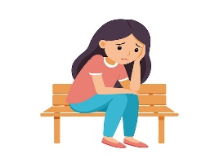**Read the sentences then match them with the correct pictures:**

|  |  |  |  |
| --- | --- | --- | --- |
| Big Image - Student Carrying Books Clipart - Free Transparent PNG ... |  | Boy Watering The Plant Illustrations, Royalty-Free Vector Graphics ... | robs - Clip Art Library |
| a-_I call my friend.  b-_I carry the books. | a-_She looks sad.  b-_She looks happy. | a-_I fix the hose.  b-_I water the plants. | a-_He robbed the house.  b-_He clapped his hand. |

1. **Grammar:**
   1. **Choose the correct answer:**

|  |  |
| --- | --- |
| 1-He **(play – plays – played)** soccer yesterday. | 4-She **(didn’t call – didn’t called)** her mom. |
| 2-He didn’t **(play – plays – played)** soccer. | 5-**(Does – Did)** hesend an e-mail last week? |
| 3-He **(laughs – laughed)** at my joke last night. | 6-Did you **(invite – invited)** your friends? |

* 1. **Do as shown between brackets:**
     1. **(Write the past form of the following verbs)**

|  |  |  |  |
| --- | --- | --- | --- |
| Base Form | Simple Past | Base Form | Simple Past |
| dream |  | play |  |
| stop |  | carry |  |
| plan |  | score |  |

1. **Vocabulary:**
   1. **Write the words under the correct pictures:**

**jump – worm – fix – drop – cry – clap**

|  |  |  |  |  |  |
| --- | --- | --- | --- | --- | --- |
| Royalty Free Boy Falling Clip Art, Vector Images & Illustrations - iStock | Jumping Clipart Images - Free Download on Clipart Library - Clip Art ... | Clapping Applause Drawing Hand Png Clipart Applause Arm Clap Images ... | 12 important things babies try to tell you | BuzzOh | Crying cartoon ... | Premium Vector | Cute pink smiling worm on white background concept of ... | Premium Vector | A flat vector design of spanner |
|  |  |  |  |  |  |

1. **Orthography:**
   1. 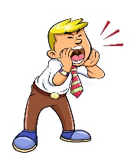**Fill in the missing letters:**

|  |  |  |  |  |  |  |
| --- | --- | --- | --- | --- | --- | --- |
| Cartoon Man Dreams of Money House and Luxury Car While Sleeping Vector ... | soccer net clipart 10 free Cliparts | Download images on Clipground 2024 |  | Premium Vector | Sad Girl Sitting On Bench Feeling Lonely and Worried | Funny Cartoon Monster Halloween Vector Illustration Mascot Silly Comic ... | Premium Vector | Vector illustration of planting trees in the garden | Kids Birthday Card/Invitation cards/Celebration card/Party Cards ... |
| d__eam | sc__re | shou__ | a__one | mo__ster | pl__nt | inv__te |

**Name:** ...................................                                                                                                    Ms. Tahani ☺

**Class:** 4th + 5th + 6th Elementary / ........

**Revision Sheet _ Unit (4): After-School Fun**

1. **General Questions:**
   1. **Match the questions with the correct answers:**

|  |  |  |
| --- | --- | --- |
| 1. Do you want to play hide and seek? |  | I go swimming. |
| 1. What activities do you do in your free time? |  | I usually do it on the weekend. |
| 1. Did you go shopping on Saturday? |  | Because I had to buy clothes. |
| 1. When do you do the activity? |  | No, I prefer to play board games. |
| 1. Why did you go to the shopping mall? |  | No, I didn’t. |

1. **Controlled Writing:**
   1. **Rearrange the words to form sentences or questions:**
      1. catch – I – ball – the

……………………………………………..

* + 1. took photos – zoo – at the – She

……………………………………………..

* 1. 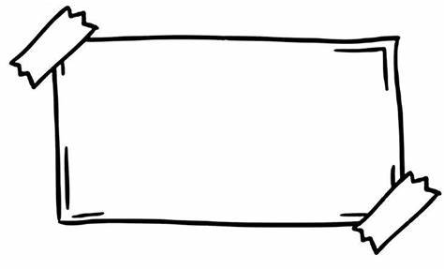**Complete the poster. Use the words in the box:**

**models – Enjoy – sports – fun – dress**

**AFTER-SCHOOL CLUB**

Come to the **after-school club**. It’s ……………..!

* Meet lots of new people.
* ……………… lots of different activities.
* Learn new things.

**Inside:**

Make ……………….. and ……………….. up

**Outside:**

Go swimming and play …………………..

1. **Reading Short Sentence:**
   1. **Read the sentences then match them with the correct pictures:**

|  |  |  |  |
| --- | --- | --- | --- |
| Happy Person Drawing PNG Transparent Images Free Download | Vector ... | Free Vector | Man athlete running in a race | Young woman vlogger 6911704 Vector Art at Vecteezy | OLA J4B Unit 8 Vocabulary | Baamboozle - Baamboozle | The Most Fun ... |
| a-_I play video games.  b-_I play board games. | a-_He walks slowly.  b-_He runs quickly. | a-_She likes vlogging.  b-_She likes texting. | a-_She talks loudly.  b-_She talks quietly. |

1. **Grammar:**
   1. **Choose the correct answer:**

|  |  |
| --- | --- |
| 1-He **(go – goes – went)** shopping yesterday. | 6-**(Does – Did)** hemake a model last week? |
| 2-He didn’t **(go – goes – went)** shopping. | 7-I can speak Arabic **(and – but – so)** English. |
| 3-He **(sleeps – slept)** late last night. | 8-I am hungry, **(and – but – so)** I order a burger. |
| 4-She **(didn’t see – didn’t saw)** amovie. | 9-I go to the hospital **(because – and)** I am sick. |
| 5-Did you **(take – took)** photos in the park? | 10-I like soccer, **(and – but)** I don’t like tennis. |

* 1. **Do as shown between brackets:**
     1. **(Write the past form of the following verbs)**

|  |  |  |  |
| --- | --- | --- | --- |
| Base Form | Simple Past | Base Form | Simple Past |
| go |  | see |  |
| take |  | sleep |  |

1. **Vocabulary:**
   1. **Write the words under the pictures:**

**present – seeds – vegetables – piano – dominoes – graduation**

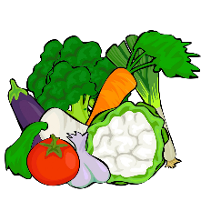

|  |  |  |  |  |  |
| --- | --- | --- | --- | --- | --- |
| watering coriander Seeds in a pot are Growing up is a soft shoot Flat ... | Graduation Free Clip Art - ClipArt Best | Present clipart 4 image - WikiClipArt |  | Dominoes Vector Illustration | AnnTheGran | Piano Clipart Pictures – Clipartix |
|  |  |  |  |  |  |

* 1. **Match the opposites:**
     1. quickly a- inside
     2. loudly b- quietly
     3. outside c- happily

d- slowly

1. **Orthography:**
   1. **Fill in the missing letters:**

|  |  |  |  |  |  |  |
| --- | --- | --- | --- | --- | --- | --- |
| Kids Music Vector Art, Icons, and Graphics for Free Download | Scout in Tent Theme Image 1 Stock Vector - Illustration of eps10 ... | What is a Preschool Teacher's Job Description? | 350+ Sign Language Words Drawings Stock Illustrations, Royalty-Free ... | Digital Library of Stories for Kids | Stories | Storyweaver | Text Message Clipart | Hand Drawn Cute Boy In Green Dinosaur Suit, Childhood, Cartoon ... |
| mu__ic | i__side | ho__scotch | fin__ers | h__de | te__ting | d__ess up |

**Name:** ...................................                                                                                                    Ms. Tahani ☺

**Class:** 4th + 5th + 6th Elementary / ........

**Revision Sheet _ Unit (5): Outdoor Fun**

1. **General Questions:**
   1. **Match the questions with the correct answers:**

|  |  |  |
| --- | --- | --- |
| 1. Which places in nature do you like visiting? |  | I can swim there. |
| 1. Could you ride a horse? |  | I like visiting the countryside. |
| 1. What did you do on your vacation? |  | I enjoy fishing and cycling. |
| 1. What can you do at the beach? |  | I went riding on my bike. |
| 1. What outdoor activities do you enjoy the most? |  | No, I couldn’t. |

1. **Controlled Writing:**
   1. **Rearrange the words to form sentences or questions:**
      1. He couldn’t – when – read books – he was three

……………………………………………..

* + 1. forgot – her backpack – She – to take

……………………………………………..

* 1. **Read and write. Use the words in the box:**

**field – desert – forest – hill – Earth**

* + 1. A place that has lots of trees. ( )
    2. The planet we live on. ( )
    3. A large green area where cows and sheep can live. ( )
    4. This is like a mountain, but much smaller. ( )
    5. Very dry land, usually with sand. ( )

1. **Reading Short Sentence:**

|  |  |  |  |
| --- | --- | --- | --- |
| Dry ground clipart 20 free Cliparts | Download images on Clipground 2023 | Man Riding Speed Boat Water Transport Graphic by aryo.hadi · Creative ... | Download Cave Png Clipart, Transparent Png is free transparent png ... |  |
| a-_It is a deep lake.  b-_It is a dry ground. | a-_I climb a mountain.  Premium Vector | Mountain vector artb-_I take a boat trip. | a-_We visit a cave.  b-_We walk in the forest. | a-_He runs fast.  b-_He rides a horse. |
| Premium Vector | Water mountain waterfall river vector nature cascade ... |  | Image result for  boat close to island clipart | cute little kids picnic together cartoon vector illustration 16883431 ... |
| a-_It is a lake.  b-_It is a waterfall. | a-_It is a high mountain.  b-_It is a low tide. | a-_It is close to island.  b-_It is far from island. | a-_We had a picnic.  b-_We took a photo. |

* 1. 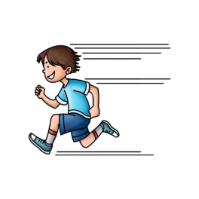**Read the sentences then match them with the correct pictures:**

1. **Grammar:**
   1. **Choose the correct answer:**

|  |  |
| --- | --- |
| 1-He went **(to shop – shopping)** yesterday. | 4-She wants **(to be – being)** a nurse. |
| 2-He decided **(to play – playing)** soccer. | 5- I could **(read – reading)** when I was 2. |
| 3-He hates **(to swim – swimming)** in the lake. | 6-I **(could – couldn’t)** speak when I was 1. |

1. **Vocabulary:**
   1. **Write the words under the pictures:**

**roller coaster – snail – dragon – lake – flag – backpack**

|  |  |  |  |  |  |
| --- | --- | --- | --- | --- | --- |
| Premium Vector | Cute cartoon dragon | blue flag clipart 10 free Cliparts | Download images on Clipground 2024 | Cartoon children on a rollercoaster - isolated - illustration for ... | 池塘 自然 湖 - 免费矢量图形Pixabay - Pixabay | Backpack Clipart Pictures – Clipartix | Funny, cute cartoon snail. Vector illustration. 557072 Vector Art at ... |
|  |  |  |  |  |  |

1. **Orthography:**
   1. 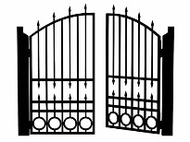**Fill in the missing letters:**

|  |  |  |  |  |  |
| --- | --- | --- | --- | --- | --- |
|  |  |  | roller skate images clipart 10 free Cliparts | Download images on ... | Compass East West North South Logo - Clip Art Library | Bird nest with egg clipart, Illustration of a Bird Nest with Egg ... |
| __ __ og | __ __ og | __ ate | __ __ ate | __ est | __ est |

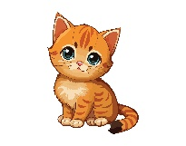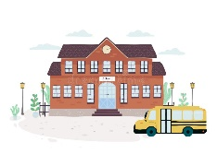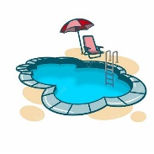

|  |  |  |  |  |  |
| --- | --- | --- | --- | --- | --- |
|  |  |  | Free Hat Clipart Pictures - Clipartix | King PNG Transparent Images | PNG All | Collection of PNG Sheep Cartoon. | PlusPNG |
| __ ool | __ __ __ ool | __ at | __ at | __ ing | __ __ eep |