
Kingdom of Saudi Arabia 4th, 5th & 6th Elementary Grade
Ministry of Education Time: An hour and a half
……… Elementary School Number of papers: 3 . Final Exam – Second Term – 1446 AH
- General Questions:
/ 6
- Choose the correct answer:
- What is your favorite story?
- I like to jump a rope b- Cinderella
- How was your day at school yesterday?
- It was great b- I played soccer
- Did you go shopping on Friday?
- Yes, I did b- Yes, she did
- What activities do you do in your free time?
- I usually do it on weekend b- I go swimming
- Could you ride a horse?
- Yes, I can b- No, I couldn’t
- What did you do on your vacation?
- I climbed the mountains b- It was boring

- Controlled Writing:
/ 5
- Fill in the missing words:
Earth – loudly – robbed – desert

  He talks (……………….) | 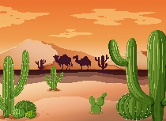  Very dry land, usually with sand.  (……………….) |   The planet we live on. (……………….) |   He (……………….) the house.

- Rearrange the words to form a sentence:
- forgot – her backpack – She – to take
……………………………………………………..

- Reading Short Sentence:
/ 4
- Read the sentences then choose the correct sentence for each picture:
 | 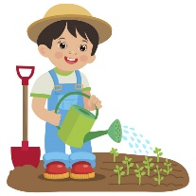 |  | 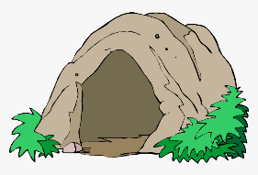
a-_I call my friend.  b-_I carry the books. | a-_I fix the hose.  b-_I water the plants. | a-_I play video games.  b-_I play board games. | a-_We visit a cave.  b-_We walk in the forest.

/ 5
- Grammar:
- Choose the correct answer:
- Did you (called – call) your friends?
- I like soccer, (and – but) I don’t like tennis.
- She (didn’t see – didn’t saw) a movie.
- He decided (to play – playing) soccer.
- I could (read – reading) when I was 2.

- Vocabulary:
/ 6
- Choose the correct answer:
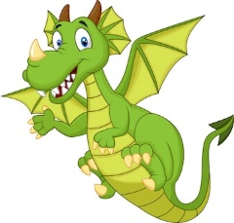 | 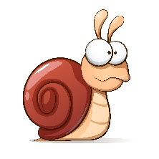 |  |  |  | 
- island  - dragon | - snail  - frog | - rope  - present | - homework  - graduation | - clap  - paint | - cry  - carry

- Orthography:
/ 4
- Choose the correct missing letters:
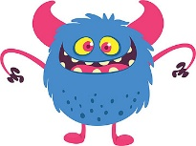  mo__ster |  | 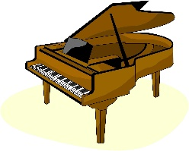  pi__no |  |   __ing |  | 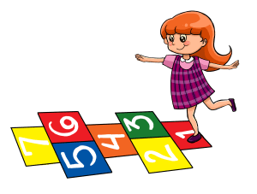  ho__scotch
m | n | a | e | j | k | p | q
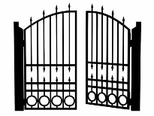  __ate |  |   te__ting |  | 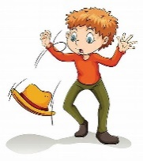  dr__p |  | 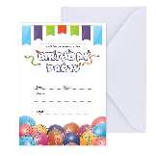  in__ite
g | r | x | k | o | u | f | v

BEST OF LUCK
Ms. Tahani Al-Ghamdi



اختبار نهاية الفصل الثاني ( الدور....)
للعام الدراسي 1446هـ
المادة /اللغة الانجليزية
الصف :رابع، خامس،سادس (.......)
زمن الإجابة / ساعة ونصف
التاريخ : 12/7/1443 هـ

المملكة العربية السعودية
وزارة التعليم
الإدارة العامة للتعليم بالمنطقة الشرقية
مكتب التعليم بالخبر
مدرسة ....................

30

الدرجة كتابة :

``
اسم الطالب ……………………………………………………………………….……………………………………………رقم الجلوس …………………………
Answer the general questions:

- What do you like to do for fun?

I like to climb ……………………
- Did you win?
No, we………………..
- Which activities do you do in your free time?
I like to play………………………….. games.
- Can you run quickly?
Yes, I …………………….
5- Which places in nature do you like visiting?
I like to visit ………………….
- Could you swim when you were six?
Yes, I…………………..

Reorder the words:

- the books! / drop / Don’t
………………………………………………………………………………………………………………………………....
- jumped / the rope. / She
………………………………………………………………………………………………………………………………….
- play / I want to / board games.
…………………………………………………………………………………………………………………………………..
- Did you / the car. / fix
………………………………………………………………………………………………………………………………….
- Happily. / playing / She is
…………………………………………………………………………………………………………………………………..
Match the questions to their answers:


1-What is your favorite story? Yes, I did. I like football.
2- Did you play football today? My favorite story is the city mouse.
3-Do you want to make a model? No, I couldn’t
4-Could you ride a horse? No, I want to play hide and seek.

أقلب الورقة
Choose the correct words:
- I ( score – scored) three goals yesterday.
- She didn’t ( drop – dropped ) the cup.
- Did he ( play – played ) video games last night.
- I want to go out, ( but – and ) it’s raining now.
- He’s walking ( quick – quickly ).

Circle the correct word:
fixed  e-mailed | 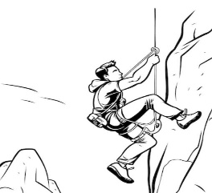  climbed  invited |   cave  Earth | 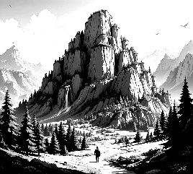  loudly  mountain | 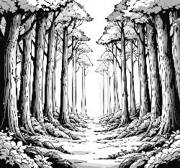  robbed  forest | 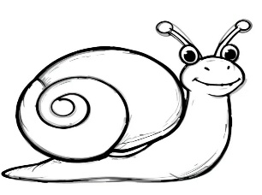  vlogging  snail
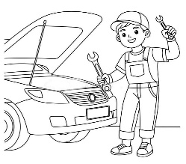

Circle the missing letter:
  Tex_ing  n  t | 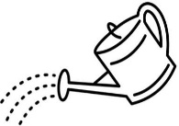  Wate_ed  s  r | 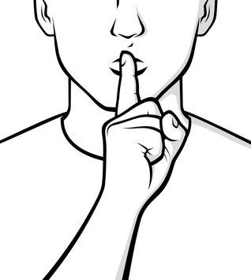  Qu_etly  i  g | 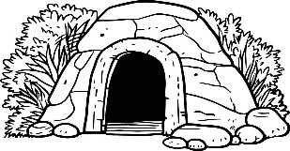  Ca_e  v  z

انتهت الأسئلة

المملكة العربية السعودية  وزارة التعليم  الإدارة العامة للتعليم بمحافظة ............ |  | اختبار مادة (اللغة الانجليزية) الفصل الدراسي الثاني للعام الدراسي 1446 هـ للصف الرابع والخامس والسادس
مدرسة ............................... |  | الدرجة من 30 /
الزمن / ساعة ونصف |  | المصحح / المراجع/
الاسم / الصف / رقم الجلوس :( )

***********************************************************************************************************
انتهت الأسئلة
مـع أطيب أمنياتي لكم بالنجاح
معلم المادة : فكري عبدالله بوصبيح

