

English Language

Intermediate Grade 1st

period Exam

………\20

Kingdom of Saudi Arabia

Ministry of Education

………..Education Directorate

………………… Intermediate School

Student's Name : class:

**Reading comprehension ✦**

[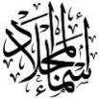](https://t.me/Asmaworld)

……\ 5 marks

1-Read the following passage and answer the questions below:

Ahmad goes to the gym every evening. He likes to exercise and stay healthy. At the gym, he runs on the treadmill and lifts weights. Sometimes, he also does yoga. After his workout, Ahmad drinks water and eats a banana. He feels happy and strong after going to the gym.

|  |  |  |
| --- | --- | --- |
| 1-When does Ahmad go to the gym? | | |
| c- every week. | b- every evening | a- every morning |
| 2-At the gym, Ahmad ………… on the treadmill. | | |
| c- jumps | b-runs | a- walks |
| 3- After his workout, Ahmad drinks …………. | | |
| c- orange juice | b- coffee | a- water |
| 4- What does Ahmad eat after his workout? | | |
| c- a banana | b- an apple | a- burger |
| 5- How does Ahmad feel after going to the gym? | | |
| c- happy | b- sad | a- angry |

……\ 4 marks

**Grammar**  ✦

**A. Choose the correct answer.**

|  |  |  |  |
| --- | --- | --- | --- |
| c- wearing | b- wears | a- wear | 1- I'm going to ………. jeans. |
| c- going | b- goes | a- go | 2- We like to ………… shopping. |
| c- play | b- playing | a- plays | 3- I can …………………chess. |
| c- watch | b- watches | a-watching | 4- We are…….a film on TV this evening. |
| c- Am | b- Is | a- Are | 5-……… you going to go to Dubai? |
| c- books | b- booking | a- book | 6- Amal is……….the restaurant tonight. |
| c- doesn't | aren't b- | a- don't | 7- John ………….like to ride horses. |
| c- swim | b- swims | a-swimming | 8- They enjoy ………… in the summer. |

……\ 2 marks

**B. Do as shown between brackets.**

**1-Correct**

a- You can **speaks** English. …………………….

b- He is **wash** his car on Wednesday. …………………… ……………………….

Turn the page

**2- ( Give the negative ).**

……\ 2 marks

a-Omar likes to fish

………………………………………………………………..……………



**3-Make ( yes or No ) question.**

a-They are going to buy a tie for their dad.

.………………………………………….…………..?

.

✦  **Vocabulary**

……\ 5 marks

**A.Match the correct word for each picture.**

ice-skate forest socks boots

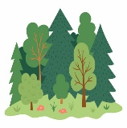

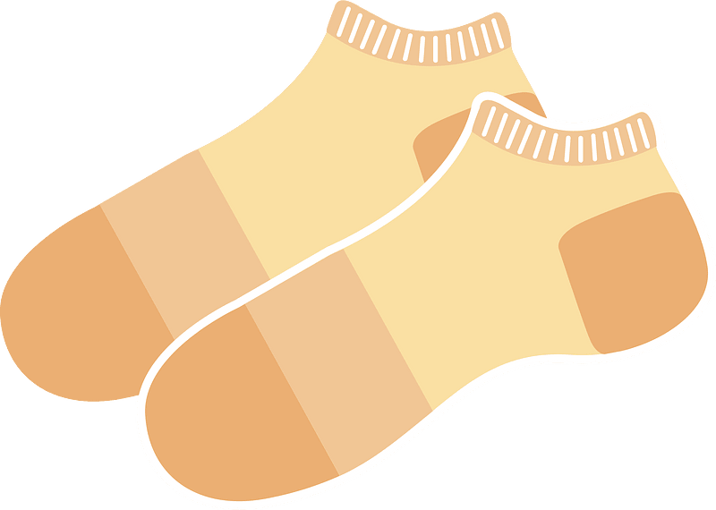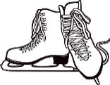

………………..

………………..

………………..

………………..

**B-choose the correct answer.**

1- a-a place you can go shopping and meet friends ( mall – hospital – school).

2- Saudi men wear ( thobe- suit – tie ).

3- a place you can fly to places. ( airport - bus station – park).

**✦ Orthography**

**Choose the corre**

……\ 2 marks

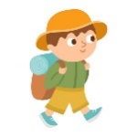**A-Write the missing letters.**

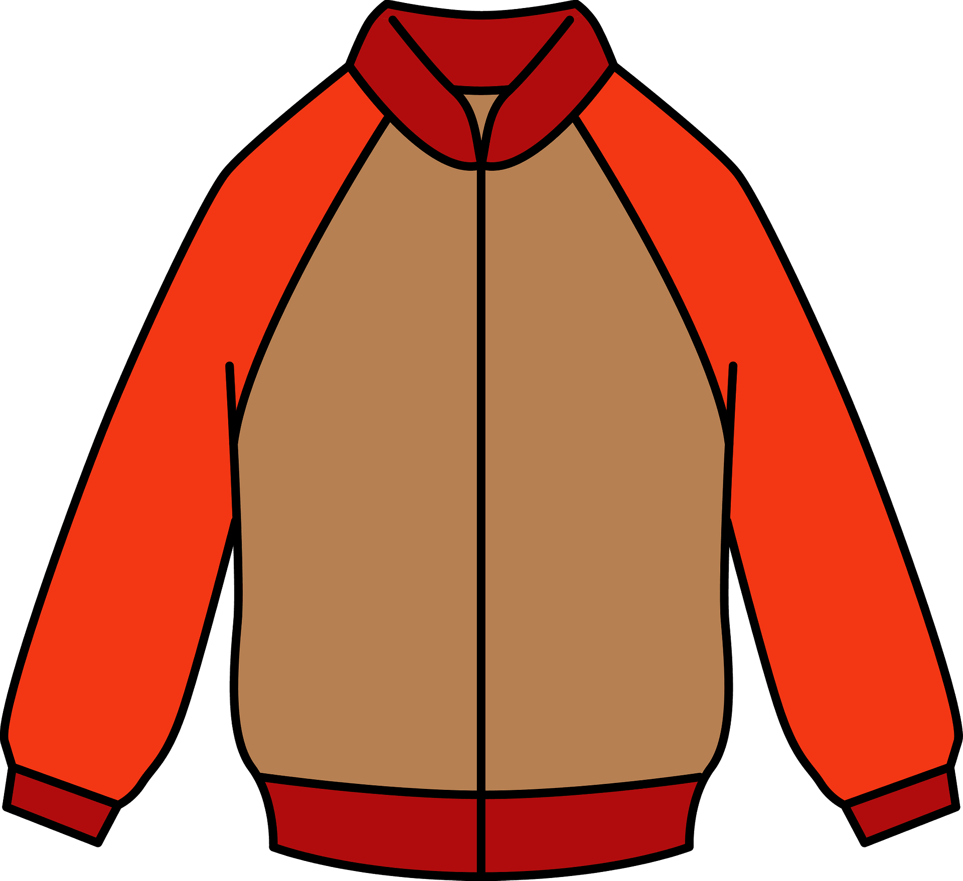

2-Jacke…

1-Hi…….ing

**B.Choose the missing letters.**

1- They ate in an Italian restauran…. ( t – o – I )

2- Basketball players wear snea…ers. ( k – d – f )

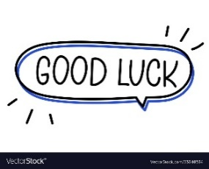

Your teacher …..:…………………………….

Kingdom of Saudi Arabia Name: ……………………………

Ministry of education Class: 1st Intermediate Grade

**20 /**

Hefar Intermediate School Mid-Term Exam Third Term

1. **Comprehension:**

**Read the passage to answer the questions below:**

Jenny is a beautiful eight-year-old girl. She has black hair and brown small eyes. Jenny loves books. She loves reading a lot. She is in third grade. She reads all the time: morning, afternoon, and night. She reads for everybody: mom, dad, sister, brother, grandma, teachers, and friends. She likes to read about places but she loves to read about animals.

1. **Choose the correct answer:**
2. This text is about ………………
3. Jenny’s family b- Jenny’s hobby c- Jenny’s cat
4. Jenny is ……… years old.
5. 8 b- 9 c- 10
6. **Check ( T ) or ( F ) :**
7. Jenny has brown hair and black eyes. ( )
8. Jenny reads for her parents only. ( )
9. **Grammar:**
10. **Choose:**
11. I can **(speak – speaks – speaking)** English.
12. Do you enjoy **(go – to go – going)** to football matches?
13. He **(visits – is going to visit – visiting)** his uncle next week.
14. She is wearing a **(red new shoes – new red shoes – shoes red new)**.
15. **Do as shown between brackets:**
16. I want **(buy)** some stickers. (**Correct the verb)**

…………………………………………………………

1. Talal is going to buy a car.  **(Change into negative)**

…………………………………………………………

1. **Vocabulary:**
2. **Write the words under the pictures:**

**fish – rollerblade – dress – graduation – sneakers**

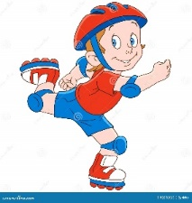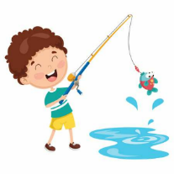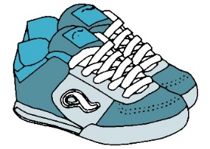

_____________ _______________ ________________ ______________

1. **Classify the words:**

**hotel – skirt – tie – bookstore**

|  |  |
| --- | --- |
| **Clothes** | **Places in a town** |
|  |  |

1. **Orthography:**
2. **Choose the correct missing letters:**
3. Today’s football **ma__ch** is France versus Brazil.

|  |  |  |
| --- | --- | --- |
| 1. s | 1. t | 1. n |

1. You can go shopping and meet friends. This place is a **m__ll**.

|  |  |  |
| --- | --- | --- |
| 1. a | 1. o | 1. i |

1. The color of my school **uni__orm** was dark green.

|  |  |  |
| --- | --- | --- |
| 1. c | 1. m | 1. f |

1. In the summer, Ali wears shorts and **san__als**.

|  |  |  |
| --- | --- | --- |
| 1. b | 1. d | 1. p |

**Good Luck ☺**

**Ms. Tahani Al-Ghamdi**



English Language

Intermediate Grade 1st

period Exam

Kingdom of Saudi Arabia

Ministry of Education

………..Education Directorate

………………… Intermediate School

Student's Name : class:

**Reading comprehension ✦**

……\ 5 marks

1-Read the following passage and answer the questions below:

Omar is a teacher at a small school. He goes to his work by car. He teaches children. He has 21 children in his class. He likes them too much, and they like him too. He is very patient and helps them a lot. He is a very good teacher.

[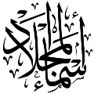](https://t.me/Asmaworld)

|  |  |  |
| --- | --- | --- |
| 1- Omar is a …………………. | | |
| c- farmer | b-doctor | a-teacher |
| 2- Omar works at small…………… | | |
| c-hospital | b- house | a- school |
| 3- He goes to his work by ……………… | | |
| c- car | b- bus | a- train |
| 4- He has …………. children in his class. | | |
| c- 13 | b-21 | a-200 |
| 5- He is a very ………..teacher. | | |
| c- good | b- big | a- bad |

**Grammar**  ✦

……\ 4 marks

**A. Choose the correct answer.**

1-They enjoy ( swim – swims – swimming) in the summer.

2- I can ( play – plays – playing ) chess.

3- I'm going to ( wear – wearing – wears ) jeans.

4-We like to ( goes – going – go) shopping.

5-We are (watch - watching – watched )a film on TV this evening.

6- Amal is( book – books – booking) the restaurant tonight.

7-John ( isn't – don't – doesn't ) like to ride horses.

8-( Are – Am – Is ) you going to go to Dubai?

**B. Do as shown between brackets.**

**1-( Correct)**

a-You can **speaks** English. ………………………….

b- He is **wash** his car on Wednesday. ……………………

**3- ( Give the negative ).**

a-Mark is going to wear jeans.

…………………………………………………………

**4-(Make yes or No question).**

a-He can drive a bus.

…………………………………………………………?

**3-(reorder)**

a-Ali wears a ( lovely , leather , black ) shoes .

……………………………………………………………………………….……………………

……\ 4 marks

**A-choose the correct answer.**

1- a place you can go shopping and meet friends ( mall – hospital – school).

2-Saudi men wear ( thobe- suit – tie ).

3- a place you can fly to places. ( airport - bus station – park)

4- In the summer, Ali wears shorts and ( boots – jacket – sandals ).

**B- Write the correct word under each picture**

✦  **Vocabulary**

……\ 5 marks

ice-skate coat - socks - forest -

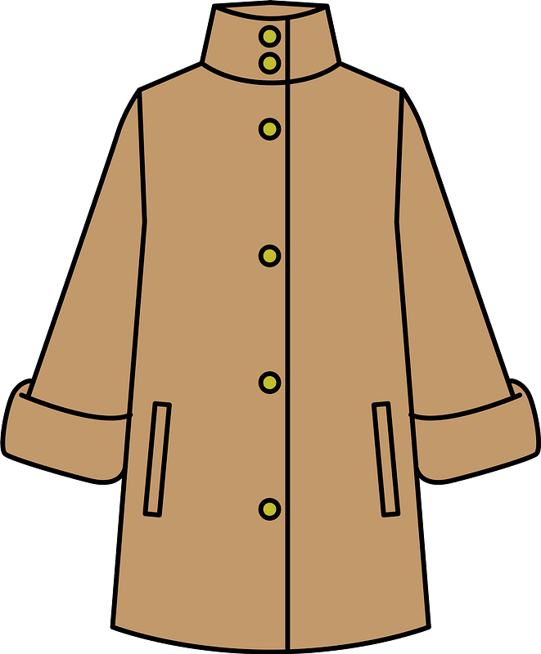

…………………………

…………………………

…………………………

…………………………

**C-Find the odd words.**

1- bank school writer

2- shirt boots sandals

**✦ Orthography**

**Choose the corre**

……\ 2 marks

**A. Choose the missing letter.**

1-A businessman usually wears a suit and a …ie. ( s – t – p )

2- They ate in an Italian restauran…. ( t – o – I )

3- He goes to the gy…. every day. ( b – m – z )

4- Is it better to have a rain…oat or an umbrella? ( v – c – a)

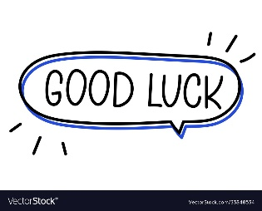

The end of the questions

Good luck

Your teacher ………………………

Your teacher:



English Language

Intermediate Grade 1st

period Exam

Kingdom of Saudi Arabia

Ministry of Education

……………… intermediate school

Student's Name : class:

|  |
| --- |
|  |
| 5 |

1-Read the following passage and answer the questions below:

My favorite mall is Al-Othem shopping Centre . It is in Riyadh .It is very big and it has two floors. There are many shops . It also has a large supermarket . There are many places that sell tasty food. Shopping in Al-Othem is easy .

**A-Choose the correct answer:**

1-Al-Otheim shopping Centre is in …………………………..

a- Riyadh b-Jeddah c- Abha

2-There is a large ………….. in AL-Otheim shopping Centre .

a-bookstore b-bank c-supermarket

3- It is very big it has ………………………. floors.

a- two b-five c-three

**B) Put (√ ) or (×):**

1- Shopping in AL-Othem is easy . ( )

2- There aren't any restaurant . ( )

|  |
| --- |
|  |
| 5 |

**2-choose the correct answer**

1- We like to ( goes – going – go) shopping.

2- I'm going to ( wear – wearing – wears ) jeans.

3-( Are – Am – Is ) you going to go to Dubai?

4- I can ( play – plays – playing ) chess.

5- Amal is( book – books – booking) the restaurant tonight.

6- They enjoy ( swim – swims – swimming) in the summer.

7- He’s going to ( taking – takes – take) light clothes.

8- John ( isn't – don't – doesn't ) like to ride horses.

9- We are (watch - watching – watched )a film on TV this evening.

10- She can't stand ( cook – cooking – cooks ).

|  |
| --- |
|  |
| 6 |

**3. Do as shown between brackets.**

**A-(Correct)**

1-You can **speaks** English. …………………….

2- He is **wash** his car on Wednesday. ……………………

3- I would like to **buying** a new laptop. …………………

4- I’m going to **meeting** my friends. ………………..……

**B-(answer )**

a- Can Fred drive a bus?

No, …………………………………………………….

**C- ( Give the negative ).**

a-Omar likes to fish.

…………………………………………………………

**D-(reorder)**

a- She / going / a new dress / is / to buy

………………………………………………………………………………………………………………..…….

b- -Ali wears a ( lovely , leather , black ) shoes .

……………………………………………………………………………………………………………………….

|  |
| --- |
|  |
| 4 |

4- **choose the correct answer.**

a- a place you can fly to places. ( airport - bus station – park)

b- Saudi men wear ( thobe- suit – tie ).

**5-Write the missing letters.**

1- mu…….eum 2- restaura……t.

6-**write the correct word for each picture.**

pants boots socks skirt

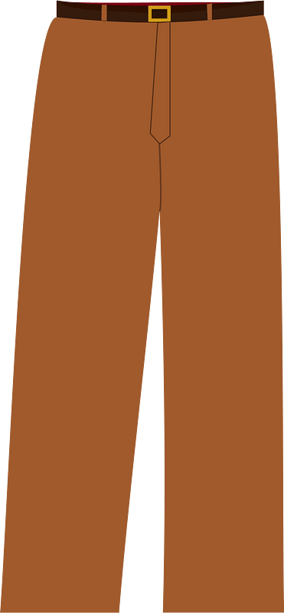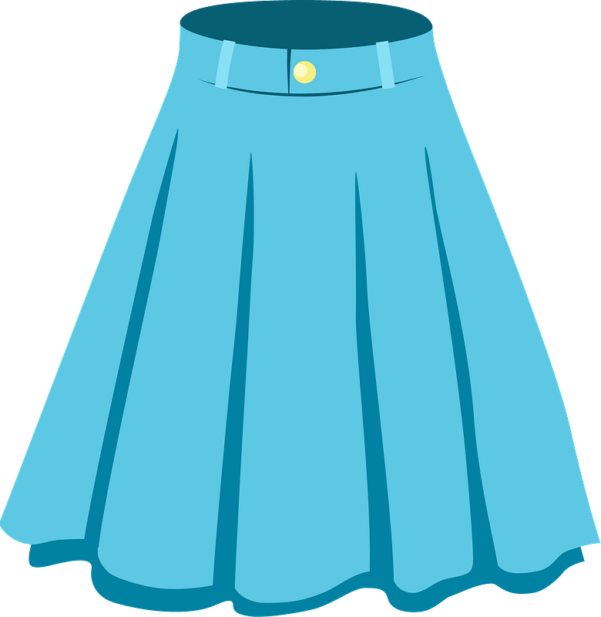

………………..

………………..

………………..

………………..



Your teacher



Kingdom of Saudi Arabia

Ministry of Education

………… Education Directorate

……………….. Intermediate School

**Super Goal 1** - **Test** unit 12 & 13

By **Rashed Alsulami** | **Telegram:** https://t.me/iRashed

Name :………………………………………………………………………… Class:…….……….

**Comprehension**

2 Marks

* **Read the text and answer the questions. Write T or F at the end of each question/statement.**

I like to go to the sports center. I go there every weekend. At the sports center, you can do many things. For example, you can play golf or tennis. There is a pool, so you can also swim or relax by the pool. There is a beach next to the sports center. You can swim, water-ski, or windsurf in the ocean. You can also sail on windy days. There aren’t any fish near the beach, so you can’t snorkel. When I go to the sports center, I like to play volleyball on the beach. I also like to jog on the beach. I can’t swim well, so I don’t like to water-ski or windsurf.

1. The writer likes the sports center. ( )
2. You can swim in the pool or in the ocean. ( )
3. People can windsurf in the pool. ( )
4. You can’t use a boat in the ocean.( )

**Grammar**

* **Choose the best answer to fill in the blank in each question.**

5 Marks

1. He can’t surf, but he _____ water-ski.

**a**. can’t **b**. can  **c**. not can **d.** don’t can

1. **Jill:** Does she like to cook? **Kate:** No, _____.

**a**. she does **b**. she don’t  **c**. she doesn’t **d.** doesn’t she

1. I’d like _____ a new laptop, but I can’t afford one. (buy)

**a**. to buy **b**. buy  **c**. buy to  **d.** bought

1. I’m not going to buy jeans. ____________ pants.

**a**. I buying **b**. I’m going to buy **c**. I’m going buying **d.** I going to buy

1. He ____________ a big wedding.

**a**. is have **b**. having **c**. going to have **d.** is going to have

**اقلب الصفحة**



* **Write the gerund or infinitive of the verb in parentheses to fill in the blank.**

1. I’d like _________ a new laptop, but I can’t afford one. (buy(

1.5 Marks

1. Hameed enjoys ____________ volleyball at the beach. (play)
2. Amal spends her free time _________________ books. (read)

* **Write the correct answer to fill in the blank.**

1.5 Marks

1. **Mei:** _______________ you going buy a new dress? **Lisa:** No, I’m not.
2. **Ella:** _____________ are you going to wear?  **Laura:** A black skirt.
3. **Tim:** Are they going to wear jackets? **Harry:** Yes, ______.

**Vocabulary**

* **Choose the best answer to fill in the blank in each question.**

5 Marks

1. You can _____ at the pool.

**a**. swim **b**. surf  **c**. rollerblade **d.** sail

1. I sometimes _____ my bike to work.

**a**. ride **b**. drive  **c**. go **d.** get up

1. Do you need to buy new ____________ to play basketball.

**a**. suit **b**. shirt  **c**. sneakers  **d.** blouses

1. It’s hot. Are you going to wear ____________?

**a**. jeans  **b**. shorts **c**. coat **d.** jacket

1. Women should wear a formal _______to a wedding.

**a**. tie **b**. suit **c**. thobe  **d.** dress

* **Write the correct word under the picture.**

3 Marks

Skirt – Boots – Gym



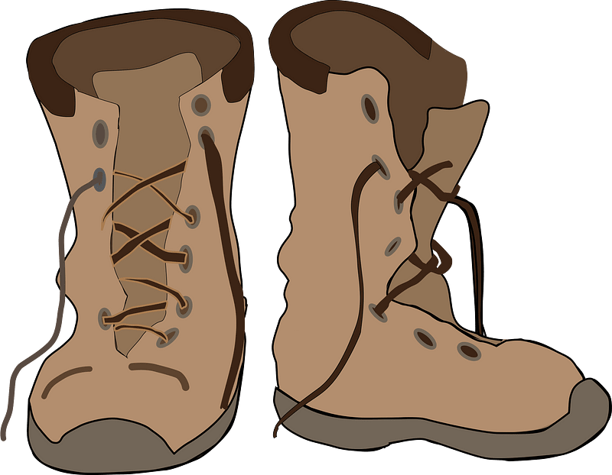

………………………………………….

………………………………………….

………………………………………….

**Orthography**

* **Choose the correct letter.**

2 Marks

* You can go sho…..ping and meet friends. ( v – p – r)
* You need warm clothes it’s …..old in Abha ( n – o – c)

**انتهت الأسئلة....**

**التوفيق والنجاح دوماً في طريقكم أبنائي.. تذكروا دائماً بأنني فخور بكم فأنتم مستقبل هذا الوطن الغالي إن شاء الله ونجاحكم هو نجاحي..**

**الأستاذ / راشد السلمي**



**Kingdom of Saudi Arabia**

**Ministry of Education**

**………… Education Directorate............**

**…………..……………….. Intermediate School**

|  |
| --- |
|  |
| **20** |

**Total**

**Midterm Test units 12 & 13**

|  |
| --- |
| **First Intermediate Grade** |

**Name ………………………………… Class ………………………………**

__________________________________________________________________________________________

/ 4

**Comprehension**

**Read the following then answer the questions:**

My favorite mall is Al-Othaim shopping Centre. It is in Riyadh. It is very big and it has two floors. There are many shops. It also has a large supermarket. There are many places that sell tasty food. Shopping in Al-Othaim is easy.

**A- Put (√ ) for true or ( ᵡ ) for false :**

|  |  |
| --- | --- |
| **( )** | **1. Shopping in Al-Othaim is easy**. |
| **( )** | **2. There aren't any restaurant**. |

**B- Choose the right answer:**

|  |  |  |  |  |
| --- | --- | --- | --- | --- |
| **Tabuk** | **Abha** | **Jeddah** | **Riyadh** | **1-**The shopping Centre is in ______. |
| **five** | **three** | **two** | **four** | **2-**It has ___ floors. |

_________________________________________________________________

/ 5

**Grammar**

**Choose the right answer:**

|  |
| --- |
| **1-**  I _____ play volleyball, but I can play tennis **.** |
| A**. am** B**. can't** C**. can** D**. do** |
| **2** - Do they like to relax on the beach? Yes, ____ ___. |
| A**. I can .** B**. I do .** C**. they do.** D**. he does.** |
| **3 -**  I’d like _____ a new laptop. |
| A**. to buy** B**. buying** C**. buy** D**. buys** |
| **4 -**  We are _________ go to the zoo tomorrow. |
| A**. doing** B**. going** C**. going to** D**. go to** |
| **5 -**  Sara ____ going to wear a dress in the wedding. |
| A**. am** B**. are** C**. is** D**. she** |

/ 4

**Vocabulary**

**A- Choose the best answer to fill in the blank:**

|  |  |  |  |
| --- | --- | --- | --- |
| 1. Jack can _____ a boat. | | | |
| D. sail | C. **water-ski** | B. **kite surf** | A. **swim** |
| 2. A place you can fly to places. | | | |
| D. **park** | C. **Bus station** | B. **Airport** | A. **Train station** |
| 3- I need to put on my ____________. My feet are cold. | | | |
| D. **shorts** | C. **shirt** | B. **shoes** | A. **coat** |
| 4- You need_____clothes. It’s cold in Abha. | | | |
| D. **formal** | C. **warm** | B. **cold** | A**. hot** |

**B- Put the right word under its picture:**

|  |  |  |  |
| --- | --- | --- | --- |
| 840+ Pair Of Ice Skates Stock Photos, Pictures & Royalty-Free Images -  iStock | Pair of ice skates icon | Gym Room stock vector. Illustration of lifestyle, equipment - 34028667 | tie | ‪Dress Cartoon Images – Browse 468,137 Stock Photos, Vectors, and Video |  Adobe Stock‬‏ |
|  |  |  |  |

**Gym , Tie , Dress , Ice-skate**

/ 4

_______________________________________________________________________________

/ 3

**Orthography**

**Choose the correct letter:**

|  |  |  |  |
| --- | --- | --- | --- |
| **g** | **k** | **v** | 1. Fred plays bas__etball. |
| **r** | **b** | **d** | 2. I’m going to a we__ding on the weekend. |
| **n** | **h** | **f** | 3. The weat__er is very hot. |

Good luck T.