Kingdom of Saudi Arabia Third Elementary Grade

Ministry of Education Third Term

**20**

3rd Elementary School . . . Mid-Term Exam 1446 AH

**Name:** ………………………………………………………….………………. **Class: …………..**

|  |  |  |  |  |  |  |  |  |  |  |  |  |  |  |  |
| --- | --- | --- | --- | --- | --- | --- | --- | --- | --- | --- | --- | --- | --- | --- | --- |
| 1. **General Questions:** | | | | | | | | | | | | | | | |
| 1. **Match the questions with the correct answers:** | | | | | | | | | | | | | | | |
| 1- What’s the matter? | | | | | | |  | | It is 60 Riyals. | | | | | | |
| 2- How much is this skirt? | | | | | | |  | | Yes, it does. It has a big yellow bus. | | | | | | |
| 3- Which city do you live in? | | | | | | |  | | I have a stomachache. | | | | | | |
| 4- Does your school have a school bus? | | | | | | |  | | I live in Al-Lith. | | | | | | |
| 1. **Controlled Writing:** | | | | | | | | | | | | | | | |
| 1. **Rearrange the words to form a sentence:** | | | | | | | | | | | | | | | |
| to – Listen – teacher – the | | | | | | | | | | | | | | | |
|  | | | | | | | | | | | | | | | |
| 1. **Reading short sentence:** | | | | | | | | | | | | | | | |
| 1. Little boy suffering from headache or migraine touching his forehead ...**Read the sentences then choose the correct sentence for each picture:** | | | | | | | | | | | | | | | |
| |  |  |  |  | | --- | --- | --- | --- | | No Talking Sign Stock Vector - Image: 51426412 |  | Premium Vector | Cartoon illustration of cute sheep |  | | a-_Don’t shout  b-_Do your homework | a. I have a toothache.  b. I have a headache. | a. I have a little cat.  b. I have a little lamb. | a. I brush my teeth.  b. I eat breakfast. | | | | | | | | | | | | | | | | |
| 1. **Grammar:** | | | | | | | | | | | | | | | |
| 1. **Choose the correct answer:** | | | | | | | | | | | | | | | |
| 1. Last year Sara ………….. Arabic. | | | | | | | | | | | | | | | |
| 1. like | | | | | 1. likes | | | | | | 1. liked | | | | |
| 1. I didn’t ………… milk this morning. | | | | | | | | | | | | | | | |
| 1. drink | | | | | 1. drinks | | | | | | 1. drank | | | | |
| 1. **Vocabulary:** | | | | | | | | | | | | | | | |
| 1. BenQ MX560 XGA Business Projector Price in Bangladesh**Choose the correct answer:** | | | | | | | | | | | | | | | |
|  | | | ملصقات تعليم education stickers | Aritmética, Simbolos matematicos ... | | | | Belt PNG Transparent Images Free Download - Pngfre | | | | | | Premium Vector | Poses and expressions of a funny boy | | |
| 1. projector 2. computer | | | 1. science 2. math | | | | 1. trousers 2. belt | | | | | | 1. grumpy 2. sleepy | | |
| 1. **Orthography:** | | | | | | | | | | | | | | | |
| 1. **Choose the correct missing letters:** | | | | | | | | | | | | | | | |
| Squeeze Stock Illustrations – 19,228 Squeeze Stock Illustrations ...  **__ __ ueeze** | | roller skates clip art 10 free Cliparts | Download images on Clipground ...  **__ __ ate** | | | | Premium Vector | Hand drawn Halloween scary sketch of ghost isolated on ...  **__ __ ary** | | | | 56 Free Hamburger Clipart - Cliparting.com  **b __ __ ger** | | | | Download High Quality bird clipart cartoon Transparent PNG Images - Art ...  **b __ __ d** | |
| **sk** | **sq** | **sc** | | **sk** | | **sc** | | **sq** | | **ir** | | **ur** | | **ir** | **ur** |

**BEST OF LUCK ☺**

**Ms. Tahani Al-Ghamdi**

**المملكة العربية السعودية المادة: لغة انجليزية**

**وزارة التعليم اختبار فتري للفصل الثالث 1446هـ**

**إدارة التعليم بمنطقة مدرسة :**

|  |  |  |
| --- | --- | --- |
| **المجموع: 20 /** | **الصف: الثالث** | **الاسم:** |

**Choose the right answer:**

______________________________________________________________________________

|  |  |  |
| --- | --- | --- |
| **No, I am not.** | **About 500.** | How many students are there in your school? |

**Read then circle (✔) or (✖):**

|  |  |  |  |
| --- | --- | --- | --- |
| 1- Don't shout. |  | ✔ | ✖ |
| 2- I have a headache . | صورة تحتوي على شخص, الوجه الإنساني, بشرة, حائط  قد يكون المحتوى المعد بواسطة الذكاء الاصطناعي غير صحيح. | ✔ | ✖ |

______________________________________________________________________________

**Do as shown between brackets:**

|  |  |  |
| --- | --- | --- |
| ______________________________ | | **1–** in – lives – He - Riyadh **. ( rearrange )** |
| **Shout** | **Speak** | **2-**  ----------- English in class. **( choose )** |

______________________________________________________________________________

**Choose the right word :**

|  |  |  |
| --- | --- | --- |
| **got up** | **get up** | 1- did you _________ this morning? |
| **went** | **go** | 2- Last week we ______ to Abha . |
| **did** | **do** | 3- Did you eat breakfast? yes, I ______. |

______________________________________________________________________________

**Choose the correct word**:

|  |  |  |  |  |  |  |
| --- | --- | --- | --- | --- | --- | --- |
| صورة تحتوي على نافذة أو شباك, منزل, مستطيل, ساعة حائط |  | صورة تحتوي على تلبيس, شخص, رسوم متحركة, توضيح | صورة تحتوي على علم | Black And White Cartoon Math Symbols Stock Illustration - Download Image  Now - Bizarre, Book, Clip Art - iStock | [هذه الصورة](https://www.pngall.com/skirt-png/download/38267) بواسطة كاتب غير معروف مرخصة بالاسم [CC BY-NC](https://creativecommons.org/licenses/by-nc/3.0/) | Lights in the Heights t-shirt designs needed | Clipart black and white,  Blank t shirts, T shirt |
| **school** | **PE** | **earache** | **bag** | **math** | **belt** | **T-shirt** |
| **language** | **Art** | **toothache** | **flag** | **science** | **skirt** | **scarf** |

______________________________________________________________________________

**Fill in the missing letters:**

|  |  |  |  |  |
| --- | --- | --- | --- | --- |
| Free Square Clipart & Cartoon｜Illustoon | White clouds with shadow on black sky background. eps Ai 10 illustration,  could be used in several ideas and topics like cloud computing, weather  condition, child room wall background, cartoons. Stock Vector | | Pin em Free Clipart Download | Cartoon Cute Bird Isolated On White Background Stock Vector Image by  ©Aratehortua #177005352 | Document Scanning Cartoon Stock Illustrations – 187 Document Scanning  Cartoon Stock Illustrations, Vectors & Clipart - Dreamstime |
| **__ __ uare** | _ _ **y** | **b** _ _ **ger** | **b** _ _**rd** | _ _ **an** |
| **sq** | **sk** | **ur** | **ur** | **sk** |
| **sc** | **sq** | **ir** | **ir** | **sc** |



Kingdom of Saudi Arabia

Ministry of Education

……..Education Directorate

………………… School

English Language

elementary Grade …..

period Exam

…………….\20

Student's Name : class:

……\ 4 marks

General questions

**A.Answer the questions**

[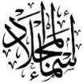](https://t.me/Asmaworld)**1-How many students are there in your school?**

a-About 500 b- sorry c- Littlerock Elementary School.

**2-** **What‘s the matter?**

a-I like pizza. b-I have a stomachache. c-I'm 12 years old.

**3-Which city do you live in?**

a-I'm 11 years old b- I live in Najran c-We bring our own.

**4-Did you drink milk this morning?**

a-Yes, I can b- Yes, I do c-Yes, I drank milk this morning.

……\ 1 marks

Controlled Writing

**A. Choose the correct answer**

|  |  |  |  |
| --- | --- | --- | --- |
| kitchen | bed room | library | 1-The best place in our school is ………… |
| write | book | drink | 2- I should …………a lot of water. |

Reading short sentence

……\ 4 marks

|  |  |  |
| --- | --- | --- |
| Free stomach aches, Download Free stomach aches png images, Free ClipArts  on Clipart Library | 1- I have a headache ( ) | |
| Kids Sports Day clipart | 2- This year I like P.E ( ) |

**A-Put (** ✔ **) or (**  X  **)**

**B.Match**

|  |  |  |
| --- | --- | --- |
| English in class! |  | 1- She has a toothache |
| because she never goes to the dentist. |  | 2-Use |

……\ 4 marks

Grammar

[](https://t.me/Asmaworld)**A-Choose the correct answer.**

1- You should ( do – did – does ) some exercise.

2- Last year we( go - went - goes ) to Riyadh.

3- I didn‘t (brush – brushes – brushed )my teeth this morning.

4-( Who – When - Which )subject do you like most this year?

……\ 5 marks

Vocabulary

**A.write the correct word under each picture**

**( scan – sweater - lamb - science - soda )**

**)**

|  |  |  |  |  |
| --- | --- | --- | --- | --- |
| Free Science Class Cliparts, Download Free Science Class Cliparts png  images, Free ClipArts on Clipart Library | 28 Pepsi Stock Illustrations | Depositphotos |  | Sheep Lamb Watercolor Clipart AI Generated 24637624 PNG | Cartoon knitted hand made autumn sweater. Vector ugly autumn sweater clipart  28003408 Vector Art at Vecteezy |
|  |  |  |  |  |

Orthography

……\ 2 marks

**A. Fill in the missing letters**

ir sq sk ur

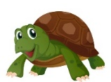

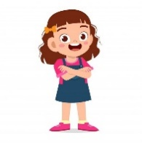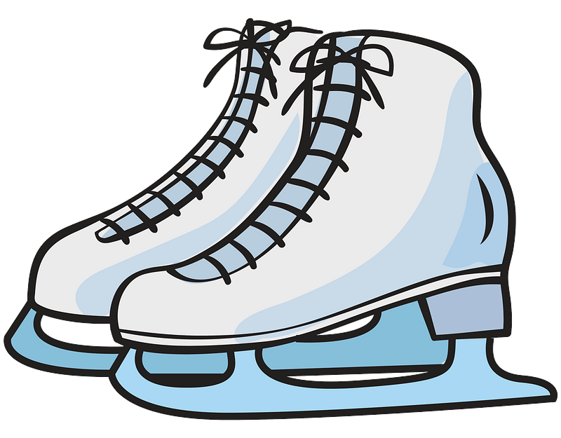

g…..l

….uare

….ate

t….tle

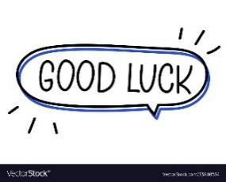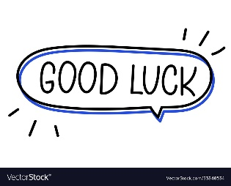

Your teacher:

Your teacher …..:…………………………….

**1- Choose the correct answer:**

|  |
| --- |
|  |
| 2 |

|  |  |  |
| --- | --- | --- |
| **المملكة العربية السعودية** |  | **المادة: انجليزي** |
| **وزارة التعليم** |
| **إدارة التعليم بمنطقة** |
| **مكتب تعليم** | **الزمن : حصة دراسية** |
| **مدرسة :** |
| **اسم المعلم / هـ:** | **20**  **المجموع** |
| **اختبار فتري لغة انجليزية - الفصل الدراسي الثالث – الصف ابتدائي** | | |
| **اسم الطالب / هـ :** | | |

|  |  |
| --- | --- |
| 1. **How many students are there in your school?** | |
| 1. **No, I am not .** | 1. **About 500** | | 1. **I should skip breakfast.** |
| 1. **What should you do to live a healthy life ?** | |
| 1. **I should go to bed early**. | 1. **Yes, he is.** | | 1. **I should skip breakfast.** |

__________________________________________________________________________________

|  |
| --- |
|  |
| **3** |

2- **Read the sentence then choose ☑ or 🗵** :

|  |  |  |
| --- | --- | --- |
| **Our school has a school bus .** | **I shouldn't do some exercise** | **Don't shout** |
|  | Free Exercise Clipart Black And White, Download Free Exercise Clipart Black  And White png images, Free ClipArts on Clipart Library |  |
| **🗸 🗴** | **🗸 🗴** | **🗸 🗴** |

_________________________________________________________________________________

3- **Do as shown between brackets:**

|  |
| --- |
|  |
| **2** |

|  |  |  |  |
| --- | --- | --- | --- |
|  | | | **1- in – live – I - Riyadh . ( rearrange )** |
| **earache** | **toothache** | **headache** | Headache icon hi-res stock photography and images - Alamy  **2– I have a _______**. **( choose )** |

________________________________________________________________________________

4- **Choose the correct word:**

|  |
| --- |
|  |
| **3** |

|  |  |  |  |
| --- | --- | --- | --- |
| **did** | **does** | **do** | **1- Which subject ______ you like this year ?** |
| **got up** | **get up** | **do** | **2- Did you ____ early this morning ?** |
| **plays** | **played** | **was** | **3- The PAST of ( play ) is ____** |

5- **Choose the right word under its picture:**

|  |
| --- |
|  |
| **5** |

|  |  |  |  |  |
| --- | --- | --- | --- | --- |
| Black And White Cartoon Math Symbols Stock Illustration - Download Image  Now - Bizarre, Book, Clip Art - iStock |  |  | Kid, Little Boy, Get Pain At Toothache. Vector Illustration Character,  Outline Hand Draw Style, Sketching, Doodle, Cartoon Design. Royalty Free  SVG, Cliparts, Vectors, And Stock Illustration. Image 82344304. | Vintage Clipart 159 Cartoon Man Listening To His Right Stock Illustration -  Illustration of monochrome, white: 177149499 |
| **Math** | **Science** | **stomachache** | **Headache** | **Don't shout** |
| **English** | **PE** | **earache** | **toothache** | **Listen** |

_____________________________________________________________________________________________

6- **Fill in the missing letters:**

|  |
| --- |
|  |
| **5** |

|  |  |  |  |  |
| --- | --- | --- | --- | --- |
| Cartoon Cute Bird Isolated On White Background Stock Vector Image by  ©Aratehortua #177005352  **b_ _ d** | 2,200+ Black And White Scarves Illustrations, Royalty-Free Vector Graphics  & Clip Art - iStock  **_ _arf** | Free Square Clipart & Cartoon｜Illustoon  **_ _uare** | Hand Drawn Women Skirt Doodle Isolated On White Background Stock  Illustration - Download Image Now - iStock  **_ _ irt** | Pin em Free Clipart Download  **b_ _ger** |
| **ur** | **sk** | **sq** | **sk** | **ar** |
| **ir** | **sc** | **sk** | **sc** | **ur** |

_______________________________________________________________________________

Good luck